Jane Homma

November 11, 2013

WRIT 340

Professor Townsend

**The Hidden Engineering in Shopping Cart Wheels**

**Abstract:**

Engineering is hidden in little details of our daily lives such as shopping cart wheels. Because of the number of hidden drug deals and shopping cart related injuries of children under the age of 15, all connected to the abundance of abandoned and stolen shopping carts, a special type of wheel was engineered. This invention originally designed by Elmer H. Isaacks in 1968 resulted in a noticeable decrease in the amount of shopping carts that leave the store property boundaries. This inevitably resulted in a decrease in injuries associated with shopping carts as well as homeless people being able to hide drug deals from the police. Even though it is one wheel on a cart that was engineered, that hidden engineering ultimately results in many lives and money saved.

**Introduction:**

A few years ago, it was pretty common to see homeless people pushing shopping carts filled with their own collections of blankets clothes and personal items, and the occasional stray carts in the neighborhoods and bus stops. However, in recent days it has not been as common. This change is the result of various anti-theft methods implemented in stores, most commonly, the anti-theft wheel lock. I’m sure people have seen these signs in supermarkets without being convinced that they work, like the signs in the parking lots and carts shown in *Figure 1*. This 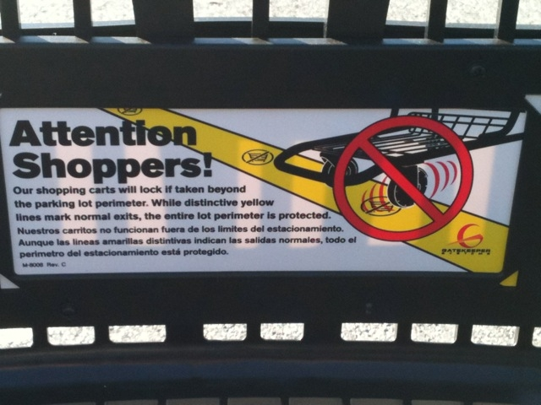anti-theft wheel mechanism implemented in each cart has actually helped with the drastic drop in the number of abandoned and stolen carts resulting in the decrease in costs to replace those carts for the store managers, decrease in hidden drug deals, and injuries of children under 15 years of age.

*Figure 1*: Warning Sign on Cart of Anti-Theft System [21]

**Consequences of Stray and Abandoned Carts:**

**Abundance of Abandoned and Stolen Carts**

The Supermarket Institute in Washington estimated in 1999 that in the United States, a shopping cart was stolen every 90 seconds [7]. That added up to about 1.8 million shopping carts taken from stores [7]. In 2008, one Wal-Mart store lost approximately 60 carts on a daily basis, which is an extreme [2]. In 2012, a Kroger store in Tennessee calculated 180 carts lost or stolen just in March [14]. This adds up to about 2,160 carts in one year. If one store is losing about 2,000 carts in one year, and there are 3,800 Kroger stores in the United States, that adds up to 7,600,000 shopping carts [16]. Even though this calculation assumes that each Kroger store loses the same number of carts, it was only looking at one chain store. Adding all the other large chain stores such as Safeway, Costco, Wal-Mart, and Target would only increase the number of shopping carts lost in the United States. These shopping carts that don't return back to the stores are then associated with hidden drug deals and injuries in young children.

**Hidden Drug Deals**

 With stray shopping carts, homeless people are able to collect them and create shopping cart encampments. With these, it makes it easier to hide drugs and drug deals because they help shield criminal activity from police officers [13]. These encampments are strategically created with shopping carts, blankets, and any other scrap material. Sometimes they can reach up to a height of six to eight feet tall [13]. Recently, in September of 2013, the police had “confiscated a backpack full of drugs from a dealer” operating behind these encampments [13]. Because of the amount of blankets and bags stored in these shopping carts by homeless people, it is very difficult for police officers to keep an eye on any drug possessions, especially when they look like the cart in *Figure 2*. Not only are shopping carts used to hide drugs, but they can also end up in the hands of teens and children resulting in injuries.

*Figure 2:* An example of a homeless person’s cart. [17]

**Increasing Child** **Injuries**

For young children, these shopping carts become racing devices to race down hills and roads ending in accidents. Other times it’s children pushing their younger siblings in these carts resulting in injuries when the cart tips over or the sibling falls out of their seat in the shopping cart. In 1993 the number of children 5 years and under who were sent to the emergency hospital for injuries estimated about 25,100 as seen in *Figure 3* [23]. 75% of all injuries were associated 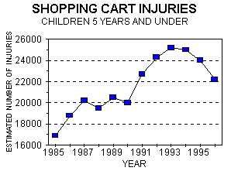with the head and neck and injuries resulting in fractures were about 45% [12]. In the second graph (*Figure 4)*, the rate of injury decreased till around 1998 and then increased again from around 2000. Some of these falls and cart tip-over accidents led not only to some severe injuries, but also to deaths. More than two thirds of these injuries had occurred on linoleum, asphalt, or concrete surfaces [12]. 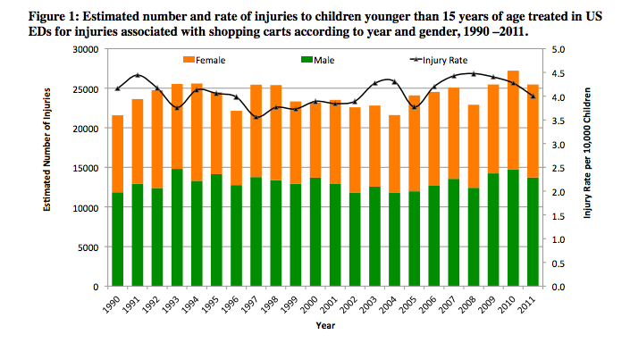

*Figure 3*: Graph of Estimated Number of Shopping Cart Injuries for Children 5 Years and Under [23]

*Figure 4*: Estimated number of children young than 15 years of age treated for injuries and injury rate [1]

**Consequences of Lost Shopping Carts for Store Owners:**

**Costs to Replace, Retrieve, and Repair Carts**

|  |  |  |
| --- | --- | --- |
|  | Unit Cost x Time | Cost/Year |
| 1. Cart Replacement (replace 2 times a year) | $75 x 756 carts | $56,700 |
| 2. Retrieval Services | $2 x 117 carts x 12 | $2,808 |
| 3. Repair Costs | $5 x 100 wheels | $500 |
| Total Cost | | $60,008 |

Each cart that stores have to replace, costs anywhere between $75 and $100 [15]. When a store needs to replace 180 carts per month, just like the Kroger store in Tennessee, the cost adds up to anywhere from $13,500 to $18,000 per month, which is not a small sum of money. However it isn’t necessary to replace all because most are abandoned in the local neighborhood. For the abandoned carts, stores will consider hiring contractors to locate and collect those carts around the area. In 2004, the California Shopping Cart Retrieval Corporation served as a primary contractor. In the first two months, 1,679 carts were picked up with an average about 117 carts a week [1]. Typically the charge for retrieval service is $2 per cart [1]. Since stores only hire contractors at most for one week out of a month to retrieve shopping carts, the service would cost about $234 per month. Since 117 of the 180 carts are abandoned, that leaves the rest to be stolen. Therefore, the rest then has to be replaced, adding up to be 756 carts per year. On top of that, to meet customer’s satisfaction, if a cart needs a wheel to be replaced so it moves smoother, that’s another $5 per wheel [7]. With all these variables, the amount of money the store has to pay a year to maintain a certain number of sufficiently working carts can easily add up to a little over $60,000 per year as seen in the example in *Table 1*.

*Table 1:* Example Cost Outline for a store like Kroger in Tennessee

On a larger scale, the Food Marketing Institute in Washington, D.C. calculated that, as of 2012, there were 37,053 supermarkets [9]. This number however does not include any stores that don’t make $2 million or more in annual sales. This means that the country spends nearly $2 billion dollars to maintain the shopping carts. The money to maintain these carts could better be used to pay the employees higher salaries and updating technology within the store. To help reduce this cost, different anti-theft methods have been put in place in the recent years.

**Methods to Avoid Cart Theft and Abandonment:**

**The Original Anti-Theft Wheel**

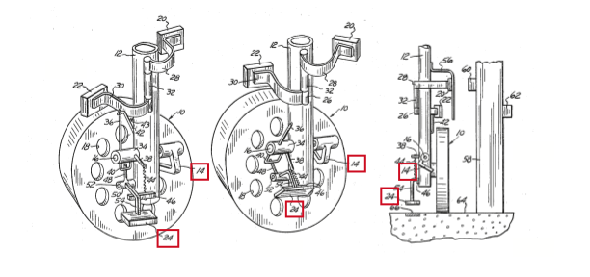 One of the most efficient devices is the anti-theft wheel originally designed by Elmer H. Isaacks in 1968. The original design of the wheel consisted of three sets of magnets; one to arm the brake system when the cart left the store, the second magnet sensed the presence of magnetic tracks embedded in the pavement, and the third system that disarmed the brake system [8]. The magnetic track that triggered the second magnet was placed around the perimeter of the parking lot, so that once the wheel rolled past the track, the magnet (24 in *Figure 5)* would feel a magnetic push that then rotated a hook (14 in *Figure 5*) into the wheel to lock it in place.

*Figure 5:* Sketch of the Original Anti-Theft Magnetic Lock Wheel (modified from [8])

**Other Anti-Theft Methods**

Other methods that have been used, but have been less effective include vertical poles that keep the carts from leaving the building itself, security guards at each entrance/exit, an alarm system, a loan system requiring customers to insert a quarter before taking the cart, and a GPS system to track all the missing carts [3], [7], [15]. Although all these methods work, they are not as efficient and effective as the anti-theft wheel locks for various reasons.

The vertical poles method kept the carts within the building because the poles that were attached would extend past the height of the entrances and exits. However it also refrained customers from being able to transport groceries in the carts, to their cars in the parking lot. This deterred many customers from shopping in these stores when they needed more than a few bags of groceries. Some stores still use them, but with the customers’ negative feedback, many have replaced this method with others.

Another method is by hiring security guards to stand near the store exit and entrances as well as those of the parking lot to help reduce shopping cart theft. Even though locating security guards around the parking lot and the storefront is very effective because it deters theft in general, there are many distractions that occur and carts could be stolen during those times [3]. Because a security guard costs about $14 an hour in California, that accumulates to about $29,975 a year per person, if there are two entrances/exits, that calculates to an additional $59,950 a year [19]. Since the cost is so high when the service the most efficient especially for busy parking lots and super markets, it isn’t a method that is highly used.

For the alarm system, there is the alarm device located at the front of the shopping cart and the transmitter perimeter circuit installed at each exit and entrance [3]. The transmitter perimeter circuit is an underground wire that triggers a signal that is sent to the alarms. Each cart is equipped with a warning signal that goes off once the shopping cart passes the first set of lines, and a much louder alarm goes off when the cart continues and passes the second line [3]. The flaw to this method is that the alarms may embarrass some people, but it does not stop them from taking the cart all together.

One of the more common methods other than the locking wheel is the loan method. This system consists of a device attached to the handle of the cart with a key and a coin insert. The key would then connect to the device of the one ahead of it so that once a coin was inserted, the key would release [6]. Ideally the person would then come and return the cart by locking the key into another device that would then return the coin to the customer. However, when the device only cost a quarter, many seem to think it is too cumbersome to return the cart just to have the coin returned [6].

Lastly, the GPS tracking system is a method that allows store managers to keep track of the location of their shopping carts. The minor flaw is that the system only notifies the location, but does not prevent people from taking the carts. Not only that, but to implement the device on every cart is costly. Each GPS could cost about $70, which means that for 200 carts, that’s an additional $1400 added to the cost [20]. Even if the carts are traceable, it is still necessary to hire people to collect them and if they are too far from the store, the contractors won’t track them down.

**Improved Anti-Theft Wheel Lock Systems**

Because of the use of magnets in the original design of the anti-theft wheel lock, there was a slight design flaw that people started to realize. Since the design relied on magnetic force, people realized that once the wheel was hit hard enough, the magnetic force would release and the device would unlock [21]. Therefore, the design needed to be improved and instead of relying on magnets, the newer versions base their designs on radio frequency signals.

**Gatekeeper Systems:**

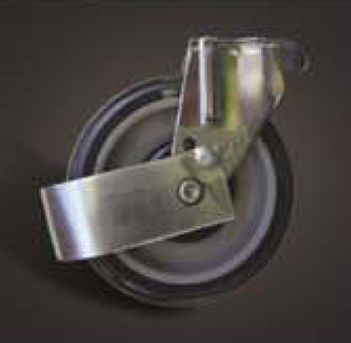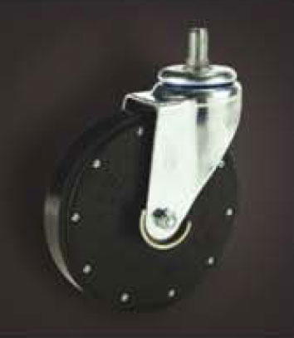Gatekeeper is one of the main companies known for their cart management systems and is implemented on about 1.4 million shopping carts since 1998 [22]. Their system, CartControl, combines three components: “digitally-encoded radio frequency (RF) locking signal, embedded perimeter antenna, and … patented self-braking wheel” [11]. The installation process consists of four main steps*.*  First, the CentralTransmitter is mounted on the inside of the store, to receive the radio frequency signals from the wheel to lock it [11]. Then the ¼” diameter perimeter antenna cable is embedded 1” deep with a precision saw cut around the boundary of the parking lot as seen in *Figure 6* [11]. The third step is to install the SmartWheel and the anti-tilt bar on each cart (*Figure 7)*. The SmartWheel is a wheel that replaces one of the existing front wheels, which sends radio frequency signals to the CentralTransmitter when the wheel rolls over the perimeter antenna [11]. Once the CentralTransmitter receives the signal, it releases the cover of the wheel, locking it in place [6]. The anti-tilt bar prevents people from tipping the cart back and rolling it [11]. Last and most importantly, the perimeter of the store must be visible through perimeter strips painted as well as signs warning customers of the implemented systems [7]. The whole installation process takes less than a day and costs between $6,000 for a small local store and $50,000 for a store with a larger parking lot such as Costco [7], [21].

*Figure 7:* Anti-tilt bar and SmartWheel [11]

*Figure 6:* Perimeter antenna cable embedded [11]

**CAPS (Cart Anti-Theft Protection System):**

Carttronics is another company that has supplied much of the anti-theft locking devices since 1997, founded by John French. One of the systems that he developed is CAPS, the Carttronics version of the anti-theft wheel lock system [4], [7], [15]. CAPS is very similar to Gatekeeper’s system and uses radio frequency to lock and unlock the device. It also has the underground “electric fence” (a similar device to the antennae used by GateKeeper). Both of the systems have been used by many stores, but GateKeeper’s system is implemented in most because they are a company focused specifically on the anti-theft wheel locking device while CAPS has a broader focus on shopping cart maintenance.

**Results:**

As advertised by GateKeeper and Carttronics, the anti-theft wheel lock has decreased cost for the stores and prevented the many carts from leaving the property lines. Even though the cost of implementing the system is on average about $18,000, that investment is returned in as little as 6 months. This means that one payment at the beginning prevents further theft of carts and the only cost that the store would have to account for is the occasional repairs on the carts that cost only a few thousand dollars per year. Compared to the original over $60,000 spent per year to maintain the carts, the stores have been making more profit and implementing newer systems as well as fixing up the store to better satisfy their customers.

In response to the decrease in abandoned carts and stolen carts, there has been a noticeable decrease in the amount of shopping cart related injuries in the past few years after the increase in the use of the anti-theft wheel systems as well. Shown in *Figure 4,* from around 2008, there has been a decrease in the rate of injuries. Although the decrease isn’t significant, as of 2011, the estimated injury rate for every 10,000 children had dropped to 4 [1]. Although the anti-theft wheel lock device has been implemented in many of the shopping carts, they are more widely used by larger chain stores such as Costco, Target, Safeway, and Walmart.



*Figure 4*: Estimated number of children young than 15 years of age treated for injuries and injury rate [1]

The anti-theft wheel lock was invented and engineered in response to a small issue that had escalated and affected people through drug deals and injuries. This shows how much our lives and our safety can rely on science and engineering in the smallest details such as these shopping cart wheels.

**Bibliography**

1. C. J. Kurtz (City Manager), “Abandoned Shopping Cart Program Update,” California Shoppng Cart Rerieval Service, Memo, 2004.
2. C. Swirko (2008, May). Solving shopping cart thefts. *Gainesville.com*. [Online] Available: http://www.gainesville.com/article/20080517/news/805170338
3. CartManagment. (2009, May 26). *Effective Ways to Prevent Shopping Cart Theft or Loss* [Online]. Available: http://cartmanagement.hubpages.com/hub/Effective-Ways-2-Prevent-Shopping-Cart-Theft
4. Carttronics. *Carttronics CAPS (Cart Anti-Theft Protection System)* [Online]. Available: http://www.carttronics.com/Brochures/Carttronics_CAPS_US_1.pdf
5. Center for Injury Research and Policy of the Research Institute at Nationwide Children’s Hospital, *Pediatric Cart-Related Injuries Treated in US Emergency Departments, 1990-2011*, Nationwide Children’s Hospital, 2012.
6. D. A. William, “Corralling Carts; Anti-Theft Device Keeps Shopping Baskets in Their Place,” *Daily News,* Apr. 20, 1999.
7. D. A. Williams, “Device Stops Grocery Cart Thieves in Their Tracks,” *Los Angeles Times*, May 1999.
8. E. H. Isaacks, “Shopping cart wheel lock,” U.S. Patent 3 495 688 A, Feb 17, 1970.
9. Food Marketing Institute. (2012). Supermarket Facts. *Food Marketing Institute*. [Online] Available: http://www.fmi.org/research-resources/supermarket-facts
10. Gatekeeper Systems. (2007). *Loss Prevention* [website]. Available: http://www.gatekeepersystems.com/sol_loss_prevention.php
11. Gatekeeper Systems. (2007). *CartControl Installation* [website]. Available: http://www.gatekeepersystems.com/sol_cc_cc_install.php
12. G.A. Smith, MD, DrPH, “Shopping Cart-Related Injuries to Children,” *Pediatrics*, vol. 118, no. 2, pp.540-544, August 2006
13. G. Haagenson. (2013, Sept. 18) *Homeless with shopping carts are growing police problem* [Online]. Available: http://abclocal.go.com/kfsn/story?section=news/local&id=9253630
14. H. Bryan (2012, Nov.). Shopping carts a surprisingly large expense for retailers. *Personal Money Network*. [Online] Available: https://personalmoneynetwork.com/moneyblog/2012/11/14/shopping-carts/
15. K. Wilkinson, “Wheels of Fortune” *Silicon Valley’s Weekly Newspaper,* June 3-8, 1999 issue.
16. Kroger (2012, Sep.) Kroger Company Statistics. *Statistic Brain*. Available: http://www.statisticbrain.com/kroger-company-statistics/
17. M. Wit. (2009, Apr.) “Homeless person’s shopping cart next to Ballard Condo.” *Flickr.com*. [Online] Available: http://www.flickr.com/photos/marywit/3434695599/
18. S. Taba, “Anti-theft vehicle system,” U.S. Patent 6 945 366 B2, Sep 20, 2005.
19. Security Guard. *Salary.com*. [Online] Available: http://swz.salary.com/salarywizard/Security-Guard-Salary-Details-Los-Angeles-CA.aspx
20. SilverCloud Tracker. *GPS Tracker Shop*. [Online]. Available: http://www.gps-tracker.com/real-time-gps-tracker/silvercloud-tracker-detail
21. T. F. Linderman. (2010, Aug. 10). *Retailers employ technology to cut down on loss of carts*. [Online]. Available: http://www.post-gazette.com/stories/sectionfront/life/retailers-employ-technology-to-cut-down-on-loss-of-carts-258892/
22. “Time on My Hands.” *Dull is the New Fabulous.* [Online]. Available: http://dullfab.blogspot.com/2011/11/time-on-my-hands.html
23. United States Consumer Product Safety Commission. *Shopping Cart Injuries: Victims 5 years old and younger.* [Online] Available: http://www.cpsc.gov/en/research--statistics/injury-statistics/topics/shopping-cart-injuries-victims-5-years-old-and-younger/
24. W. Bezanson, “Abandoned Shopping Carts,” in *Abandoned Shopping Carts: Personal and Spiritual Responsibility,* Trafford Publishing, 2011, Sep 7. pp. 9-22.