This easy to operate machine that is found in the majority of homes has a rich history and is an underrated appliance in society. The engineering concepts put into building the electrical washing machine that we have today, was a process of improvements that were developed by different engineers throughout time. From the man-powered wooden machine, to the “Mighty Thor” washing machine, which had the first electric motor; the washing machine is considered one of the top inventions of all time for its impact on society. It reduced the time it took washing clothes from one day to a forty minute process. This allowed for women, who did most if not all the washing in the early days to have a more social life and a bigger role in society.

The Washing Machine

Introduction

Some people see washing clothes as an annoying chore that they have to do multiple times a week, especially those who don’t own their own washing machine and have to drive to a laundry mart near their home. But we should consider ourselves lucky because of how simple the process of washing our clothes has become. We have a choice of two washing machines, top loading washing machines and front loading washing machines. All we have to do is pick a machine, throw in our dirty clothes, select the mode of washing, add in the soap and sit back and let the machine do all the cleaning for us.
Many of us probably never thought much of the washing machine as we wait for our clothes to be cleaned. The washing machine is a complicated device that can be broken down to two parts, the washer’s control system and its mechanical system. The control system is made up of a timer, control boards, the pressure and lid switch, and the temperature selector. The mechanical system drives a motor, transmission, two wash tubs (inner and outer), suspension system, pumps and water valves, as well as a motor coupling belt [2].
Before the washing machine was invented and available to everyone, people had to use clean water, rocks, and scrub boards to wash their clothes. It was a task that many people found to be too unappealing and so many would hire washerwomen to do the job. A better method for this had to be developed and so there were many ideas and improvements on emerging washing machines.

History of the Washing Machine

As we look at today’s method of washing clothes and compare it to the times when there was no running water, gas, or electricity, we should appreciate how much easier the washing machine has made washing clothes, because in the old days, the standard method of doing laundry took up an outstanding amount of time and labor to complete. Back then in order to do laundry required about 50 gallons of water. It was a long process that required multiple types of washes. Women did all the washing in the old days, and the rubbing, and lifting of water-laden clothes hurt their arms and wrists. They moved heavy tubs filled with clothes in order to hang them up on the string line outside their homes [3]. In entrepreneurship, this is an opportunity for an inventor to come up with a better way of doing laundry since it was needed in order to ease the pain of the woman who normally did the laundry in these times.
The first washing machines that were developed were manual machines that tried to copy the human hand on a washing board (See Figure 1.) The machines had a lever and two curved surfaces. The lever would move one of these curved surfaces over another and it would rub clothes that were placed between these two curved surfaces. This type of washing machine was first developed in the U.S in 1846 [3].
Figure 1. Hand Power Washing Machine (Source: Google Images

James King designed the first washing machine that the modern day washing machine is based on. These machines used a drum device that is found in washing machines today. Two key improvements were made to the machine that James King developed. The first rotary powered washing machine was developed by Hamilton Smith in 1858, which consisted of a hand-turned crank that rotated a cylinder within a wooden shell. This machine also ran on a low speed gasoline engine and was the first washing machine introduced for home usage. William Blackstone developed the first mechanical-washing machine around 1878 [5]. His machine used a wooden paddle that moved clothes around and had wooden pegs which would loosen and take out dirt. These important improvements were what helped the development of the electric powered washing machine.
The first electric powered washing machine was developed in 1908 [1] by Alva J. Fisher who held a position at the Hurley Washing Machine Company. It was given the code name “Mighty Thor.” This new machine had a motor installed within the unit. This new addition allowed the machine to perform faster and a lot more effectively than its predecessors. It allowed for larger loads in a shorter amount of time and was the cannon design for today’s washing machine.
Early problems with this new type of washing machine included the motor, which was not protected at all and so water would drip on to it causing malfunctions and often it gave off electrical shocks to the person using it. From an engineering point of view, these manufacturers had many problems. Some of these problems were to find a method that would allow them to transfer power from the motor to the washing mechanism, as well as actually develop a motor that would have enough initial torque, and making sure that the machine wouldn’t give an electrical shock to the user during operation [3].
The challenges of transferring power properly were solved by having washing machines chain driven and having others use shaft and gears. To solve the problem of resistance that a machine had when starting up the motor, manufacturers used a 1/8 horsepower motor [3]. The stator and rotor of the washing machine were put into a housing that had a fan installed in order to prevent overheating and electrical shocks to the operator.
How the Washing Machine Works
Washing machines clean clothes by forcing the mixture of water and soap through your clothes which help loosen the dirt from the fabric. The two types of washing machines mentioned earlier (See Figure 2.), do this differently. The top loading washing machine has an agitator (See Figure 3.) which moves back and forth grabbing the pieces of clothing and sending them to the bottom of the tub, the clothes rise back up towards the surface and get dragged back down by the agitator. The front loading washing machine spins as the clothes tumble in water allowing the water-detergent mix to remove the dirt off the clothes. The process continues by pumping out all the water from the tub and using centrifugal force to squeeze out as much water as possible from the clothes by spinning really fast at about 500 to 1200 RPM [2].
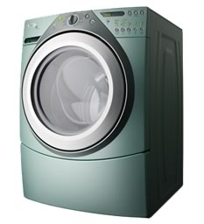
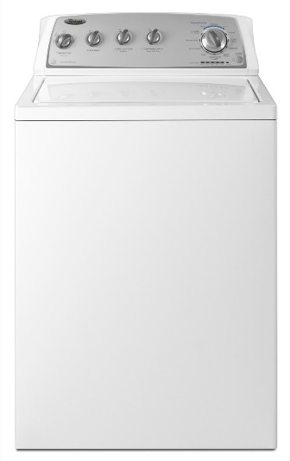

Figure 2 Front Loading Washing Machine (Left), Top Loading Washing Machine (Right) (Source: Google Images)

Parts of the Washing Machine
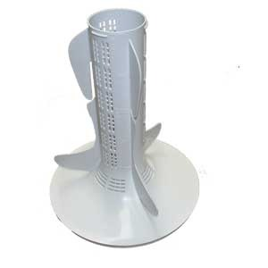

Figure 3 The agitator (Source: Google Images)

The Tub

Washing machines have two tubs, an inner and an outer tub. The inner tub is where you put your clothes in and it has a lot of holes that allow the flow of water between tubs. The outer tub is where all the water is actually contained. As the machine spins, the water flows through the holes of the inner tub and back into the outer one. The top loading and front loading washers spin at 500 RPM and 1000 RPM respectively in order to suck out the majority of water from clothes as well as reduce the amount of drying time needed afterwards [2].
The Suspension System
The suspension system is made up of springs, sliding plates, and load bearing pads that keep the tubs in their correct position (See Figure 3.) The suspension system also controls the forces that are required to spin and stop the inner smaller tub. The system also helps reduce the amount of noise that is given off by the machine mechanics.

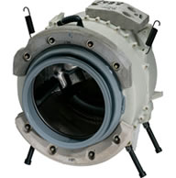

Figure 4. The Washing Machine Suspension System (Source: applianceassistant.com)
The Timer and Control Boards
Washing machines use either a timer or control boards to start a mechanical component when it is the right time for it to be used. In a timer, a rotating cam opens and closes many small contact switches. When these switches are closed, they start up the component that is needed. Control boards on the other hand are a bit more advanced. They monitor different sensors placed around the washing machine in order to regulate water temperature, wash speed and spin speed, as well as the fill and drain time. Since these control boards are computerized, it makes it more difficult to diagnose malfunctions and they are more expensive to replace compared to the timer [2].
The Lid Switch
The lid switch is a very important piece to a washing machine. This part lets the machine know if the lid is open or closed. This is a safety mechanism which has reduced the amount of injuries to the operator. If the lid switch is open, most new washers will stop all mechanical functions and will not work until the lid switch is closed.
The Water Valve
Washing machines have a water valve that is connected to the water supply of the location they are in. This valve controls the flow of hot and cold water into the outer tub by using electromagnetic solenoids. One solenoid controls the flow of cold water while the other controls the flow of hot water. The pressure switch works together with the water valve. This switch controls the amount of water released into the outer tub by increasing its air pressure as the amount of water in the tub increases. When a certain level is reached, this switch stops the electricity flow to the water valve, causing the solenoids to close and stopping the flow of water [2].
The Pump, Motor and Transmission
The drain pump is used to transfer the dirty water out of the washer tub. It is usually attached to the washing machine’s motor, or it can have its own small internal motor. The washing machine’s principal motor drives the mechanical system; the pump, agitator, and the inner tub. If the motor is considered “direct drive”, this means that it is connected directly with the pump and transmission. The transmission controls the spinning of the inner tub and the rotational movement of the agitator in top loading washing machines [2].
Conclusion: Social Impact of the Washing Machine
Reducing the amount of time and labor that doing laundry used to cost, has made the electric washing machine one of the best inventions of all time. According to a study done by Tesco Mobile (UK), the washing machine was named the 12th most important invention ever. In the UK, women voted that the washing machine was the greatest time-saving invention of all time [4].
The invention of the washing machine had a big economic impact on the world. When the electric washing machine was invented it reduced the amount of time spend doing laundry from 4 hours to 41 minutes. All the different components that make the inside of the machine were carefully built and placed in order to allow the tub to spin at great speeds [6]. The implementation of an electric motor as well as a water valve ease the pain of doing laundry. This machine that is now in almost everyone’s home or apartment changed the way we all live our lives by allowing us to have more time away from washing our clothes. The next time you wash your clothes, as you’re walking away from the washing machine, consider yourself lucky and thank the engineers who were able to turn a whole day of work to a 40 minute process.

Works Cited
- "History of The Washing Machine." Timetoast. Web. 15 Nov. 2013.

- "How Washing Machines Work." Appliance Assistance. Web. 15 Nov. 2013.

- "Washing Machine History - Invention of the Washing Machine." The Great Idea Finder. Mar. 2005. Web. 15 Nov. 2013.

- "Washing Machine Named 12th Most Important Invention Ever." Electrolux Group. Electrolux Media Relations, 4 June 2010. Web. 15 Nov. 2013.

- "Who Invented The Washing Machine?" Who Invented It? Web. 15 Nov. 2013.

- Wade, Matt. "How the Washing Machine Changed the World." The Sydney Morning Herald. 8 Apr. 2012. Web. 21 Nov. 2013.

