Payment of the Future: Digital Wallets

By: David Pair
dpair@usc.edu or davidapair@gmail.com
(310) 266-5019

Abstract:
Credit cards are now a well established method of payment that is quickly advancing to the next stage of mobile payments and digital wallets. These digital wallets being created can store your credit card information and be used to make purchases, track history, keep loyalty cards, and receive special offers. Companies such as Google and Visa are leading the trend by developing their own digital wallets and methods for consumers to use and make purchases with. Through the use of NFC technology, as well as other developing ideas, the transactions can be made safely and securely in a quick fashion. While the exact future of payment methods cannot be known, digital wallets are certainly the next step.

Author Bio:
In the fall of 2011, David Pair was a junior studying Mechanical Engineering at the University of Southern California. After receiving his B.S. degree, he hopes to continue his education in graduate school in pursuit of an engineering design master’s degree so he can design the very phones he writes about.

Keywords:
Digital wallet, NFC, mobile, payment, smartphone
A History of Modern Payment Systems
Beginning with department stores and hotels in the 1920s, companies began offering cards to people who didn’t want to have to take out and carry around large sums of cash in order to buy expensive items. Then in the 1950s, Diners Club began to issue a card that could be used in restaurants around New York City and like today were a way for people to spend larger amounts of money without the hassle of carrying cash around. Not long after, a trend was beginning to take shape and American Express and Bank of America began offering their own cards to the public [1]. And the rest, as they say, is history. BankAmericard (of Bank of America) soon transformed into what is now Visa and MasterCard joined the scene in 1966 to become the last of the early major credit card companies.
Now millions of people around the world use credit cards on a daily instead for carrying around money. Credit cards and debit cards have become as asset seemingly essential to the modern consumer. The way people pay their credit card bills has also evolved. With the development of broadband Internet, many people have started to move towards paying their bills online and making mobile payments and transactions. Nowadays, thanks to high level mobile internet capabilities, these transactions can even be made on cell phones by connecting to the banking site through a phone application. And so, from this natural progression of payment methods, we arrive at the next step in making payments, digital wallets.

Digital Wallets Explained
So what is a digital wallet? In simplest terms, a digital wallet is an account on your phone that keeps your credit card information and is available to use to purchase goods. However, with multiple companies and partnerships developing the technology, the potential for digital wallets is growing fast. There are two main companies leading the charge into the digital wallet territory, and both in similar, but not quite the same way. The first is Google, with Google Wallet. Google Wallet’s aim, as stated by Google’s VP of Commerce Stephanie Tilenius, is “creating tomorrow’s shopping experience” [2]. The digital wallet will be a place not only to store your credit card information, but also your credit card history, loyalty cards, and even special offers and discounts available. This last point is one of particular interest, because it brings up something called the redemption loop, and is able to close it. “The redemption loop starts when a consumer sees an ad or an offer for a local merchant, and is completed when the consumer makes a purchase and that purchase can be tracked back to the offer” [3]. With digital wallet technology, the wallet will be able to consider what you are purchasing, and show you any available discounts as the transaction is taking place. It is simple, convenient, and helpful.
The other big company pushing for digital wallets and beyond is Visa. Visa plans to create this same style of digital wallet, but move it even beyond just the card history, loyalty cards, and offers. On any device, Visa wants to use the digital wallet to eliminate the need for inputting credit card information all together. Let’s say you were buying something from an online merchant, instead of having to input your credit card information every time, you would instead have the option of a single button press, that would access your digital wallet on that device and process the payment. These aren’t the only companies developing digital wallets either, and thus there is great possibility for even further advancement of digital wallets.

Digital Wallets, the Engineering Side
Digital wallet technology is possible through the convergence of broadband internet and mobile devices. Today, all smartphones have internet capabilities, and thus the ability to connect to a network and establish a link with your credit card company. While now taken for granted by most smartphone users, this is in fact the most important step in creating a digital wallet. This connection is what allows all of the information to be gathered and confirmed by the digital wallet. Through secure links, a credit card can be verified upon being entered. From the other side of the transaction, this link is how confirmation and a history will be reported to the digital wallet, as well as offers and discounts that get pushed to the device.
The next most important step in creating a digital wallet is the communication between the buyer and the seller; the process of making the actual payment and getting the information from your phone to the merchant. For most companies, Near Field Communication (NFC) has been the chosen path of development. NFC technology is based on pre-existing contactless payment standards already in use around the world in places such as bus and train ticketing. An example of this is the London Underground system. They implement what they call an Oyster Card, which is simply a plastic card with an electronic chip inside that can hold a balance and communicate with a reader on the ticket stall. When you swipe your Oyster Card over the reader, your ticket transaction is processed and you can proceed to you train quickly and efficiently assuming your card is holding enough money. How it works is by using an inductive-coupling system, “where loosely coupled inductive circuits share power and data over a distance of a few centimeters” [4]. In other words, the circuit produces a small electric field than can transmit data and be picked up and read by a similar circuit. The great thing about NFC technology that has led companies to pursue the technology is the ability for whatever device using it to have multiple modes: a reading/writing mode, a peer-to-peer mode, and a Card Emulation mode. The device can receive and send data, exchange data, or be open to reading by other devices, thus allowing for the same technology to be used by both the consumer and merchant [4]. The last step needed is to incorporate a small NFC chip into the mobile device, as well as the merchant’s credit card reader. Instead of swiping a card, placing your phone in read/write mode next to the merchants’ device in Card Emulation mode completes the transaction nearly instantly.
As mentioned earlier, not all companies have the same approach. A startup called MobilePay USA makes the claim that “merchants have been reluctant to adopt Near-Field Communications because of the cost” [5]. They instead have an approach that uses the phones built-in GPS to locate the phone and confirm the location at the merchant before approving the transaction. An encrypted pin is then sent between the phone and the merchant’s card reader to finalize the transaction [5]. While NFC technology is what is being most widely adopted, other solutions like this still exist and are being developed.

Implementation
A digital wallet sounds great in theory, but like any technology, it is nothing if it is not implemented properly and effectively. To accomplish this, virtually all those developing digital wallets are using smartphone application marketplaces, such as the Apple App Store or Google’s Android Market along with similar hubs on all smartphones, to create and distribute their own unique digital wallet application that contains all the needed functionality for the wallet. Because of this, anyone with a smartphone can gain access to a digital wallet to store and track their information. Furthermore, there is a view of openness and sharing to an extent when looking at digital wallets. Google, for example, is planning to publish their API for Google Wallet and work with partners to promote standards for digital wallet applications. This will help to not create a world with too many choices that make it difficult to understand the differences between wallets, and instead fosters the opportunity for a unified order to different company’s approaches.
It is also important to note the current trend of NFC chip integration into smart phones for the purpose of creating digital wallets. Even though anyone can access a digital wallet app now, the ability to make transactions is not possible without an NFC chip installed in the device. Thankfully, this is changing rapidly, and by 2014 it is estimated that at least one in five smartphones worldwide will be equipped with NFC capabilities [6].
Last, but not least is the issue of security with all of these wireless communications. If mobile payments and digital wallets take off the way the trend is heading, secure dedicated channels will need to be created in order to properly and securely handle the load of confidential data streaming though. This process will be similar to how credit card payments are handled and communicated now, but will most likely require making current systems more robust or duplicating them altogether to handle the increased use and system load created from this technology. But if the proper steps are taken, the processing and logistics of all this information can be easily achieved and provide a reliable system for mobile users [7]. However, this process must be a unified effort made by those companies leading the way in order to set fair standards of practice.

Conclusion
Digital wallets are still very much an emerging technology in the world, with new and exciting announcements being unveiled every few months. Not only is the current trend of engineering development leading towards the formation of a digital wallet, but credit card companies such as Visa, MasterCard, and American Express are pushing for these technologies to emerge. NFC technology is also becoming cheaper and cheaper as time goes on, and is being integrated into other IC chips that get placed into smartphones, giving even more reasons to include them in the phones of tomorrow, and of today. Also more and more companies like MobilePay USA continue to receive new support in driving towards more solutions for digital wallets. No matter which direction the world decides to turn with this new technology, it is certain the credit cards won’t be around forever, and that the future of transactions is being created now, with digital wallets.

References

[1] M.J. Stephey (2009, April). “A Brief History of: Credit Card” Time Magazine U.S.[On-line]. Available: http://www.time.com/time/magazine/article/0,9171,1893507,00.html [Nov. 5, 2011]

[2] M.G. Siegler (2011, May). “Google Unveils Wallet and Offers: An Open Platform for Mobile Payments” Tech Crunch [On-line]. Available: http://techcrunch.com/2011/05/26/google-wallet-offers/ [Nov. 5, 2011]

[3] E. Schonfeld (2011, July). “Closing the Redemption Loop in Local Commerce” Tech Crunch [On-line]. Available: http://techcrunch.com/2011/07/24/redemption-loop-local-commerce/ [Nov. 5, 2011]

[4] (2011). “Frequently Asked Questions” NFC Forum [On-line]. Available: http://www.nfc-forum.org/resources/faqs/ [Nov. 5, 2011]

[5] M. Hachman (2010, September). “MobilePay: Your Phone is Your Credit Card” PC Mag [On-line]. Available: http://www.pcmag.com/article2/0,2817,2369877,00.asp#fbid=52Y9VMihPzs [Nov. 5, 2011]

[6] D. Murphy (2011, July). “1 in 5 Smartphones NFC enabled by 2014” Mobile Marketing [On-line]. [Nov. 5, 2011]

[7] Dai, Weihui, Cai, Xiang, Wu, Haifeng, Zhao, Weidong, AND Li, Xuan. "An Integrated Mobile Phone Payment System Based on 3G Network" Journal of Networks [On-line], Volume 6 Number 9 (1 September 2011) [Nov. 5, 2011]

Included below are Images and their source that could be used to highlight features of the article, but are not mandatory to be mentioned in the article itself.

Caption for the following images would be:
Credit card information is transferred and transactions completed by placing the phone with the digital wallet app open against a reader.

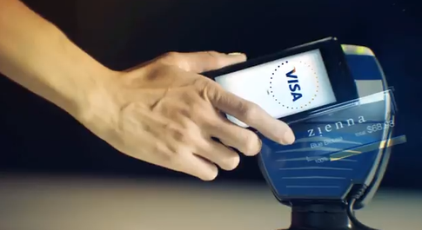
http://www.quora.com/Visa-Wallet
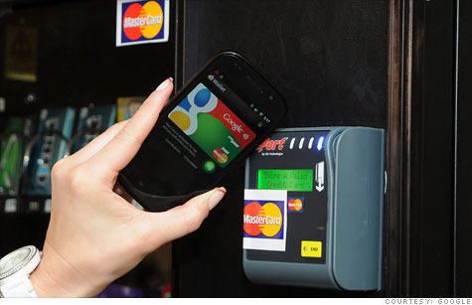
http://infotech.bplaced.net/2011/05/google-wallet-mobile-payment-service-video/
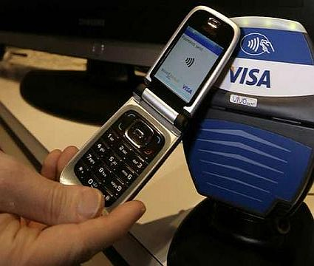http://www.cellphonebeat.com/entry/nokia-teams-up-with-visa-to-turn-mobile-phones-into-mobile-wallets/
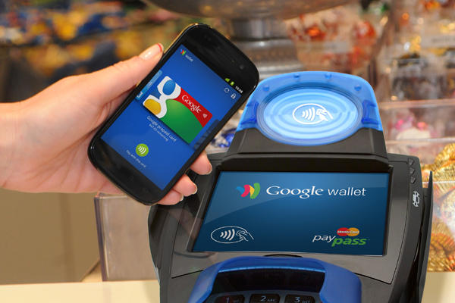http://www.csmonitor.com/Innovation/Tech/2011/0920/Google-Wallet-Shop-with-a-swipe-of-your-phone
Captions: Digital wallets such as Google Wallet aim to provide more convenience and security while making the payment process even faster.
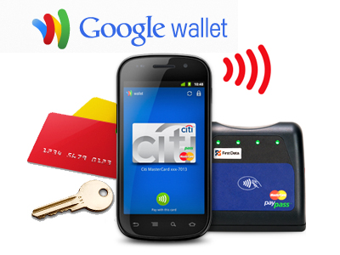
http://articles.businessinsider.com/2011-05-26/tech/30044973_1_nexus-s-4g-google-wallet-nfc-chips
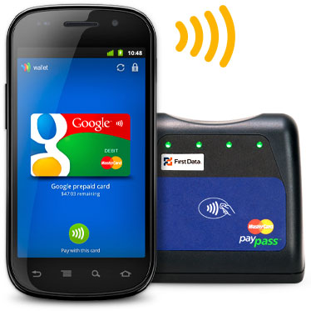
http://www.forbes.com/sites/elizabethwoyke/2011/09/19/what-mastercard-learned-from-testing-googles-google-wallet-app/
Caption:
Digital wallets such as Google Wallet aim to bring all your payment needs including credit card information, purchase history, and discount availability through a more convenient and secure process by integrating it into your cell phone.

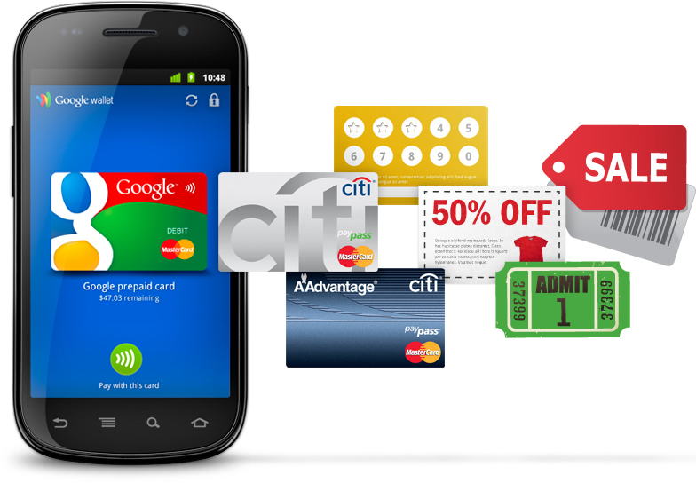
http://googleblog.blogspot.com/2011/05/coming-soon-make-your-phone-your-wallet.html

