Scott Berman
October 11, 2013
WRIT 340

“Punch it Chewie:” Going Faster than Light

Introduction:
Ever since the modern universal speed limit was set at 299,792.458 kilometers per second, the speed of light, in 1975, humankind has been trying break that speed limit. (Bureau International des Poids et Mesures, 1975) But humanity’s obsession with getting that speeding ticket has been going on for much longer than that. Our fascination with the speed of light has gained an almost fantastical aura to it. Entire movies, TV shows, books, even video games have had their foundations rooted in traveling faster than light. Star Wars, Star Trek, the Honor Harrington series, and Halo are prime examples of these. But we do not have the technology to create our own version of the Enterprise hurtling around new galaxies at Warp 7.0. Scientists and researchers are already working on many promising theories and machines that could one day prove that going faster than light is even possible. That being said, there are still many different obstacles and new technologies we must overcome and create in order create a practical faster than light device. But once we are able to do travel faster than light, the things we can accomplish are mindboggling.
Background:
The speed of light, or “c,” is how fast light propagates through a vacuum. The first calculation of the speed of light was done by Ole Rømer and Christiaan Huygens in 1675, which was done by calculating when the eclipse of Jupiter could be seen on Earth versus the actual time the eclipse happened. Using that time difference Rømer was able to calculate that the speed of light was 200,000 kilometers per second. Fast-forward 300 years and the 15th Conférence Générale des Poids et Mesures in 1975 defined the speed of like as 299,792.458 kilometers per second. A light year, as one might expect, is the distance of how far light travels in one year, which is 9,461,000,000,000 kilometers, give or take a couple million kilometers. To put it in perspective our sun, Sol, is 93 million miles away which is 8.333 light minutes away. That means it takes light from the sun 8.333 minutes to reach us. Now the closest solar system to us, Alpha Centauri, with its trio of stars, is approximately 4.365 light years away. (Cain, 2009) The current fastest man-made object in our Universe is the Voyager 1 space probe which is puttering (compared to light speed) around at 44.191 kilometers per second relative to Earth. (Voyager Mission Team, 2013) At that speed it would take Voyager 1 31,572.74 years to reach the nearest solar system to us.
If we are to explore our little corner of our galaxy, then we must travel faster than light. But that is easier said than done, and it’s all because of one little equation.
$$E=mc^{2}$$
This equation is Einstein’s for mass-energy equivalence. But we need to take this equation a few steps forward to have it apply to faster than light travel. If we apply this equation in the frame of special relativity we can find, as Einstein found, that the kinetic energy of a moving body is:
$$E_{k}=\frac{m_{0}c^{2}}{\sqrt{1-(\frac{v^{2}}{c^{2}})}}-m_{0}c^{2}$$
Where $E_{k}$ is the kinetic energy, $m_{0}$ is the rest mass of the moving body, $c$ is the speed of light, and $v$ is the velocity of the moving body. This equation is only valid for values of$v^{2}$<$c^{2}$, when the square of velocity is less than the square of the speed of light. If the square of the velocity of the moving body is greater than the square of the speed of light, then we get a ratio above or equal to 1. This causes us to get a non-real number and therefore invalidates the entire equation. At the same time, as we get closer and closer to $v=c$ the greater and greater $E_{k}$ gets, it gets so large that it will take an infinite amount of energy to even accelerate a small object up to relativistic speeds (speeds closer to the speed of light.) From the time Einstein determined this equation in 1905, no one has been able to prove it to be wrong. So unless someone can prove this equation wrong, we must find a way to go around this equation to go faster than light. These equations have not stopped fiction from going faster than light.
How Light Speed works in Fiction:
In multiple types of media traveling faster than light has played a major role. Star Wars travels faster than light thanks to Hyperspace Generators, Halo has the Shaw-Fujikawa Translight Engine, and Start Trek has the Warp Drive. Each device are based off entirely different theories.
Star Wars’ Hyperspace Generators works by allowing a ship, say Han Solo’s Millennium Falcon, to enter and exit an alternative region of space that exists outside our own universe. That is why whenever you see in the movies one sees a distorted blue-black view when a ship is traveling through hyperspace. (Figure 1) Another interesting faster than light technology that the Star Wars universe has is the “holocomm”. The holocomm allows for faster than light communications to be sent through hyperspace. This means that not only can beings can travel across entire half galaxies (thousands of light-years) in less than 24 hours, but one can send messages that same distance at sometimes greater speeds without leaving the comfort of their homes.
In the video game series “Halo” the United Nations Space Command (UNSC) ships use Shaw-Fujikawa Translight Engines to tunnel into slipstream space. Slipstream space is an interstellar realm that has alternate physical laws. (Figure 3) In this realm it is possible to go faster than light without any of the relativistic laws getting in the way. Traveling in slipstream space is non-instantaneous, meaning that ships do not reach their destinations instantly, but have to take time to travel there. Due to the rather unique properties of slipstream space, special relativity becomes a unique concept. Space and time no longer exist together. Space seems bigger, smaller, and distorted at different moments, and time seems to be going at a random pace. (Halopedia, 2013) Yet still a ship can enter at one point in space and travel faster than light. This is one of fictions more esoteric methods of going faster than light, Star Trek’s method on the other hand, has potential to actually work!
In the Star Trek universe one travels faster than light thanks to the Warp Drive. The Warp Drive’s concept is that warp drives use their warp nacelles to create warp “bubbles” that surrounds a ship that allows it to travel faster than light in normal space. (Figure 3) The Warp Drive does this by using warp cores to collect the energy released by matter-antimatter annihilation (when matter and antimatter collide they release incredibly amounts of energy) regulated by “dilithium crystals.” The end result to this incredibly complicated reaction is that a starship can reach factors of Warp (1.0, 1.5, 2, 3…) that are all faster than light. For example the Intrepid-class of starships (Star Trek: Voyager) could travel at Warp 9.975, which is around 2,922 times the speed of light. (Memory Alpha, n.d.) Like Star Wars, beings in the Star Trek realm can also send messages faster than light. But it is where Star Trek differs from Star Wars that gets very intriguing. Due to the fact that Warp Drive causes a warp “bubble” to surround a vessel rather than have it enter an alternative region of space (like the Hyperspace Generator does) it allows the people inside to be able to interact with things in normal, non-warp space.

Going Faster than Light in Modern Times:
While it is true that human beings have yet to go faster than light, there are many promising experiments and theories that currently exist that have the potential to do just that. I will be focusing on three of them, the OPERA experiment, MINOS, and the Alcubierre drive.
The CERN Oscillation Project with Emulsion-tRacking Apparatus (OPERA) instrument based in Geneva, Switzerland, is used to detect tau neutrinos from muon neutrino oscillations. What all this rather confusing vernacular means is that protons are fired at a carbon target, when then cause particles to be produce that then decay into different particles. These particles, the muon neutrinos, are then calculated to find out how fast they are traveling. (OPERA, 2000) In September 2011 OPERA announced that it had found a particle traveling faster than light, but unfortunately due to loose fibre optic cable, their data was wrong. (OPERA Collaboration, 2011) However the researchers at OPERA were able to calculate that their particles were traveling at speeds consistent with light speed. (OPERA Collaboration, 2012)
The Main Injector Neutrino Oscillation Search (MINOS) is an experiment, designed to study neutrino oscillations. It is similar to OPERA, but it uses different particles and detectors to do its calculations. By measuring the differences in neutrino beam composition and energy distribution through its detectors, the researchers at MINOS can calculate how fast these neutrinos are going. In 2012 MINOS announced that they had calculated the speeds consistent with the speed of light within a very small uncertainty. (Hesla, 2012)
The Alcubierre drive is a theoretical method of traveling faster than light that was proposed by physicist Miguel Alcubierre in 1994. The basic concept of his drive is that since objects cannot reach faster than light speeds (in modern physics), it would instead create a warp “bubble” around the spacecraft. The space in front of the bubble would be contracted and the space behind the bubble would increase, thus accelerating the spacecraft to speeds in excess of the speed of light. By shifting the space around the spacecraft, the spacecraft is no longer technically in normal space-time, which allows it to travel faster than light without being restricted by normal space-time laws. Regrettably the Alcubierre drive works only because it is powered by negative matter (Star Trek’s anti-matter!) and to date, there is no evidence that negative matter even exists. That means that until the day we can create negative matter or Zefram Cochrane invents a new warp drive, we cannot travel to places no man has gone before.

Faster than Light Travel and You:
Traveling faster than light has many benefits. First off, humans could explore the universe and find new planets, with alien creatures and environments. They could discover new technologies and resources that can improve our way of life. We can colonize distant planets and ensure that humanity will survive. I believe that in order to even discover faster than light travel, the entire world will have to join up and work for it together. Eventually countries will cease to exist and Earth will become united as a planet. Even just creating these spaceships is a plus, these ships will require huge amounts of both blue and white collar employees. An entirely new industry will have to be created to support this, thus allowing world economies to become stronger. On a more individual level, faster than light travel will allow the everyday person to have the opportunity to strike it out on their own, to become the next Christopher Columbus, or Magellan. There are thousands upon millions of planets out in our corner of space. The opportunities for exploration are endless. After thousands of years of humans looking up into the stars, wondering, and asking what is out there, isn’t it about time we started answering some of them? I’ve always wanted to pop in for a quick lunch at the Restaurant at the End of the Universe, anyone else in? I’m buying.

Figures:
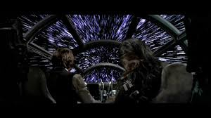
Figure 1 shows the Millennium Falcon entering Hyperspace, sourced from http://www.itsvery.net/star-wars-4.html
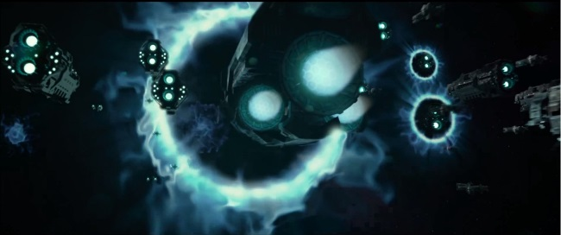
Figure 2 shows a picture of multiple HALO vessels going into Slipstream Space, sourced from http://halo.wikia.com/wiki/Slipstream_Space
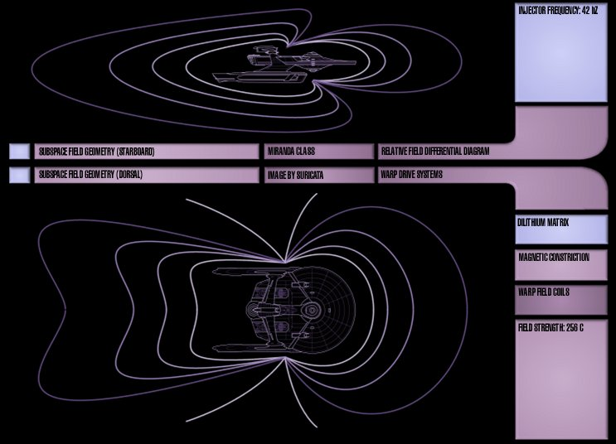
Figure 3 shows a Star Trek starship vessel inside its warp “bubble,” sourced from http://www.suricatafx.com/?p=170
Figure 4 shows a picture of OPERA experiment, sourced from http://www.sciencedaily.com/releases/2011/09/110923084425.htm

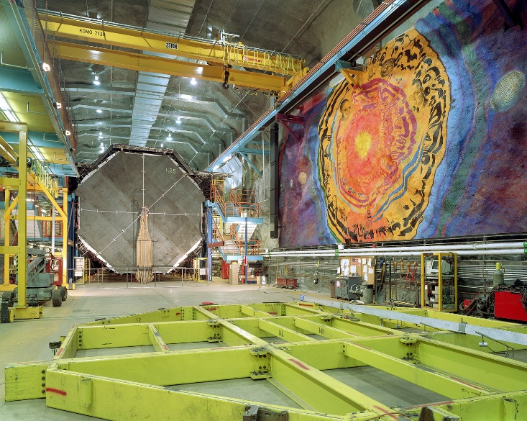
Figure 5 shows a picture of the MINOS experiment, sourced from http://www.fnal.gov/pub/today/images/images12/minos-farview-03-371.jpg

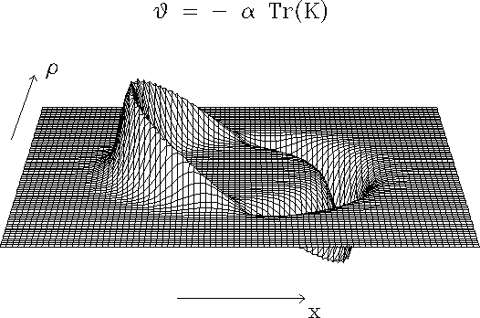
Figure 6 shows a model of the curvature of space in the region of traveling warp according to Alcubierre’s paper, sourced from http://www.npl.washington.edu/av/altvw81.html

References
Bureau International des Poids et Mesures. (1975). Resolution 2 of the 15th meeting of the CGPM. Comptes Rendus de la 15e CGPM. Bureau International des Poids et Mesures. Retrieved from Bureau International des Poids et Mesures.
Cain, F. (2009, December 30). Distance to Alpha Centauri. Retrieved from Universe Today: http://www.universetoday.com/48904/distance-to-alpha-centauri/
Halopedia. (2013, October 9). Slipspace Drive. Retrieved from Halopedia: http://www.halopedia.org/Slipspace_drive
Hesla, L. (2012, June 8). Fermilab Today. Retrieved from Fermilab Today: http://www.fnal.gov/pub/today/archive/archive_2012/today12-06-08.html
Memory Alpha. (n.d.). Warp factor. Retrieved from Memory Alpha: factor
OPERA. (2000, December). The OPERA Detector. Retrieved from OPERA: http://proj-cngs.web.cern.ch/proj-cngs/Download/CNGSDGVE/cngsdgve.pdf
OPERA Collaboration. (2011, September 22). Measurement of the neutrino velocity with the OPERA detector in the CNGS beam. Retrieved from Cornell University Library: http://arxiv.org/abs/1109.4897v1
OPERA Collaboration. (2012, December 17). Measurement of the neutrino velocity with the OPERA detector in the CNGS beam using the 2012 dedicated data. Retrieved from Cornell University Library: http://arxiv.org/abs/1212.1276
Voyager Mission Team. (2013, October 10). Voyager Mission Operations Status Report # 2013-10-04 Week Ending October 4, 2013. Retrieved from Voyager: http://voyager.jpl.nasa.gov/mission/weekly-reports/

