Eric Chang
WRIT 340
Illumin Article
Elisa Warford

Keeping Us All Unplugged – The Battery
Abstract:
When we need a portable and convenient power source, count on the battery to let your tech, tool and toys surge with electricity. Early batteries started developing in the 1800s when an Italian physicist, Alessandro Volta, discovered that certain liquids would generate an electric flow when used as a conductor. Batteries have a number of benefits, such as their high specific energy, simple charging and low maintenance. Engineers are experimenting with conductive polymers and lithium-air batteries to offer higher energy storage, higher battery life and higher charge.
Introduction:
One of the most exciting and remarkable discoveries in the last 400 years is electricity. It is a supply of electrical power and a driving force to much of our existence. But we have not fully utilized electricity till the 1800s. The earliest promotion of electricity was during the 1893 World’s Columbian Exposition when electricity powered the attractions and the newly invented light bulbs [1]. However, plugging every electrical appliance into a source such as a socket limits the mobility of the appliances as well as the users, so when we need a portable and convenient power source, count on the battery to let your tech, tool and toys surge with electricity. Batteries do not contain electricity, but rather the potential for electricity in the form of chemicals. By textbook definition: “A battery is a device that converts chemical energy to electrical energy through an oxidation and reduction reaction. [2]” Although batteries are hard to recycle and treat after use, scientists and engineers are developing new materials to replace current metal batteries to ensure the sustainability of this convenient power source.
History of the Battery:
Early 19th Century – Discovery and Invention of the Battery:
The first discovered battery is called the Parthian battery or Baghdad battery (Figure 1.) because it was found by a railway in 1936 near Baghdad, Iraq [1]. This prehistoric battery can be traced back about 2000 years. It is a clay jar which contains a metal rod circled by a copper cylinder. In order for the battery to work, the jar must be filled with an electrolyte such as lemon juice to complete the circuit, which will produce about 1.5 volts [1]. However, researchers believe that this device had other uses twenty centuries ago. [1] [2]

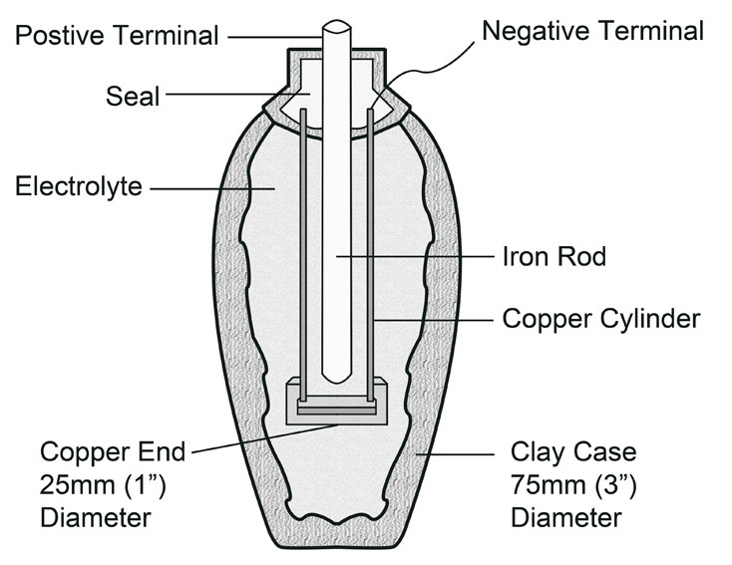
Figure 1. Parthian Battery
http://www.arrl.org/when-was-the-battery-invented
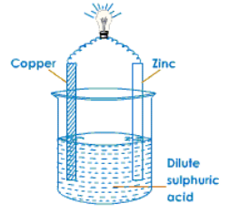
Early batteries started developing in the 1800s when an Italian physicist, Alessandro Volta, discovered that certain liquids would generate an electric flow when used as a conductor (electrolyte). This is commonly known as the battery, or scientifically speaking, a voltaic cell, as shown in Figure 2. Furthermore, Volta stacked the cells on top of each other with an electrolyte separating each component to increase the voltage of the electrical system, called the Voltaic pile [1] [2].

Figure 2. Simple Voltaic Cell
http://www.meritnation.com/ask-answer/question/how-does-a-simple-voltaic-cell-works/chemistry/511489
Late 19th Century – Mass Production of Cylindrical Batteries and Invention of Rechargeable Batteries
After mastering the concept of voltaic cells, many scientists started experimenting with high citrus content fruit such as lemons to create a simple household cell; the lemon in this case would be the electrolyte. But if you are looking for a power source that is a little less sour, you can always opt for the smaller, uniformly sized, more durable varieties made by battery manufacturers. Energizer, one of the industry’s leaders, is a direct descendent of the first cylindrical shaped battery called “The Columbia” [3]. The Columbia was introduced in 1896 by the National Carbon Company [3].
Up until this time, all the batteries produced in the world were primary batteries, meaning that they wore out with time and could not be recharged; scientists and engineers tried ways to increase the efficiency of the batteries, but it was still impossible to re-charge the same battery. However in 1859, the French physicist Gaston Planté invented the first rechargeable battery based on lead acid [3] [4].
20th Century – Improvements of Battery life and First Alkaline Batteries
While the cylindrical batteries are in production, in 1900, Waldmar Jungner from Sweden improved the idea of rechargeable (secondary) batteries by using different metals as electrodes and invented the nickel-cadmium battery, also known as NiCd, which used nickel for the cathode and cadmium for the anode [2] [4].
NiCd batteries were on the market for many years, serving as the leading battery for portable electronics. However, during the 1990s, there were concerns about the sustainability of nickel-cadmium batteries because it was hard to recycle and treat once used and it polluted the environment; therefore, the government took action and banned NiCd, while directing the manufacturers and the consumers to focus on nickel-metal-hydride (NiMH) batteries [1]. NiMH has similar ingredients to that of NiCd but created less pollution and led the engineers to discover the lithium ion (Li-ion) batteries later on.
Since the inclusion of nickel in batteries created many problems, most research activities today focus on systems that include the lithium element. Proposed in the 1970s, Li-ion batteries power most of our portable electronics such as cell phones, cameras and laptops. Li-ion is also used on a larger scale from electric vehicles to Mars rovers [1] [4] [5].
At the same time, NiCd and NiMH were not forgotten. Engineers modified the chemistry of the NiCd and NiMH batteries by changing the metal to zinc instead of nickel. This is commonly known as alkaline batteries that consumers use nowadays as a primary battery.
The Science:
From the Parthian battery to the Li-ion battery, they all follow the same concept to produce electric energy. There are two electrodes, each made with a different metal. The positively charged electrode is called the cathode and the negatively charged electrode is called the anode. A liquid paste or gel electrolyte must contain either an acid or an alkaline that is caustic enough to cause a chemical reaction in the metals; this reaction creates an exchange in electrons between the two electrodes [2].
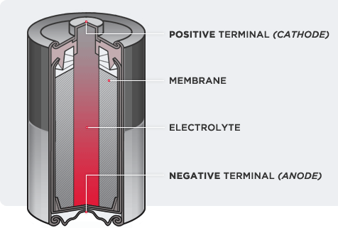
In cylindrical alkaline batteries, the electricity will only begin to flow when one or more of the cylindrical batteries is placed in a device, like a flashlight, and the circuit is closed by turning it on. The anode that is in the middle of the cylindrical batteries is oxidized, causing a release of electrons. Then, the electrons are attracted to the cathode that is undergoing a reduction reaction. As the electrons travel through the circuit, they provide electricity to power the device. The battery is considered empty or dead when the chemical reactants within the cell run out and therefore the oxidation and reduction comes to a halt. The reason why batteries are made in a cylindrical shape is due to the strength and durability of the container, the cylinder allows even distribution of internal pressure which allows for a more effective sealing (Figure 3) [3] [5].

Figure 3. Inside of a Cylindrical Cell
http://www.poweringnow.com/technology/how-it-works
Similarly, in the Li-ion battery (Figure 4), the electrical current produced by the cell is due to layered conductive surfaces made from metals such as aluminum. The cathode is made of a very pure lithium metal oxide; in order to increase performance and battery life, the chemical composition must be uniform. The anode is made of graphite, a form of carbon [4]. Similar to all batteries, the Li-ion battery contains the electrolyte so that the lithium ions and the battery’s charge can flow freely. “This electrolyte must be extremely pure and as free of water as possible to ensure efficient charge and discharging [4]”. However, unlike the cylindrical batteries which position the electrode on the ends of the body, the Li-ion has a risk of short circuiting because the anode and the cathode are very close to each other, therefore a layer called the separator is placed between the two electrodes. To the tiny lithium ions the separator is actually permeable; this property is known as microporosity [6]. When the battery is charging, the anode (graphite) stores the positively charged lithium ions. When the battery discharges the ions move from the anode back to the cathode (lithium oxide). After continuously charging and discharging, the process forms deposits inside the electrolyte that interfere and eventually stop ion transport, the increased resistance reduces the cell’s ability to produce electricity. Therefore it is better to let your electronic device run down rather than constantly keeping your device plugged in and fully charged. The number of charging cycles depends on the appliance, but on average can last from 2 to 3 years. Typical Li-ion batteries are thin and rectangular-shaped in order to fit into daily battery powered devices such as laptops and cell-phones, which are rectangular as well. [1] [6]
Insert picture of Li-ion battery cut in half showing each important component. (Figure 4.)
The reason why some batteries have different properties than others is based on the difference in material used for the anode, the cathode and the electrolyte.
Problems with Batteries:
Batteries have a number of benefits, such as their high specific energy, simple charging and low maintenance. But no matter the type of battery or its quality, eventually they all run out of charge. Every year billions of batteries are used up by consumers and it leaves us with a problem of how to deal with dead batteries. There is a way of burying dead batteries in the landfills like regular non-degradable materials; however the batteries will not rest in peace. The state and local governments manage battery recycling programs but sources say that only 2% of all used batteries are recycled [4]. Most of the batteries are made from heavy metals such as nickel, cadmium and lead which are considered an environment and health hazard. The batteries that are decaying over time can release toxins into the air and soil which can eventually destroy the area. Furthermore, as technology developed, the electrical appliances have evolved to a certain stage that requires huge amounts of electrical power; however batteries are having a hard time catching up. Take an electrical powered sports car, for example: it may have stunning top speeds of 160 miles per hour and accelerate from 0 to 60 mph in 3.6 seconds, but the battery within the vehicle contains almost 7000 lithium ion cells, costs over $90,000 and takes more than 4 hours for a full charge [4]. As you can see, the battery technology available is not good enough for modern electrical appliances and machines; thus scientists and engineers continue to look for alternative materials to increase battery lifespan and decrease cost.
The Future of Batteries:
The Lithium Air Battery
Started as a project in 2009, the lithium-air battery is developing rapidly. With our advances in technology including graphene, carbon nanotubes and fancy membranes, the lithium-air battery is light-weight and packs a higher energy density than normal lithium ion batteries. In the battery, carbon is the positive electrode and lithium is the negative electrode; oxygen reacts with lithium to create lithium peroxide during the discharge [5]. When the battery re-charges, the chemical process is reversed and oxygen is released. This battery is considered as the “air breathing battery” because during discharge and recharge the battery only uses oxygen, which is abundant in air; therefore the battery can be much lighter than regular self-contained lithium-ion batteries or alkaline batteries. Furthermore, the battery electrodes use carbon as electrodes, which are lighter than original batteries that use metal oxides. [4] [6]
Not only does lithium-air produce a lighter battery, engineers speculate that using lithium-air can provide five to ten times the storage ability than traditional Li-ion batteries, along with a lower charging rate; this means an electric car can drive 1000 miles instead of 200 miles with one charge. This is due to the high energy density produced by the lithium-air batteries, four times to be precise. Even though the lithium-air battery technology still has safety issues outside controlled laboratory areas, it has the potential to outperform most of the existing battery technology and be a solution in the near future. [1] [6]

Conducting Polymers
Storing electricity in plastic is a new process that includes many advantages over metallic materials. Plastic batteries offer higher energy storage, higher battery life and higher charge than other metal based batteries. Companies are creating many competitive designs such as flat shaped batteries that can be bent to a certain extent, just like cardboard. The discovery of plastic batteries started in the 1970s when a Japanese student worked with polyacetylene and added too much catalyst; the student later realized a thin film wrapped around his test-tube that looked like aluminum foil [7]. Polyacetylene is a substance that looks like a metal but is in fact a plastic with metallic properties, one of which is high electrical conductivity[1] [7]. The reason why metals conduct electricity is due to free electrons within the metallic bonds, but polyacetylene conducts electricity due to the impurities in the catalyst which chemically dope the material to produce an excess of electrons. [7]
Chemically, plastic batteries differ from metal-based batteries. In conventional batteries, metal ions flow back and forth from the cathode to the anode in a reversible chemical reaction; however in conducting plastic batteries, “only the stored ions of the solution move and the electrodes are not consumed and reconstituted.” as explained by chemist Alan McDiarmid [7]. Since plastic batteries are not limited by the number of times the “the plates are reconstituted” [7], they have a longer lifetime and lesser re-charge time than that of conventional batteries.
Even though polyacetylene seems promising, it is not the most sensible material for batteries because it is chemically unstable in air and degrades quickly; therefore engineers replaced polyacetylene with another conducting polymer called polyaniline, which was cheaper, stronger and stable in both air and water [5] [7]. With advances in plastic batteries, there are increasingly important applications of this new technology from electric cars to most portable electronics. [1] [7]
Conclusion:
Battery technology has been around for some time; it is ubiquitous in all portable electric devices. But when it comes to recycling batteries, the methods are questionable; it is important to find sustainable battery solutions. Recent projects and implementations show promising results in increasing the lifetime and efficiency of batteries, but the research is still at its infancy. One thing is for sure though, engineers who research and test batteries are working hard to protect the environment and keep us all unplugged.

Citations:
[1] I.Buchmann. (2003). Battery University [Online]. Available: http://batteryuniversity.com/learn/article/when_was_the_battery_invented
[2] D. Johnson. (2013, May 14). A Nanoscale Peek at Lithium-air Batteries Promises Better Electric Vehicles [Online]. Available: http://spectrum.ieee.org/nanoclast/green-tech/advanced-cars/nanoscale-peak-at-lithiumair-batteries-promise-better-electric-vehicles
[3] Energizer. Battery Types, Energizer Co., [Online].
[4] D. Chandler. (2013, May 13). Research update: Team observes real-time charging of a lithium-air battery [Online]. Available: http://web.mit.edu/newsoffice/2013/real-time-charging-of-lithium-air-battery-0513.html
[5] T. Norh, Li4Ti5O12 as an anode material for Li ion batteries in situ XRD and XPS studies, M.S. thesis, Dept. Chemistry., Uppsala Universitet., Uppsala, Sweden, 2013.
[6]Discovery. Supercharged! Battery Power for the Future, Discovery News, [Online].
[7] A.McDiarmid. (2012, July 11). Conductive Polymers and Plastic Batteries [Online]. Available: http://www.osti.gov/accomplishments/macdiarmid.html

