Jake Rudolph
jrudolph@usc.edu

The Physics of a Water Polo Skip Shot

In order to become a successful water polo player, one must understand and perfect the different techniques used in the game. A player must have a strong eggbeater kick in order to raise his body out of the water. This will reduce the drag on his body, thus allowing him to use proper shooting techniques. With this proper shooting technique, a player can then throw the ball at a maximum speed. Once the player’s maximum speed eclipses 27 miles per hour, he can learn a necessary skill in the sport, a skip shot. A skip shot is important because of its unpredictability. It is much easier to score on a goalie if he cannot accurately predict where the ball will go. This use of deception is necessary in the sport because goalies are also very skilled and can expect where any normal shot will be in order to make the save. A skip shot will provide any player with an increased chance of scoring a goal.

I am a graduating senior pursuing a Bachelor’s Degree in Civil Engineering Building Science, and am also pursuing my Master’s Degree in Structural Engineering through the Viterbi Progressive Degree Program. I have played water polo for 11 years through Age Group, High School, and Collegiate Club programs.
Introduction

Water polo is a sport that has been growing throughout Southern California for several years and has become very popular in high schools throughout the area. Most Southern California high schools have water polo teams. The number of divisions in the CIF-Southern Section, the governing body of Southern California High School Sports, demonstrates this. There are seven different divisions based on skills of teams for men’s water polo [1].
Water polo’s popularity comes from it being a highly competitive and challenging sport. It has been called one of the toughest sports for fitness level [2]. The sport requires one to be both physically strong enough to wrestle for position with the opposing player, and agile enough to stay above water and swim. It is a sport that has aspects similar to other popular sports, such as passing skills similar to basketball, the physical contact of both wrestling and hockey, and the ability to throw a ball like in baseball. All of this goes on while the players tread water using an eggbeater kick [2]. This combination creates a highly skilled and physical game, which requires great endurance from all players.

Significance of a Skip Shot
The art of shooting is important in the sport. A shot can be broken down into two parts; what goes on above and below water. A player must practice his shot consistently in order to add speed and accuracy to it. Although having proper shooting motion can create a strong and accurate shot, in the upper levels of the sport, goalkeepers are quick enough to be able to make a save even when a player shoots to the corner. The goalies ability to make a save on most shots creates the key to scoring a goal being the deception of the goalie. The best tool to do this is through a skip shot [3]. This is a type of shot where the player throws the ball at a high enough speed so that the ball skips off of the water. The significance of this shot is the unpredictability of it. If the ball is going to skip, then the goalie cannot perfectly predict where the ball will end up, and if properly executed will have little to no time to react to the skip (Fig. 1)[3]. In my 8 years of experience as a goalie, I still cannot predict where a skip shot will go. This is because the ball could do anything from sliding across the water to skipping up into a top corner. The only thing I can do is make a guess as to where I think the ball will be and make an attempt to react after the skip. Most of the time, I will only make the save if I have guessed correctly. The unpredictability of a skip shot makes it one of the best and most important skills to perfect in the sport.
Figure 1: Skip shot scoring on a goalie. Source: http://www.vcstar.com/photos/2009/oct/07/76915/
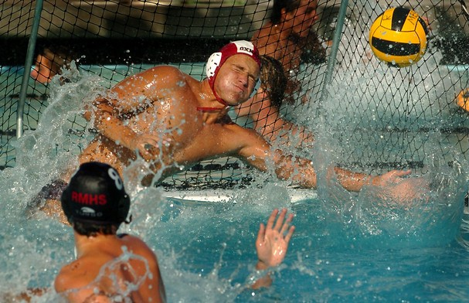
The necessary tools in order to execute a correct skip shot are having a strong eggbeater kick below the water and the proper shooting mechanics above water in order to throw the water polo ball at the necessary speed. In addition to this the player must be able to place the ball at the correct location in order to not allow the goalie to react [3].

The Eggbeater Kick
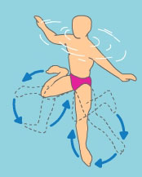
The eggbeater kick is essential to water polo. Players will use this kick to stay afloat, push players, and raise their bodies out of the water in order to take shots and make passes. On land, in order to push the body away from the ground, one must apply a force greater than his body weight. In the water, a person does not have to support the entirety of his weight in order to stay afloat due to Archimedes’ principle [4]. This states that when a body is immersed in water it will experience an upward thrust equal to the weight of the fluid displaced. This theory is based upon a difference in densities [5]. If two liquids, with different densities, are placed in a cylinder, the fluid with a lower density will rise to the top, while the fluid with a higher density will sink to the bottom. The density of a human is about 95% the density of water, so the volume of water being replaced is slightly heavier than the person who is now occupying this space [5]. This will reduce the gravitational force on the player significantly, leaving the player only needing to support a small percentage of his actual weight with the eggbeater kick [4].
Figure 2: Eggbeater kicking motion. Source: http://blog.poolcenter.com/article.aspx?articleid=6222

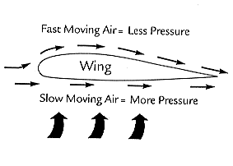
An eggbeater kick is correctly executed when the player is squatting in the water so he is in nearly the same position as he would be if he were sitting in a chair. The only difference is his legs should be spread as wide as possible in the water. The player then will rotate each leg from the knee downward in a circular motion, with the right leg moving counter-clockwise and the left leg moving clockwise (Fig. 2)[4]. This will create a hydrodynamic lift force to complement the buoyant forces and raise the player out of the water. The lift force comes from the Bernoulli principle, which states that an increase in the velocity of the fluid will create a decrease in the pressure [6]. The foot is shaped very similar to a wing on an airplane, which is ideal for lift (Fig. 3). The water moving on the top of the foot will be moving at a faster speed than underneath the foot, like air on an airplanes wing. This will create a higher-pressure gradient below the foot than above, thus producing a lift force propelling the foot and in turn the person out of the water [4]. The player can apply forces to complement his eggbeater kick by sculling his hand. Sculling is moving the hand back and forth quickly. This creates hydrodynamic lift, which will help the player elevate higher out of the water and balance him by applying a force at a new point [4].
Figure 3: Airplane Gradient. Source: http://quest.nasa.gov/aero/teachers/foa.html
Once a player has mastered the art of the eggbeater kick, he has acquired the necessary tools underneath the water for a proper shot.

Proper Shot Mechanics
Proper shot mechanics are very similar to a baseball throw, except in baseball one must have a set base. In water polo, the player must be treading water with the eggbeater kick as stated above. The shooting motion includes bringing the ball behind his head, then using both the rotation of his body and shoulder to provide enough force to throw the water polo ball [7]. The key to a good water polo shot is the elevation of the player out of the water. If a player is higher out of the water, then less of the body is resisted by the drag forces of water. Forces from the water can significantly slow down the throwing motion of the arm and the rotation of the body. The best way to avoid this drag force is to use the eggbeater kick to elevate anywhere from chest to waist height out of the water (Fig. 4)[7].
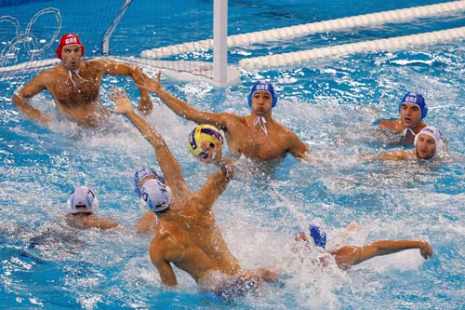
Once the throwing shoulder is out of the water then the resistance to motion will be significantly reduced because air provides less resistance to motion than water [7]. In addition, if the player is able to rise up to his waist, there will be no resistance from the water on the rotation of their upper body and shoulder resulting in a peak throwing force being applied.
Figure 4: Player elevating out of the water to reduce drag on shot. Source: http://4.bp.blogspot.com/_NwzVBnqtlj0/TIliDfvTcnI/AAAAAAAAAAM/cXz8WfNiv74/s1600-R/Img214575159.jpg

Science of a Skip Shot
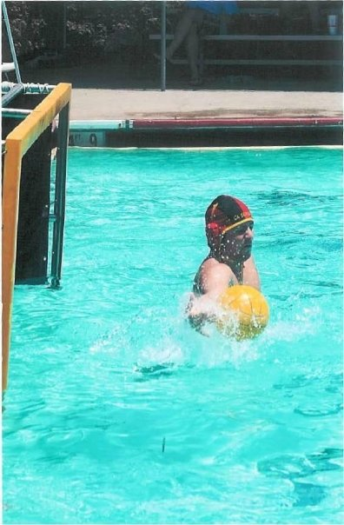
Throwing the water polo ball at the maximum speed for that player is necessary to successfully complete a skip shot. The theory behind skipping a water polo ball is similar to how one is to skip a rock. This uses the theory of conservation of momentum. When a rock or, in the case of water polo, a water polo ball is thrown at the water, the ball enters the water and will push the water downwards. This will cause the ball to in turn be forced upwards [8]. The ball must be thrown at least 27 miles per hour to provide a strong enough downward force in order to skip back up and not stick to the water. Generally, a junior male in high school can throw a ball at 36 miles per hour, while the average female junior in high school can throw a ball between 27-30 miles per hour [3].
Figure 5: Ball being skipped too close to a goalie. Source: http://sphotos-a.xx.fbcdn.net/hphotos-ash4/348_33489321047_188_n.jpg
Once this speed has been attained, then the next step to a successful skip shot is the skip spot. The ball should hit the water between 3 and 1.5 meters away from the goal. If the ball hits the water farther away than 3 meters, then the ball has a strong possibility of skipping over the goal or providing the goalie with enough time to react and block the shot [3]. If the ball is skipped within 1.5 meters of the goal, then ball will be too close to the goalie and he can stop the ball before the skip (Fig. 5). This distance between 3 and 1.5 meters does not give the goalie enough time to react to the shot and maintains the unpredictability of the shot.

Conclusion
The different aspects of the shooting motion are necessary to understand in order to successfully attempt a water polo skip shot. A player must have a strong eggbeater kick to propel him out of the water. This will lower the resistance on throwing motion caused by drag forces. Once the proper throwing motion is achieved, a player has the tools to attempt a successful skip shot. From my own personal experience as a goalie, many goals have been scored because I could not successfully predict where the ball would go due to the unpredictability of this shot. Therefore, a skip shot is a highly successful and necessary tool to acquire for any person playing water polo.

References
[1] K. Palle, “CIF-Southern Section 2012-13 Boys’ Water Polo Season,” CIF, CA, August 2012.
[2] P. Snyder, “History and Tradition,” in Water Polo for Players and Teachers of Aquatics. Los Angeles, CA: LA Olympic Foundation, 2008, pp. 7-8.
[3] J. Solum. (2008, April 1). The Skip Shot: Part 1 [Online]. Available: http://www.waterpoloplanet.com/HTML_Jim_pages/js02_shot_doctor_jim.html
[4] M. Alexander and C. Taylor, “The Technique of the Eggbeater Kick” Univ. of Mantioba Sports Biomech. Lab, Winnipeg, MB, CAN.
[5] B. Gray. (2009, November). Buoyancy [Online]. Available: http://www.barrygray.pwp.blueyonder.co.uk/Tutoring/Float.html
[6] Merriam-Webster. Bernoulli’s Principle [Online]. Available: http://www.merriam-webster.com/dictionary/bernoulli's%20principle
[7] M. Alexander et al., “Water Polo: A Biomechanical Analysis of the Shot,” Univ. of Mantioba Sports Biomech. Lab, Winnipeg, MB, CAN, 2010.
[8] L. Bocquet. (2006, February). The Mystery of the Skipping Stone (The Physics of Rock Skipping) [Online]. Available: http://209.157.64.201/focus/f-news/1587417/posts
[9] I. Wolfson. (2012, March 3). Physics of Water Polo [Online]. Available: http://beastraban.blogspot.com/2012/03/physics-of-water-polo.html

