The Under Engineering of Amateur Baseball Bats

Sean Cooney

Writing 340

Professor Townsend

7 May 2013

Abstract
In the late 1960’s amateur baseball players began using aluminum bats instead of the traditional wooden bats. These new aluminum bats could be swung faster, and coupled with their thin barrel wall design, the bats were able to hit baseballs at dangerous velocities back towards vulnerable pitchers. After dozens of catastrophic pitcher injuries, in 2011 the NCAA and high school baseball mandated that bats meet the Bat Ball Coefficient of Restitution Ratio (BBCOR) standard in order to reduce these dangerous batted ball velocities. Today, amateur baseball players use composite material bats, and engineers manipulate the fiber orientations in these bats to reduce their trampoline effect, and shrink their sweet spot size. These “under engineered” composite bats that meet the BBCOR limit of 0.5 have shown the same performance characteristics of the wooden bats used before the metal bat revolution, making the game of baseball safer for today’s amateur players.
Baseball players strive to graduate from the “ping” of the barrel to the “crack” of the bat. They yearn to leave behind rolls of rubber grip tape for the natural stickiness of pine tar. A player has reached the pinnacle of baseball competition when he stops using a metal bat in favor of one made of wood. This is because unlike most professional sports, the offensive equipment for amateur baseball players is much different than that of professionals. Professional baseball players use wooden bats, while amateur baseball players use composite material bats. Amateur players are generally weaker and less skilled than professional players, so they use bats that are engineered to enhance their hitting performance, allowing amateur baseball games to be played at the same production pace and level as professional games. This article will explore the development of these amateur bats, their performance “under engineering,” and their effect on the landscape of amateur baseball.
Amateur Baseball Bat Development
Invention of aluminum bats and their implementation
Since the invention of the game in the early 1800’s, both amateur and professional baseball players had used wooden bats. However, wooden bats broke often, and they were expensive to continuously replace. Amateur baseball players sought the same function of a wooden bat, but with a longer lasting material. Aluminum alloy use in American industry exploded after World War II due to its lighter weight and steel-like toughness. Baseball was not immune to this technological boom, and bat manufacturers began experimenting with aluminum alloy bats in the late 1960’s. Shaping procedures previously developed in the automotive and aerospace industries allowed these companies to rapidly produce aluminum bats and alleviate the financial hardships caused by their constantly breaking wooden counterparts [1].
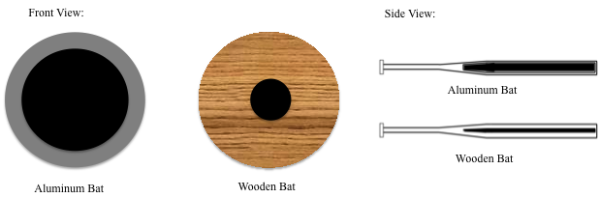
Along with decreasing the cost of playing baseball, amateur players wanted a bat that would improve their performance. Amateur players had become frustrated with the gap between their performance, and that of the professionals they aspired to be. With the introduction of the aluminum bat, amateurs were able to hit the ball with the same frequency and power as professionals using wood bats. Contrary to wooden bats, aluminum bats were designed with thin barrel walls. A comparison of a metal bat cross section to a wooden bat cross section can be seen in figure 1. Although they were the same overall bat weight, this design made aluminum bat barrels lighter than wooden barrels, allowing players to swing the bat faster [7]. This, combined with the thin barrel walls, allowed for the most possible energy to be transferred to the ball from the bat upon contact [2].
Figure 1: Comparison of aluminum bat and wooden bat cross-sections. Notice how the aluminum bat has much thinner walls than a wooden bat
These new bats were extremely popular, and by 1974, high school baseball and the college athletic association, NCAA, had approved aluminum bats for in game competition [1]. During the first four years of the aluminum bat era in the NCAA, the mean batting average increased 14 points and there were .16 more home runs hit per game, demonstrating the instant improvement of amateur baseball player performance [8]. By 1977, aluminum bats were hitting baseballs nearly 4 MPH faster than wooden bats [4]. While that might not seem like a large difference, a baseball hit 101.5 MPH has been shown to travel 13 feet farther than a ball hit 98.6 MPH. These 13 feet could be difference between a fly out and a homerun [16]. However, as aluminum bat technology improved even more, the aluminum bats began to hit baseballs at dangerous speeds with catastrophic results.
Player injuries and subsequent reform of amateur baseball bat design standards
The rise of the aluminum bat also resulted in more pitcher injuries and deaths. By the late 1990’s, aluminum bats were reportedly hitting baseballs at over 120 MPH [14]. At 120 MPH, a baseball takes less time to travel from home plate to the pitcher’s mound than the human eye takes to blink. As a result, many pitchers couldn’t react in time, and were severely injured or even killed by “comebackers,” in which a ball was hit directly back at them. Between 1983 and 2009 there were 52 “catastrophic” injuries in baseball, with catastrophic meaning a fatality or permanent disability [12]. Not all of these injuries were as a result of comebackers, but given the lack of other contact between opposing baseball players, players are most likely to be seriously injured by these fast moving baseballs. In one comebacker injury example, a twelve-year-old pitcher in New Jersey suffered extensive brain damage when a line drive off an aluminum bat hit him in the head. A negligence lawsuit was filed against Little League Baseball and the bat’s manufacturer, and the boy’s family was awarded $14.5 million, demonstrating not only the physical, but also the monetary damage caused by the dangerous aluminum bats [5].
Recognizing the dangerousness of aluminum bats, both high school baseball and the NCAA began to phase them out in favor of composite material bats more closely related in performance to that of wood. By 2011, high school baseball and the NCAA required that bats be “under engineered” to meet the Bat Ball Coefficient of Restitution Ratio (BBCOR). The BBCOR quantifies the small amount of energy lost in the collision of a bat and baseball, and approved bats have a BBCOR less than .5 [3]. With this new design standard, amateur baseball organizations hoped to reduce the speed at which baseballs were hit, thus giving pitchers a better to chance to react and protect themselves from injury.
The Under Engineering of Today’s Amateur Baseball Bats
Design aspects that affect BBCOR – Trampoline Effect and Sweet Spot
The main design factor that affects a bat’s BBCOR number is the magnitude of the “trampoline effect” that the bat produces when hitting a baseball. The trampoline effect is a phenomenon only present in aluminum or composite material bats, where the bat barrel will compress when contact is made with the ball, due to the reduced thickness of the material in the bat’s walls. With wooden bats, the wood is too thick in the walls to allow compression. Because aluminum and composite bat barrels compress, they act like a spring when the ball makes contact, resulting in an elastic collision in which nearly 100% of the energy imparted on the ball by the pitcher is returned to propel it back towards the mound [2]. The near 100% energy return by aluminum bats resulted in the dangerous ball velocities and subsequent injuries described in the previous section. Bat manufacturers can limit the degree of which the bat produces this trampoline effect by reducing the size of the bat’s “sweet spot” to lessen the chance of the bat being used at its maximum performance level.
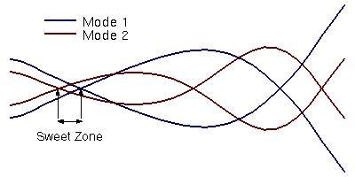
A bat’s “sweet spot” is the point on the barrel at which the trampoline effect is at its maximum, and thus an important factor in a bat meeting the BBCOR standard. Mathematically, the sweet spot is the barrel location where the bat’s relative vibration amplitude is 0, as seen in figure 2. When a bat strikes a baseball, the bat will begin to vibrate in a sinusoidal manner. These vibrations will increase in amplitude and wavelength as they move down the bat towards the user’s hands. The bats are designed to have vibration wavelength amplification such that the amplitude is 0 at two points on the barrel, usually at three inches away and six inches away from the end of the bat, as seen in figure 3 [15]. The sweet spot is located in between these two points.
Figure 2: Graphical representation of the first two vibration wave “0 amplitude” locations [15]

Figure 3: Location of the sweet spot (black box) on the barrel of a bat. The sweet spot is usually located on a barrel length interval 3” to 6” from the end of the bat
On this barrel length interval, the natural vibration of the bat will be at a minimum after making contact with the ball. The most possible energy will be imparted from the bat to the ball, instead of being wasted on vibrational energy throughout the bat. Bats with smaller sweet spot sizes reduce the chance of the bat being used to its maximum potential, as batters will have a smaller window to make contact with the baseball at the sweet spot. With the reduction of the sweet spot size, and the subsequent reduction of the trampoline effect, BBCOR certified bats are designed to be a safer bat for amateur baseball players, while still providing a level of performance that allows for the game of baseball to be played at a normal pace, rather than the video game - like scoring seen from pre -BBCOR certified bats.
How engineers can manipulate the Trampoline Effect and Sweet Spot
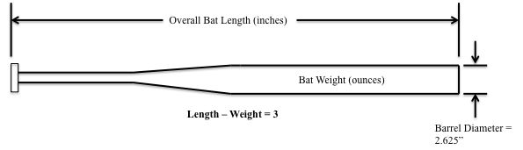
Instead of being constructed solely of aluminum, high school and NCAA bats are now composite bats made up of a combination of woven glass, graphite, Kevlar and carbon fibers coated with an epoxy sealant [10]. These composite bats still offer better performance than wooden bats, but can be more easily “under engineered” to meet the BBCOR standard than the bats made purely from aluminum. For all high school and NCAA bats, the difference between overall bat length in inches and overall bat weight in ounces must be 3, and the barrel must not exceed 2.625 inches in diameter, as seen in figure 4 [7]. With composite bats, the fibers used to construct the bat are anisotropic, meaning they have different stiffness characteristics in different weaving orientations [6]. Thus, bat designers can adhere to the overall design requirements for barrel diameter, bat weight, and bat length, but have much more leeway than aluminum bat designers in altering the performance aspects of the bat because of the orientation, layering, and quantity options with the anisotropic fibers. This leeway is crucial in designing bats that reduce the trampoline effect and that have a reduced sweet spot size.
Figure 4: Overall length, weight, and barrel diameter specifications for approved NCAA and high school bats

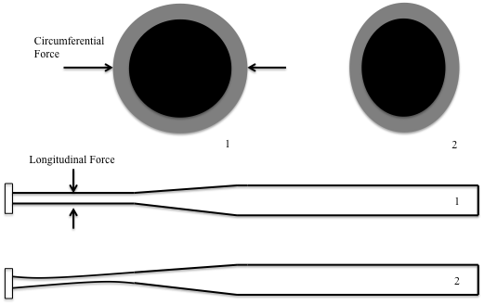
Engineers can reduce the trampoline effect of a composite bat by changing the orientation of the fibers to vary bat stiffness in the longitudinal and circumferential directions. Longitudinal stiffness is the resistance to bending at the handle, and circumferential stiffness is the resistance of the barrel walls to compress [13]. An illustration of circumferential and longitudinal forces can be seen in figure 5. To reduce the trampoline effect, engineers orientate the layers of composite fibers to increase circumferential stiffness and decrease longitudinal stiffness. Increasing circumferential stiffness decreases the compression, and subsequent spring-like decompression, of the barrel walls during contact with a baseball. Decreasing the longitudinal stiffness allows the handle of the bat to elastically bend more when the bat hits a baseball, dispersing some of the energy in the collision, rather than proving a rigid lever that imparts all of the collision energy back onto the baseball. Elastic bending is bending that does not result in permanent deformation. The orientation of the fibers in this manner takes the energy conserved with trampoline effect, and disperses it through the harmless elastic bending of the bat handle.
Figure 5: Circumferential and Longitudinal forces (1) and the resulting stresses (2). Circumferential forces compress the barrel walls while longitudinal forces cause elastic bending at the handle

The multiple composite fibers also allow engineers to shrink a bat’s sweet spot. Engineers can reduce the length of the sweet spot by layering the materials in an orientation that alters the vibrational characteristics of the bat. In order to reduce the sweet spot size, engineers add denser, more damping fiber orientations to the barrel to shorten the wavelength of the vibrations created during the collision of bat and baseball. These shorter wavelengths cause the first 0 amplitude points to occur closer together on the barrel, thus reducing the sweet spot size of the bat. These denser layers of fibers also coincide with the stiffening of the barrel walls that resist the trampoline effect, so engineers are able to reduce this and the sweet spot size through the same mechanical design feature.
How to determine a bat’s BBCOR
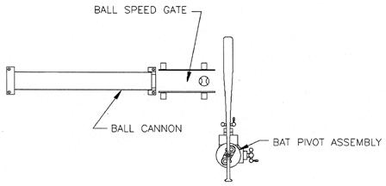
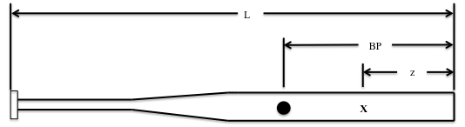
A bat’s length (L), moment of inertia (I), weight (W), and center of mass (balance point, BP) are measured. An impact location (z) is then chosen at a location on the barrel, as seen in figure 6. The mass of the baseball (m) used during testing is also measured. After the bat is anchored to prevent pivoting, the baseball is fired at the chosen impact location. The test apparatus can be seen in figure 7. By anchoring the bat, the BBCOR test removes the swing speed variable, and tests only the capability of the bat’s materials and physical design to transfer energy back to the baseball. The ball must exit the firing device traveling at least 150 MPH. The ball’s incoming velocity before it hits the bat (v_{I}), and outgoing velocity after colliding with the bat (v_{R}) are measured. Using glossary equations (1) and (2), r and e (computational constants, no mechanical relevance) are calculated. Then glossary equation (3) is computed which removes the possible contributions to the BBCOR by defects in the baseball, such as incorrect density, stitching orientation, or manufacturing error. The BBCOR is then calculated using glossary equation (4). In order to meet NCAA standards, a bat must have a BBCOR less than 0.5 [3].
Figure 7: BBCOR test apparatus [3]

Figure 6: BBCOR bat parameter test locations

The Effect of BBCOR Bats on Amateur Baseball
After the implementation of BBCOR bats in 2011, both user opinions and raw statistics have demonstrated its far-reaching effects on amateur baseball in terms of performance and player safety. Immediately after its implementation, NCAA players and coaches noticed a difference with the BBCOR bats from the pre-BBCOR bats they had used before. James Madison University shortstop David Herbek was quoted in 2011 as saying, “[The bats] are definitely different than the old ones. I feel like the sweet spot might be a little smaller. If you don’t hit one exactly on the sweet spot you notice a bigger difference to how far it will go” [9]. Washing University in St. Louis baseball coach Steve Duncan describes the effect of BBCOR certification in 2011, saying, “The BBCOR bats diminish offense. If statistics are a guide, they effectively take the offensive side of the game back to the 1970s. We’re seeing nearly the same statistics as in 1973, the last year that wood bats were used in the NCAA” [11].
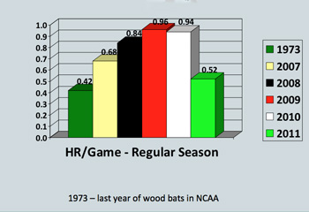
The statistics Steve is referring to include scoring average, home runs per game, and pace of play. The dramatic decrease in home runs per game since the NCAA baseball implemented BBCOR bats can be seen in figure 8. Average game pace, the barometer of overall offensive performance in a baseball game, decreased from 3:07 in 2010, to 2:47 in 2011, an 11% decrease [11]. This decrease in average game pace comes from a decrease of offensive production from batters, itself resulting from a decrease in the performance of their bats. In this way, the NCAA has achieved the player safety improvement it had hoped for with the BBCOR implementation. Fewer balls are being put in play, and subsequently, defensive players are at less of a risk of encountering a play on the ball. The game is quicker, so the defensive players are on the field for a shorter amount of time, again lessening their chance of encountering a collision with a baseball. The safety of amateur baseball players has been theoretically improved by the BBCOR bat certification and baseball players will enjoy the benefits of playing on a safer field. However, batters will have to work harder on technique and become more offensively skilled overall in order to overcome the purposeful inefficiencies of the under engineered amateur baseball bat.
Figure 8: Rapid decrease in HR/Game as a result of BBCOR bat use in the NCAA [11]

Suggested Links
University of Illinois - The Physics of Baseball
Finding the Sweet Spot on a Baseball Bat
"Over Engineering" of a Composite Baseball Bat
Engineering Our Favorite Pastime
The Design Process of Bat Technology
Author Biography
Sean Cooney
scooney@usc.edu
315-283-2379
Sean Cooney is a junior mechanical engineering student at the University of Southern California. He enjoys not only watching and playing sports, but also learning about the complex mechanical design considerations that go into today’s sports equipment.
Glossary

$r=m\left[\frac{1}{W}+\frac{{\left(L-BP-z\right)}^{2}}{I-W{\left(BP-6\right)}^{2}}\right]$ (1)

$e=\frac{v_{R}}{v_{I}}\left(1+r\right)+r$ (2)

$C_{ball}=0.528-e$ (3)

$BBCOR=\frac{v_{R}}{v_{I}}\left(1+r\right)+r+C_{ball}$ (4)

References

[1] "Aluminum bat history," Don't Take My Bat Way Coalition , [Online]. Available: http://www.dtmba.com/history.html.
[2] "Aluminum: Technological advance or dangerous change?" Exploratorium, [Online]. Available: http://www.exploratorium.edu/baseball/tools_4.html.

[3] "Bat Ball Coefficient of Restitution," Ncaa Association Standard for Testing Baseball Bat Performance , May 2009. [Online]. Available: http://fs.ncaa.org/Docs/rules/baseball/bats/NCAA%20BBCOR%20Protocol%

[4] F.O. Bryant, "Dynamic and Performance Characteristics of Baseball Bats," Research Quarterly , (Oct. 1977). [Online]. Available: http://www.eric.ed.gov/ERICWebPortal/detail?accno=EJ172664.

[5] "Boy who suffered brain injury in baseball game will receive $14.5M," Sports Illustrated, (2012, August). [Online]. Available: http://sportsillustrated.cnn.com/more/news/20120822/little-league-baseball-lawsuit/.

[6] "Composite Structures," Non Destructive Testing Resource Center, [Online]. Available: http://www.ndt-ed.org/EducationResources/CommunityCollege/Materials/Structure/composite_class.htm.

[7] R. Cross, Physics of baseball & softball - Bat Performance,, New York: Springer, 2011, pp. 183–200.

[8] "Division I Baseball Statistics Trends (1970-2012)," Ncaa, (2012). [Online]. Available: http://fs.ncaa.org/Docs/stats/baseball_RB/reports/TrendsYBY.pdf.
[9] A. Farmnum, "Opinions mixed on BBCOR impact," Ncaa, (Feb, 2011). [Online]. Available: http://www.ncaa.com/news/baseball/2011-02-24/opinions-mixed-bbcor-impact.

[10] B. Lutz, "What are composite bats made of?" Livestrong , (Mar. 2011). [Online]. Available: http://www.livestrong.com/article/397306-what-are-composite-baseball-bats-made-of/.

[11] D. Lutz, "Less lively aluminum baseball bats change game," Washington University in St. Louis , (Feb, 2012). [Online]. Available: http://news.wustl.edu/news/Pages/23427.aspx.

[12] J.L. Oriz, "As injuries mount, debate over metal baseball bats continues," Usa Today, (Jul. 2010). [Online]. Available: http://usatoday30.usatoday.com/sports/baseball/2010-07-28-metal-bat-debate_N.htm.

[13] D.A. Russell, "Are composite bats better than aluminum bats?," Physics and Acoustics of Baseball & Softball Bats, (Mar. 2005). [Online]. Available: http://www.acs.psu.edu/drussell/bats/compalum.html.

[14] D.A. Russell, "Should metal bats be banned because they are inherently dangerous?," Physics and Acoustics of Baseball & Softball Bats, (Apr. 2008). [Online]. Available: http://www.acs.psu.edu/drussell/bats/ban-safety.html.

[15] D.A. Russell, "Vibrational Bending Modes of a Baseball Bat," Physics and Acoustics of Baseball & Softball Bats, (2003). [Online]. Available: http://www.acs.psu.edu/drussell/bats/bend-sweet.html.

[16] D.A. Russell, "Why Aluminum Bats Can Perform Better than Wood Bats," Physics and Acoustics of Baseball & Softball Bats, (Oct. 2006). [Online]. Available: http://www.acs.psu.edu/drussell/bats/alumwood.html.

Multimedia suggestion - Insert trampoline effect .gif here (http://www.idac.co.uk/images/animation/Explicit%20Dynamics%20Solutions%20-%20Simulation%20Examples%20-%20Composit%20Baseball%20Bat.gif )
Multimedia suggestion - Insert slow motion movie of a bat striking a baseball and the subsequent vibrations that propagate through the bat

