Kevin Sui
Writing 340
Illumin Paper
The Engineering Behind Longboards
Abstract
Longboards have evolved from simple wood planks and roller skates into complex devices. Innovative engineering methods are used to create the individual components of the longboard, each of which are fine-tuned to perform a specific role. A longboard consists of five main components. The deck is the wooden board that is used as a standing platform. The two trucks are turning mechanisms made of metal that pivot when the rider leans to allow the longboard to turn. Four wheels attach to the trucks and contact the ground to allow the longboard to roll. Two bearings fit inside each wheel to decrease friction between the wheel and truck, increasing roll speed and longevity. Two bushings per truck provide resistance and act as suspension to the trucks, giving different turning feel. Variety in shape, composition, and materials of these components greatly change the quality and riding characteristics of the overall longboard. Such diversity and strongly engineered foundations allowed the use of longboards to be expanded from a purely recreational activity to a professional and competitive sport.

Introduction
Imagine racing down a steep mountain road. The trees around you turn into a blur as you blaze by them at astonishing speeds of over fifty miles per hour. The wind surrounds you as you cut through the air with style and grace. From this mental picture, you are probably imagining yourself in an automobile, on a motorcycle, or even on a bicycle. But none of the above are the mode of transportation previously depicted. Instead, imagine a wooden board, with two metal axles holding four wheels each the size of your fist. This machine is called the longboard.
Recent developments in longboarding technology have made this variant of the skateboard faster, sturdier, and more popular than ever. This applies especially in the sport of downhill longboard racing, which has increased in popularity during the past several years. The escalation of downhill longboarding as a sport could not have happened without the better quality materials and newly developed technology, as well as innovative riding techniques that bend the laws of physics according to the will of the rider.

What is Longboarding?
Longboards are variants of skateboards. They are typically longer and have larger wheels, making them faster and better for transportation than skateboards. At a college campus on a typical school day, many students use longboards as a means to get to class. At a nearby beach or boardwalk, people will be seen riding longboards and enjoying the nice weather. Longboards have quickly evolved to become fast, reliable, and convenient tools for transportation. Longboarding is defined as the act of riding on a longboard, and there are many subcategories of longboarding.
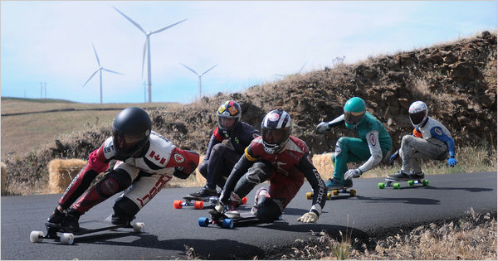
Recreationally, people ride longboards in many different styles. Some like to cruise around the beach on a nice sunny day, others like to learn tricks and do spectacular aerial flips to impress their friends, and still others love the speeds that are attainable by a board when they ride as fast as possible down a sloped hill. Competitively, longboarding has gained popularity as a global sport. In slalom longboarding, the rider weaves around a set obstacle course made of cones without hitting any obstacles in the fastest time possible. In downhill longboarding, professional longboard riders race each other in competitions, usually down a series of roads in mountains or hills, and aim to be the fastest one to reach the finish line. These riders can reach speeds of over fifty miles per hour and require great skill and technique in controlling their boards. Longboarding has been able to expand with such speed due to all the innovative technology being developed in longboarding equipment. As sophisticated as longboards are today, they originated in simple roots with primitive components. A review of longboard history shows how the longboard transformed from a garage project into the well-crafted tool it is today.
Figure 1: Downhill longboarders competing in a race
http://graphics8.nytimes.com/images/2010/07/21/sports/21longboard/21longboard-articleLarge.jpg

History
Longboards share the same origin as skateboards, both of which were created in California in the late 1950’s. [1] Longboards were created as an alternative to surfing for when the ocean conditions were unsuitable. Surfers found that the feeling riding a surfboard could be recreated on the pavement, so they began to experiment in creating a longboard. Early longboards were homemade by using plank wood and wheels from roller skates. [1] Wheels were made of clay, and as riders pushed the limits on the longboard, the wheels would not provide enough traction, making the longboard very dangerous and unpopular. Later in the 1970’s, the use of urethane in making longboard wheels revolutionized the sport, providing traction and safety that clay wheels lacked. [1] Advanced materials and better technology continued to develop over the years for the longboard, and the applications of newer equipment now allow the creation of safer and stronger longboards. Technological advancement has increased the capabilities of longboards, and the amount of innovation continues to expand in longboarding as it continues to grow in popularity. A review of the anatomy of a longboard will show how far it has transformed and how much technology is applied to its components.

Anatomy of a Longboard
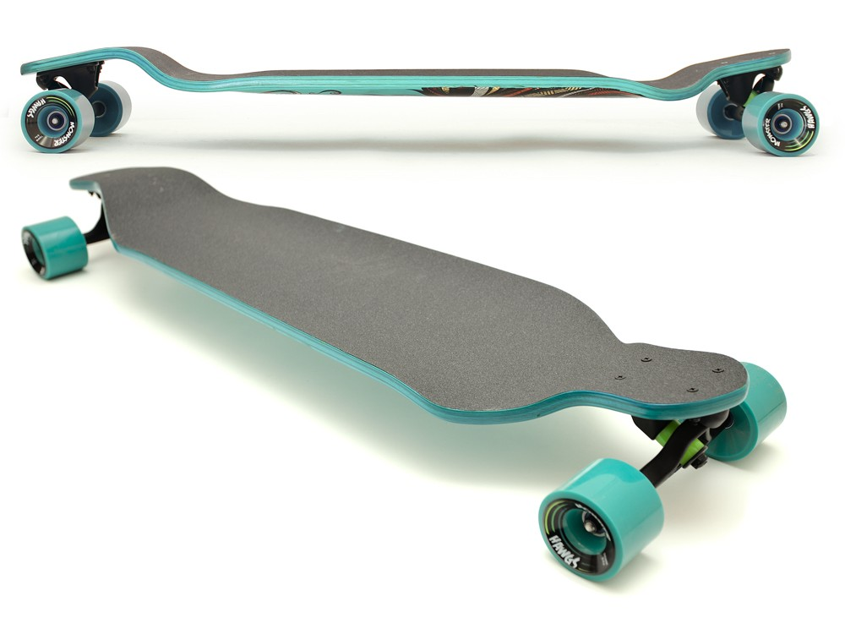
The longboard consists of many components, which work together and are interdependent to form a functioning unit. The main parts of a longboard include the deck, two trucks, four wheels, eight bearings, and four bushings. The deck has two trucks attached at opposite ends, each truck has two bushings at the center and two wheels at the ends, and each wheel has two bearings inserted into its center core. Each component is specific in how it is engineered, and large amounts of innovation have been implemented to maximize performance and reliability of the longboard.
Figure 2: Image of a complete longboard
http://www.switchbacklongboards.com/media/catalog/product/cache/1/image/9df78eab33525d08d6e5fb8d27136e95/c/h/chinook-profile-lores_1.jpg

Deck
The deck of the board is the platform on which the rider stands. It is usually made of wood and is typically between thirty-five and forty inches in length. [2] The deck of the board can be flexible for good cruising and carving characteristics or stiffer for more stability at higher speeds. Hard maple wood is a popular choice, as it is strong, dense, and shock resistant. [3] Other materials are also used, such as bamboo, fiberglass, and carbon fiber. To engineer a longboard deck, multiple plies of maple wood are glued and pressed under several tons of pressure to mold the plies into a specific shape. [4] A smaller number of plies would provide a more flexible deck, while applying more plies would create a stiffer deck.
An additional component to the deck is grip tape. Grip tape is applied to the surface of the deck and improves traction for the skater. [2] Grip tape is particularly crucial in downhill longboarding, since a great amount of grip is needed to keep the rider on top of the board. Grip tape is made using silicon carbide (SiC), which is characterized by its extreme hardness and corrosion resistance. [5] This compound is created through heating silica sand and carbon to high temperatures and then forming the mixture into bonded mass. [5] Silicon carbide is then placed onto a large strip of adhesive tape, which can be applied securely onto a longboard deck. The high surface hardness of silicon carbide makes grip tape very abrasive and wear resistant, so the grip does not wear off easily through extended use.

Trucks
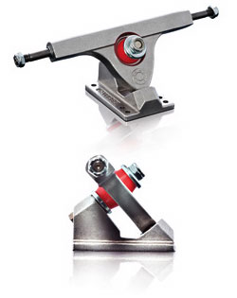
Trucks are the two metal turning components that are attached onto the deck. The angles through which the truck can pivot affects how sharply the board can turn. [2] Trucks are made of metal, the are required to be durable, since they support the entire board. There are two main types of longboard trucks: cast trucks and precision trucks. Cast trucks, as its name implies, are created through a casting process. Heated liquid metal is poured into a mold and given time to cool and solidify. The truck is then removed from the mold when it has solidified. [6] Precision trucks are created through billet manufacturing. A raw block of metal is precisely cut, and excess material is removed to form the block into the shape of the truck. This is usually a CNC, or a computer numerically controlled, process. Through billing, the resulting truck is higher in quality and durability. [6] Precision trucks are usually hundreds of dollars more expensive than cast trucks, but are stronger and more reliable. This is crucial in competitive downhill longboarding, since when physical boundaries are pushed by longboarders, cast trucks may fail from the stress. The metal could crack, the axles could bend, and the truck could even break, putting the rider at risk of injury.
Figure 3: Example of a cast truck
http://longboardskater.com/mm5/graphics/00000001/Caliber50.jpg

Wheels
Longboarding wheels are attached onto the ends of the trucks and allow the board to roll; improvements in this component has been one of the greatest advancements in allowing longboarding to grow. [2] Originally carved from wood or clay, longboard wheels are now made of polyurethane, a versatile plastic material. Polyurethane is created through chemical reactions between a polyol (a reactive type of alcohol) and a diisocyanate (a chemical compound) along with different catalysts and additives. [7] It is largely modifiable in its creation, since a wide variety of polyols and diisocyanates can be used to create polyurethane with different traits. [7] This allows longboard wheels to come in different durometers (hardness), shapes, and sizes. All of these aspects affect the wheel in how smoothly it rolls, how much shock it absorbs, and how much traction it has against the pavement.
Lower durometer wheels are softer and are able to absorb more road shock. They also compress more under the rider’s weight, increasing the amount of traction the wheel has on the pavement, though sacrificing rolling speed. Higher durometer wheels are harder, absorb less shock, have less grip, and roll faster. Low durometers wheels are commonly used for cruising or for high speeds, while high durometers wheels are popular for sliding purposes. Larger diameter wheels have a greater rolling speed at the cost of better acceleration, since more inertia is required to rotate the wheel. Smaller diameter wheels are the opposite with good acceleration, but a slower top speed. The most common wheel diameter is around 70mm.

Bearings
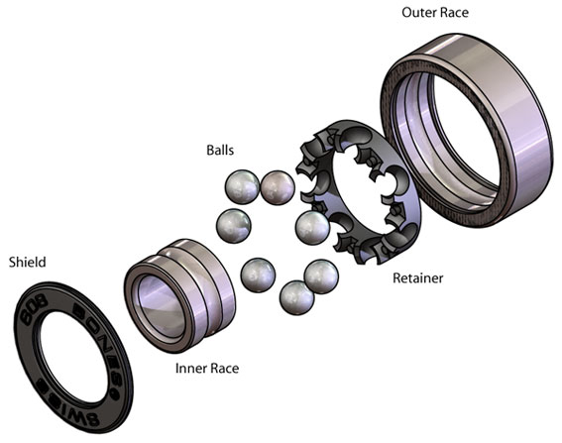
Bearings are placed inside the wheels to decrease friction, allowing the wheels to roll longer and faster. [2] Similar to other wheel bearings, longboard bearings consist of two rings with balls between them, so as the smaller ring and bigger ring rotate, friction between the two rings is greatly decreased, resulting in a smoother roll. The bearing is the component that closes the gap between the wheel and the truck. Typical longboard bearings are made of metal and have differences in smoothness and quality. Cheap bearings have more friction, which leads to increased heat energy when traveling at high speeds. This can be dangerous, as high heats can melt the wheel. Higher quality ceramic bearings have been developed, resulting in less heat waste at fast rotational speeds.
Figure 4: Anatomy of a bearing
http://blog.motionboardshop.com/wp-content/uploads/2010/08/bearing_exploded-lg.jpg

Bushings
Bushings are rubber urethane rings inserted into the trucks in order to customize turning and control in a longboard [2]; these are an often overlooked component that is crucial to the longboard. They operate under a similar concept as suspension in a car and change the way the truck turns. Softer bushings allow for more turnability, with less resistance against the truck when the rider leans. Harder bushings make the truck less turnable, but give greater rebounding force for the truck to return to center after bending for a turn. The shape of the bushing also affects the truck greatly. Cone-shaped bushings are more capable of turning, but are less stable at high speeds. Barrel-shaped bushings are the opposite with less turning capabilities, but more high-speed stability.

Conclusion
Technology is everywhere, and engineering extremely relevant in longboarding. With all of these engineering efforts, longboarding has been able to grow not only as a hobby, but also as a professional sport. As longboard and safety equipment quality increases, the experience of longboarding improves as well. Gone are the days where longboards were made of primitive wooden planks and clay wheels from roller skates. The longboard has evolved from what originated as a fun garage project to a serious instrument with precise engineering, highly durable components, and world-class quality. Thanks to engineering, longboarding can be enjoyed by all, with the benefits of less risk and injury.

References
[1] P. Foster. (2012). The History of Longboarding Skateboards [Online]. Available: http://www.livestrong.com/article/367818-history-longboarding-skateboards/
[2] C. Hill. (2012). Longboarding: A Board For All Styles [Online]. Available: http://www.thenewstribune.com/2012/06/24/2192494/a-board-for-all-styles.html
[3] American Hardwood Export Council. (2002). American Hard Maple [Online]. Available: http://www.ahec.org/hardwoods/guide/maplehard.html
[4] J. Goguen. (2012). Longboarding Parts: Anatomy of a Longboard [Online]. Available: http://www.squidoo.com/longboard-parts-anatomy-of-a-longboard
[5] AZoM.com. (2011). Silicon Carbide (Sic) – Synthesis, Properties, and Applications [Online]. Available: http://www.azom.com/article.aspx?ArticleID=5808
[6] Freshpaved Magazine. (2012). Precision Trucks [Online]. Available: http://www.freshpavedmag.com/post/16803322406/precision-trucks
[7] American Chemistry Council. (2013). How Polyurethane is Made [Online]. Available: http://polyurethane.americanchemistry.com/Introduction-to-Polyurethanes
[8] K. Chin. (2013). Loaded Advanced Freeride Gloves [Online]. Available: http://www.loadedboards.com/2013/02/loaded-advanced-freeride-gloves

