The End of the Laptop:
The Quest for the Next Version of Portable Computing

Journal Article for Illumin Magazine

Prepared by:
Danny Gil
(323)376-4395
dannygil@usc.edu
University of Southern California

Prepared on:
May 3, 2013

Prepared for:
Advanced Writing Communication for Engineers (WRIT-340)
Section 66818

Autobiography:
Danny Gil is an electrical engineering student who has had a passion for electronics for as long as he can remember. He is currently studying at University of Southern California.

Abstract - The search to buy a portable computer has become a lot more complicated over the last few years. There are laptops, notebooks, netbooks, tablets, and hybrid devices that are a combination of both a tablet and laptop. These new hybrid computers remove the restrictions that laptops and tablets have alone. They offer the ability to run full computer operating systems and programs as well as applications or “apps” that were originally designed to be used on tablets. However, designing such a device has proven to be a difficult challenge for engineers. Technical problems such as power consumption and heat generation make it hard to design and manufacture these computers. However, an even greater problem is user adaptation. Since a universal design has still not been achieved, like the laptop has with its clamshell shape, manufacturers are still experimenting with the form these devices should take. Ultimately, it is up to consumers to decide which form factor will eventually stay and become the future design for portable computers.

I. Limitations with Current Portable Computers
Tablets have become very popular because of their portability, high-resolution touch screen displays, and large variety of useful apps and games on various online application stores. However, these devices can leave the user with the desire of using a full-fledged computer while doing serious work. This is because of their limitations compared to a laptop. Yet when using a laptop we miss some of the excellent apps only available on tablets. This is where the transformation of the laptop begins. Many companies are currently selling hybrid devices that work both as a laptop and tablet. However, creating such a product gives rise to multiple problems, mainly having to do with power consumption. In addition, the device needs to be user friendly enough for people to implement into their daily lives just like the clamshell laptop has for decades. For this reason there is a large variety of configurations these hybrid devices come in. Since we still do not know what design will be the most power efficient as well as become popular with consumers, the search continues for the next portable computing device.

II. Why a Change is Needed
The idea of a portable computer is much older than most would think. In 1968 Alan Kay of Xerox designed a portable computer called the Dynabook (Figure 1). 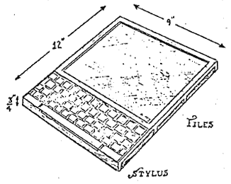
Wikimedia Commons
Figure 1: The Dynabook. This design by Alan Kay was the first concept of a portable computer.

Interestingly enough, this machine had a form that resembled a tablet more than the traditional clamshell laptop known today. Although his concept did not make it past sketches, his idea inspired others to make a similar product a reality. In 1979 William Moggridge unveiled the Grid Compass (Figure 2). 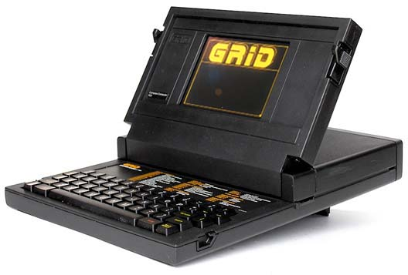
Obsolete Technology

Figure 2: The Grid Compass Computer. This was the first portable computer featuring the traditional clamshell design.

This was the first computer that had the iconic clamshell design. Until recent years, portable computers kept the same form aside from size and weight reduction. This was due to an exponential increase in hardware technology with time. It is surprising just how old this design is and how it has not changed in over three centuries. Although it is a convenient design that works well for its purpose, studies suggest that resting a laptop on the lap can lower fertility in males. This is due to the electromagnetic and heat radiation from the wireless signals emitted from the device. This is a problem that does not affect the majority of tablet users since tablets are normally held at a reasonable distance from the genital area. However, this does not seem to worry consumers since the most popular reason portable computers are being redesigned is the overwhelmingly available applications that rely on a touch screen to work property. Although a mouse can be used, it can be very cumbersome on these touch-based apps. Manufacturers like Apple have thought of implementing a touch screen into their laptops but they did not do so because user’s arms will get tired after an extended period of use. This is another factor technology companies have to take into consideration when designing their laptop/tablet hybrid devices.

III. Technical Challenges
Although hybrid computers may seem simplistic in their design, manufacturers are having a difficult time designing them. The processor (Figure 3) is one of the most important parts in a computer. 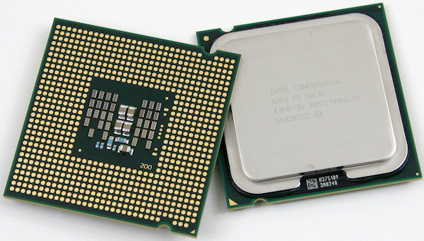
Techreport
Figure 3: This is what a typical modern processor looks like.
It is responsible for most of the calculations done on a computer. Processors today are made up of billions of transistors (Figure 4). These transistors are simply tiny switches that carry out information in binary computer language of 1s and 0s by turning on and off, respectively. 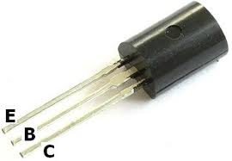
Reuk
Figure 4: This is an enlarged version of a transistor. Processor transistors are invisible to the human eye. Applying a 1, represented by a voltage, to prong B will turn on the transistor and allow current to flow from prong E to C. A 0 will stop the current flow.
Transistors work at a manufacturer specified frequency (calculations per second). For many years the frequency of the processor was synonymous with the computer’s performance. Unfortunately as the frequency increased so did heat and power consumption. Inevitably a limit was reached and processor companies had to integrate multiple processors into one in order to lower the frequency and improve performance. Despite this, different processors have to be designed for different kinds of machines according to their power constrains. Tablets have a less powerful processor because of the lack of fans that help cool it down and because of their lower battery capacity. These smaller batteries will drain quickly with a high-powered processor typically found on laptops. However, hybrid computers need that extra processing power to run full computer operating systems. Consequently, manufacturers have to find a way to integrate a faster processor into these new hybrid devices. Companies have found different ways of doing this. Microsoft’s Surface Pro includes tiny fans (Figure 5) inside the device that cool down the processor but comes at the cost of battery life. 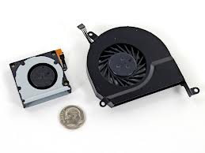
iFixit
Figure 5: Here is one of the Surface Pro’s fans (left) compared to a dime. The object on the right is the fan cover.
The Surface Pro only has four to five hours of battery life. This is low considering the industry standard is eight to ten hours. However, Lenovo found an ingenious way around this problem with the ThinkPad Helix. Instead of having fans installed inside the computer itself, they are built into the included detachable keyboard (Figure 6). 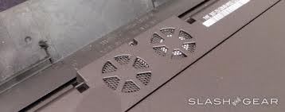
SlashGear
Figure 6: Helix Keyboard showing integrated fans.
When the Helix is detached from its keyboard the frequency at which its processor makes calculations is decreased. This lowers power consumption and generates less heat but performance is affected while using in tablet mode since lower frequency mean slower speed. Also, it is unlikely that consumers will want to keep the Helix attached to its keyboard at all times since it defeats a major purpose of being a hybrid device which is to be small and light. Although both of the above computers are very innovative, their limitations keep them from being adopted by most consumers.

IV. Noteworthy Designs
There have been many implementations of this new hybrid product. They all have had touch screens, full Windows 8, and have been relatively light and portable. The one most currently talked about is the Microsoft Surface Pro (Figure 7). 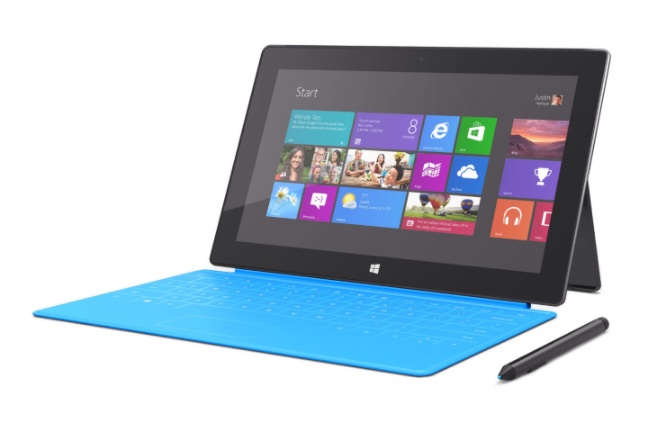
Technologizer
Figure 7: The Surface Pro with touch sensitive keyboard attached. The keyboard can either be detached or folded behind the device to give the Surface Pro more of a tablet feel.
The device itself looks much like a tablet since it does not have a build in keyboard. However, there are two keyboards that double as covers specifically made for the Surface Pro that attach magnetically to the machine. One has a more traditional keyboard feel since the keys travel down as they are pressed while the other does not. This traditional keyboard is only slightly thicker than the touch sensitive version (Figure 7) which is as thick as a piece of cardboard. This together with its integrated kickstand instantly converts the device from its initial tablet form to a laptop form. If the user wishes to use the computer again as a tablet there is no need to detach the keyboard. One can simply pop the kickstand back in and fold the keyboard back behind the device. The Surface Pro will instantly recognize this, disable the physical keyboard, and switch to its on-screen keyboard. Another innovative design comes from Lenovo. 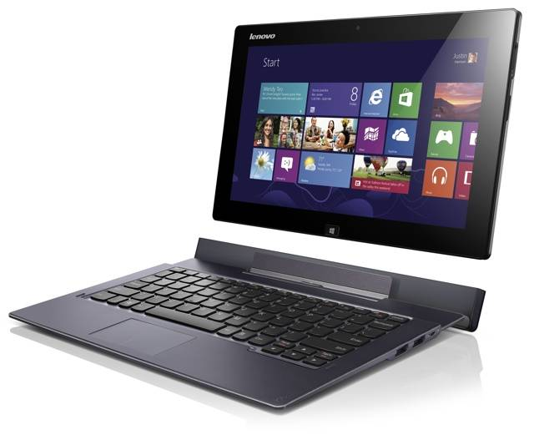
Digital Trends
Figure 8: The Lenovo ThinkPad Helix detached from its keyboard. The keyboard serves to cool the Helix as well as extend its battery life.
Their ThinkPad Helix also has a detachable keyboard but it is much heavier than the Surface Pro version. Although this makes the device less portable this comes with an advantage. There are build-in fans inside the keyboard that direct air flow inside the computer to cool down the processor. When the device is removed from the keyboard the processor is programmed to slow down the frequency in order to help keep the system from overheating and conserve battery life. In addition, the keyboard also has a build-in battery that allows the helix to be used for about ten hours. For consumers that do not want a detachable keyboard, Lenovo has another device that is quite unique, the IdeaPad Yoga (Figure 9). 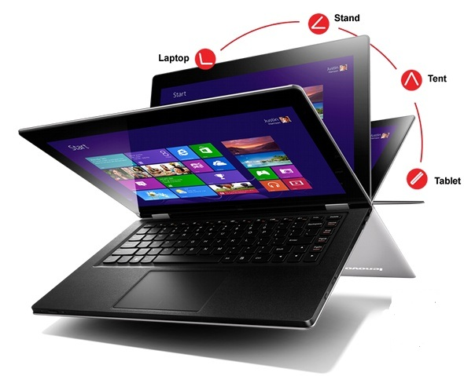
Blucable
Figure 9: The Lenovo IdeaPad Yoga. This computer has the ability swing its screen open to a full 360 degrees. This allows the Yoga to be used as multiple devices according to the angle the screen it opened to.
This flexible computer looks like a traditional laptop with its clamshell design except the screen can be completely folded back behind the device to give the user a tablet experience when desired. Another option available without the detachable keyboard is the Asus Taichi (Figure 10). 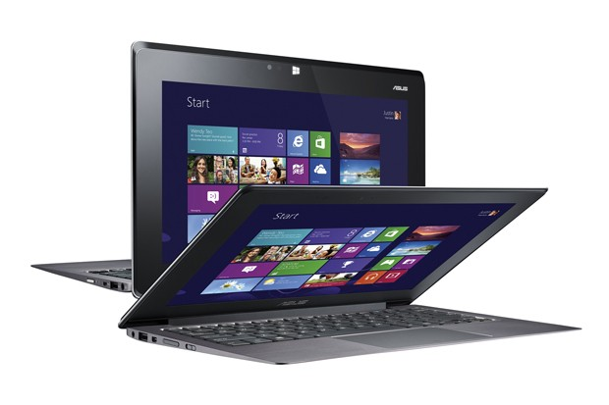
Engadget
Figure 10: The Asus Taichi. This computer has two screens that are placed one behind the other. The front facing screen is for laptop usage while the back facing screen it for tablet use. Two Taichis are shown here to show both screens.
This computer is worth mentioning because although it also has a clamshell form it has something never seen before, two screens. One screen is in the same place as a typical laptop; inside the computer lid when opened. The second screen is behind the first one and it is touch screen. Instead of powering off the when the lid is closed this device instantly transforms from its initial laptop form to a tablet. When the user is finished using the computer it can be powered down by simply holding down the power button. Although this design is very original it has two major flaws. First, the keyboard is not detachable so the user has no option but to carry it around even while using the on-screen keyboard. The second flaw is its likelihood of scratching the touch screen since it is exposed outside of the device. Although all of these computers come with pros and cons they have very ingenious designs that are unlike anything seen before.

V. Conclusion
While the popularity of tablets is increasing so is the demand for a device that can do it all. The portability of a tablet and the full functionality of a laptop seem to be the next big thing. Current designs for such a product come with flaws and can leave the user wishing for a task specific device for the job currently at hand. This is largely due to the power hungry processors currently available. However, it looks like Intel will change things quite soon. Their new Ivy Bridge processor promises to maintain high performance while reducing power consumption from 17 watts to 7 watts. These new low powered processors are due to be released later this year. This will revolutionize the way hybrid devices are made and will get rid of their biggest weakness. However, until manufacturers can get their hands on these processors and integrate them into their machines consumers will not be able to know what these hybrid devices are truly capable of. Even then, it is still up in the air what the ultimate universal form factor will be for them. It will not be until people settle and adapt to a particular design that we will know exactly what the future holds for portable computers.

References

[1] | Chandra Steele. (2011, August) PCMag. [Online]. http://www.pcmag.com/slideshow/story/285757/history-of-the-tablet/1
[2] | Tracy V. Wilson and Robert Valdes. (2011, May) How Stuff Works. [Online]. http://computer.howstuffworks.com/laptop6.htm
[3] | Intel. Intel. [Online]. http://www.intel.com/content/www/us/en/silicon-innovations/moores-law-technology.html
[4] | Reuters. (2011, November) Fox News. [Online]. http://www.foxnews.com/health/2011/11/29/how-does-laptop-wi-fi-affect-male-fertility/
[5] | Microsoft. (2013, February) Microsoft. [Online]. http://www.microsoft.com/Surface/en-us/surface-with-windows-8-pro/home
[6] | Lenovo. (2013, February) Lenovo. [Online]. http://www.lenovo.com/products/us/tablet/thinkpad/thinkpad-helix/
[7] | ASUS. (2013, February) ASUS. [Online]. http://www.asus.com/vivo/en/taichi.htm
[8] | ANSA. (2011, February) ANSA. [Online]. http://www.ansa.it/web/notizie/rubriche/english/2011/02/22/visualizza_new.html_1584088972.html
[9] | Lenovo. (2013, February) Lenovo. [Online]. http://www.lenovo.com/products/us/laptop/ideapad/yoga/yoga-13/
[10] | Gepner, Pawel; Kowalik, Michal F.; Intel Corporation, "Multi-Core Processors: New Way to Achieve High System Performance," International Symposium on Parallel Computing in Electrical Engineering, 2006.
[11] | Houman Homayoun and Ted H. Szymanski, "Reducing the Instruction Queue Leakage Power in Superscalar Processors," Electrical and Computer Engineering, pp. 1685-1689, May 2006.
[12] | Loyd Case. (2012, April) PCWorld. [Online]. http://www.pcworld.com/article/254176/intels_ivy_bridge_processor_leaner_and_meaner.html
[13] | Sean Hollister. (2012, December) The Verge. [Online]. http://www.theverge.com/2012/12/3/3725084/intel-plans-10-watt-ivy-bridge-processors-for-2013-signaling-longer
[14] | MLN. MLN. [Online]. http://www.mln.com.au/info_page/?id=laptophistory
[15] | The Wall Street Journal. (2010) WSJ. [Online]. http://online.wsj.com/adimg/sas-laptop-history.pdf
[16] | Z. Chambers, "What is beyond the laptop initiative? Perhaps: Tablet PCs and DyKnow Vision software," Frontiers in Education Conference, 36th Annual, pp. 8-13, October 2006.

