Christopher McIntosh

Prof. H. Ramsey

Writ 340 - 66805

4/30/2013

Flight in the Ground Effect Zone

*Heavy seabirds employ an energy saving mode of flight known as ground effect, but until fairly recently, craft designed to take advantage of this peculiar aerodynamic phenomenon have not been commercially viable. Ground effect refers to the increased lift and efficiency of a wing flying very close to the surface, and marine craft designed to fly in this zone are known as wing-in-ground effect vehicles (WIGs). First generation WIGs dating from the 1960s progressed only to prototype or limited production due to substantial design hurdles, including stability and the dual parameters of aerodynamic and hydrodynamic loads. Examples of the new generation of WIG designs are found in Russia, Australia, and South Korea, the latter boasting two companies with WIGs in production. The new generation of WIG designs promises to serve the broad range of practical marine transport applications well suited to the technology.*

Is energy saving flight just for the birds? Heavy birds conserve energy by flying just above the water’s surface. There the Albatross and Pelican, for example, take advantage of a peculiar aerodynamic phenomenon, known as ground effect, that increases their wings' lift and efficiency [1] [Fig.1]. Aircraft pilots commonly experience ground effect just before touch-

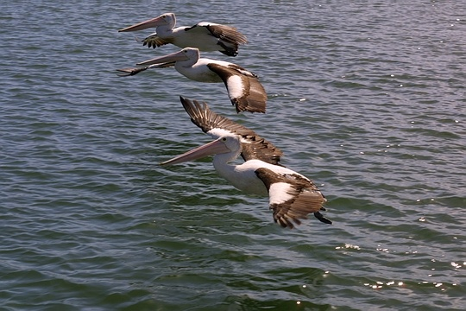

Fig. 1. Pelicans flying in ground effect [2]

down, feeling the added lift pushing the plane up until the effect diminishes with slower speed [3], [4]. This flight dynamic has intrigued creative minds for some time, because marine craft capturing the efficiency of flying in ground effect could be fast and cost effective. Researched since the 1960s, these craft are known as ground effect or wing-in-ground effect vehicles (WIGs) [5]. In contrast to first generation WIG designs that progressed only to prototype or limited production, current trends in the design of ground effect vehicles point to a promising future for the technology.

The phenomenon of ground effect is highly complicated. During ground effect, air, wing and surface interact in complex ways that increase the lift of the wing and reduce the drag that is always a byproduct of creating lift [4], [6]. Close proximity to the surface interferes with the usual airflow patterns around the wing in two major ways. First, air between the low flying wing and the ground becomes compressed. As a result, pressure increases on the wing's underside and creates an increase in lift [3], [4]. Second, the ground blocks the wingtip vortices that during normal flight at altitude produce a form of drag called induced drag [3]. Consequently less drag is produced (Fig. 2).

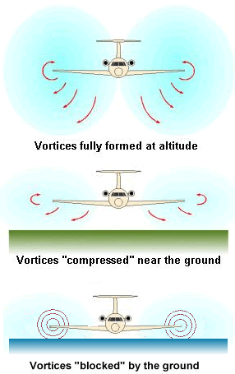

Fig. 2. Ground effect interferes with wingtip vortices and reduces induced drag [7].

This interaction of wing, surface and air increases aerodynamic efficiency, expressed as a high ratio of lift to drag [8]. Increased efficiency means the ability to carry more weight, or payload, and burn less fuel than other aircraft [8]. WIGs are designed to fly within this efficient ground effect zone, limited to a height that is equal to or less than their wingspan [6]. The target altitude is less than one-half of wingspan, where gains in aerodynamic efficiency are significant [1]. Thus WIGs, designed for their unique environment, potentially offer competitive marine freight and passenger capacities at aviation speeds.

This concept was the focus of pioneering Russian inventors who developed WIG models, called ekranoplans, for high speed military transport. Perhaps the most famous ekranoplan was the top secret Russian military craft discovered in the 1970s via NATO satellite. NATO referred to the mammoth craft as the “Caspian Sea Monster” [3][Fig. 3]. Twice the size of a Boeing 747 airliner,

Fig. 3. The Caspian Sea Monster [9]

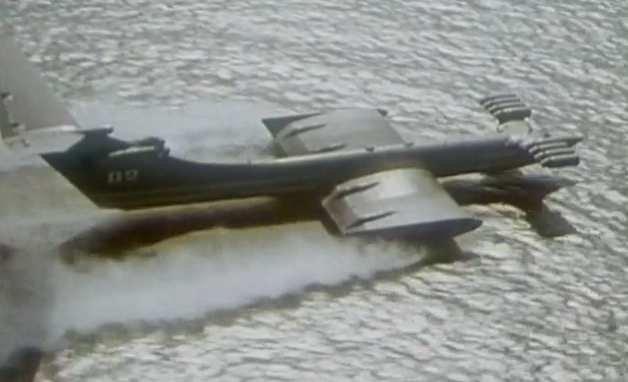

it could transport 900 troops flying at 500 mph in ground effect, or zero altitude. The 550-ton prototype never progressed beyond sea test trials [3]. The Russian military developed other ekranoplan models, but their large size confined them to the sea near where they were built. Even though ekranoplans could fly over both land and water, flight in ground effect over land requires flat desert or prairie. Flight at very low altitude over populated areas was unthinkable. But the biggest obstacle for these large ekranoplans was their stability [10]. Russian attention has since turned to smaller commercial applications. Other countries, primarily Germany, China, Japan, Australia, South Korea, and the U.S. [3], [5], [11], have developed a variety of WIG models of which only a few are currently in production.

It seems a contradiction that such a promising technology has been slow to develop. However, WIG design faces numerous challenges that early models demonstrated but could not economically overcome [5]. Compared to aircraft not flying in ground effect, WIGs have unique stability issues. Stability is not a problem when a WIG flies within the strong ground effect zone. And good stability is maintained outside of the zone by WIGs' center of gravity and effective tailplane [3]. Their Achilles heel is flight in the upper weaker ground effect zone, where most WIGs must operate briefly in order to turn or maneuver at high speed . In that weaker transition zone, a craft potentially pitches or heaves in response to wind conditions, requiring rapid pilot adjustments to maintain steady flight [3]. Therefore, the stability of WIGs, particularly the larger faster models, requires precision technology for height control that was not available to the first generation models such as the military ekranoplans [3], [5].

Other major challenges for WIG engineers stem from the dual design parameters for aircraft and high speed ships. A WIG must successfully address hydrodynamic as well as aerodynamic loads [11]. Its seaworthy body and mechanics must withstand water take-off and landing at speeds greater than marine vessels and be durable in a highly corrosive environment [3], [11]. A further challenge for designers has been the power needed to accelerate to take-off speed given hydrodynamic drag, the force resisting the craft's motion through water [5]. Once aloft, the craft's power-generating source and fuel become weight liabilities, as WIG cruising altitude requires about one-third to one-half of take-off power [11]. Such weight must be minimized because it cuts into the WIGs' payload capacity [12]. Finally, sea roughness currently limits most WIGs to coastal areas. Wave height increases take-off drag as well as reduces a WIG's efficiency because wave clearance requires flight at higher altitude [11].

These engineering hurdles are being met to varying degrees by the current generation of WIG designs [3], [11]. For example, Aquagen, a Russian company, has developed several models of the Aqualet (Fig. 4), a lightweight craft capable of up to 100 mph. It features a static air

Fig. 4. Aqualet [12]

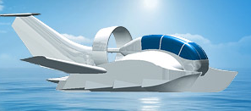

cushion that facilitates takeoff without added weight, the additional ability to operate on snow and ice, and a strong body formed of polymeric materials [12]. The Sea Eagle SE-6, built in Australia, uses a light 300 hp aircraft engine and transports up to five passengers in coastal areas [7]. Among the smaller WIGs is a U.S. product by Universal Hovercraft, the 19XRW Hoverwing. It is a hovercraft to which canvas wings can be attached in ten minutes. The Hoverwing's 6 foot cruising altitude can be boosted to 20 feet to clear obstacles. Its range is limited to 150 miles at 35 mph, although it can reach speeds of 70 mph [13].

Currently dwarfing these efforts are the WIGs being developed in South Korea. The South Korean government's support of WIG research and development has spawned commercial production by two companies [3]. The Aron-7 by Aron Flying Ship (Fig. 5) is not only in

Fig. 5. Aron-7 [14]

Aron-7 [12]

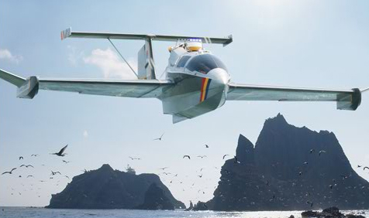

production, but also its success is spurring development of newer models designed to cater to a wider range of applications. The Aron-7 currently serves the luxury taxi transport market and is being adapted for military, coastal patrol, and search-rescue operations. The Aron-7 can jump up to 500 feet within 60 seconds in order to clear obstacles [14]. This jumping ability classifies the Aron-7 as a Type B WIG according to 2002 International Marine Organization rulings; Class B means it can fly out of ground effect for brief periods of time [3].

The second South Korean company, Wing Ship Technology, has produced the larger WSH-500 (Fig. 6). Capable of transporting a payload of 4.3 tons, the WSH-500 is scheduled to be placed

Fig. 6. WSH-500 passenger ferry [15] [[[[[[13]

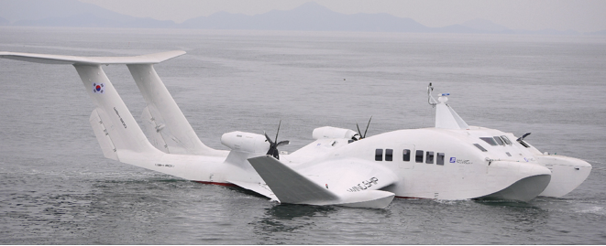

in service as a high speed ferry, cruising at 95 knots [15], [16]. The WSH-500 is a Class A WIG, meaning that it is restricted to flight in ground effect [3]. Its design is based on the hoverwing technology of a German company, Fischer-Flugmechanik. During takeoff, the propeller creates a static air cushion underneath the craft that lifts most of the wingship's weight. With less of the craft in contact with the water surface, hydrodynamic drag is reduced. Thus, takeoff acceleration uses minimal power [16]. Once aloft, the static air cushion dissipates and is replaced by the dynamic pressure of the ground effect zone. The WSH-500 operates without the aid of automated controls, which the designers state are unnecessary due to the design's "inherent stability" [16].

As demonstrated by the new generation, WIG technology has brought its practical commercial applications closer to realization. WIGs are suited to a wide variety of marine operations that would benefit from their high speed in comparison with ships, hydrofoils and hovercraft. WIGs can provide passenger transport serving islands, coastal cities, offshore installations, tourist destinations, remote areas, as well as search-rescue and emergency medical services. WIG services also include perishable cargo transport and operations over swamps, ice/snow, and otherwise inaccessible areas. In addition, paramilitary applications, such as coastal patrols, anti-smuggling surveillance and border protection, are appropriate for WIGs [3]. For example, the Russian Border Service is advancing the development of WIG designs to serve Russia's vast network of coastal areas and bodies of water. It currently foresees the use of WIGs for border security and tracking Russian fishing vessels [17]. Meanwhile, government support in South Korea will continue to advance the frontiers of WIG research and development of optimal designs for WIGs in the medium size range. As concepts continue to prove their economic viability for practical applications in various countries, flight in the ground effect zone will likely secure its role in the future of marine transportation.

References

[1] H. Fischer. (2011). "Ground effect basics." *Hoverwing WIG Craft Technology.* [Online]. Available: http://hoverwing.webs.com

[2] Kumon (Flickr). (2005, Mar. 7). "Three Pelicans." *Wikimedia Commons* [Online]. Available:

http://commons.wikimedia.org/wiki/File%3AThree_pelicans.jpg

[3] L. Yun and A. Bliault. *High Performance Marine Vessels*. New York: Springer, 2012. [eBook]. Available: Springer, doi: 10.1007/978-1-4614-0869-7_3

[4] D. Anderson and S. Eberhardt, *Understanding Flight.* 2nd ed. New York: McGraw Hill, 2010.

[5] L. Yun, et al., "Wings in ground effect" in *WIG Craft and Ekranoplan Ground Effect Craft Technology.* New York: Springer, 2010.[eBook]. Available: Springer, doi: 10.1007/978-1-4419-0042-5_1

[6] J. Scott. (2003, Jun. 29). "Ground effect and WIG vehicles." *Aerospaceweb*. [Online]. Available: http://www.aerospaceweb.org/question/aerodynamics/q0130.shtml

[7] *Sea Eagle International*. (2010). [Online]. Available: http://seaeagleinternational.com

[8] Nat. Aeronautics and Space Admin. (2010, Jul. 28). "Lift to drag ratio." *NASA* *Glenn Research Center*. [Online]. Available: http://www.grc.nasa.gov/WWW/k-12/airplane/ldrat.html

[9] "The Caspian Sea Monster Part 1." ( 2007, Aug. 8). *RT_Documentary*. [Online]. Available: http://rtd.rt.com/films/the-caspian-sea-monster/#part-1

[10] S. Wilkinson. "Flying ships." *Aviation History*, vol. 22, no. 2, pp. 14-15, Nov. 2011. [Online]. Available: ProQuest, http://search.proquest.com.libproxy.usc.edu/docview/890556979

[11] K.V. Rozhdestvensky. "Wing-in-ground effect vehicles," *Progress in Aerospace Sci.*, vol. 42, pp. 211-283, May 2006. [Online]. Available: ScienceDirect, http://www.sciencedirect.com/science/article/pii/S0376042106000637

[12] "New generation of ground effect vehicles." *Aquagen.ru*. (2011). [Online]. Available: http://www.aquagen.ru/eng/planes/akvaplan

[13] Universal Hovercraft. *19XRW-Hoverwing.* [Online]. Available: http://www.hovercraft.com

[14] Aron Flying Ship. (2012). *Aron*. [Online]. Available: http://www.cnsamt.com/eng

[15] Wing Ship Technology Corp. (2012). *Wing Ship WSH-500*. [Online]. Available: http://www.wingship.com

[16] H. J. Lee, et al., "Development of Hoverwing type WIG craft WSH-500*"* in OCEANS 2012, Yeosu, 2012. pp. 1-5. doi: 10.1109/OCEANS-Yeosu.2012.6263589

[17] "Russian security service to develop hi-tech hovercraft," *BBC Monitoring Int. Reports,* Jan. 2012. Available: Academic OneFile, http://go.galegroup.com.libproxy.usc.edu/ps/i.do?id=GALE%7CA278266938&v=2.1&u=usocal_main&it=r&p=AONE&sw=w

**Suggested Links**:

Video with animations: HW 7 (Hoverwing technology): http://hoverwing.webs.com/video.htm

Video: The Caspian Sea Monster: http://rtd.rt.com/films/the-caspian-sea-monster/#part-1

**About the Author:**

Christopher McIntosh is a third year mechanical engineering major at the University of Southern California. In his spare time he enjoys hands-on projects, such as building a personal hovercraft and a motorized recliner chair capable of 40 mph. Chris is an officer and founding member of a social fraternity at USC, and works on the chassis team for USC Racing.