Writ 340 Section 66804
Illumin Paper

Yuxing Jack Zhao

Prof. Marc Aubertin
12/6/12
Graphite Fiber and Golf Club Performance
Introduction
All golfers want one thing out of their drivers—a long driving distance. Golfers hit hundreds of ball at the driving range trying to increase their driving distance. In the past few years, golf club manufacturers made claims that any player can instantly increase his driving distance by switching to graphite shafts. Despite that fact that most golf professionals have installed graphite shafts on their clubs and spoken for graphite shafts in advertisement, the physical principles behind these magical claims are not understood by golf club buyers.
By supersport.com
Figure 1: Famous golf pro Tiger Woods swinging a graphite-shafted driver. [I]
Graphite fiber, also known as carbon fiber, has a high tensile strength, high stiffness, and low weight. These physical properties have made it very popular for aerospace, automotive, civil engineering, and military applications. This technology has also become a game-changer in golf, but before we get into the details of graphite shafts, let us take a look at the evolution of golf club making and the properties desired from the golf shaft.

History of Golf Club Making
Golf originated in the 15th century in Scotland. [1] For about four hundred years, golf clubs were hand-made by local professionals. Early golf professionals were prized as much for their club making skills as for their golfing skills. In some cases more so. Golf clubs consisted of two parts, the club head that comes in contact with the ball and the shaft held by the golfer to swing the club. At the beginning, the shafts of golf clubs were made from local European woods like ash or hazel. When the sport of golf was first introduced to America in the early 1800s, hickory was used to make shafts and became the standard material for shafts due to its durability and relatively light weight. However, because hickory was prone to fracture, it required a slow smooth golf swing and precise timing to hit the golf ball. [2]
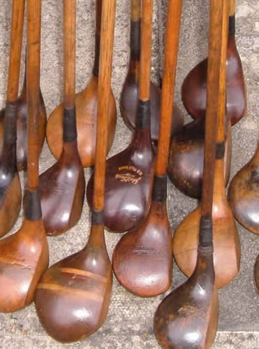
By druidswood.co.uk
Figure 2: Old fairway woods with hickory shafts. [II]
In the early 1900s, club makers started making steel club heads and steel shafts. In addition to wood club heads, steel club heads were made to make less distant but more accurate strokes. Club makers also tried to make steel shafts with solid rods or hollow tubes. However, solid steel shafts were too heavy to swing, and hollow steel tube steel shafts were very difficult to manufacture from low-carbon containing steel. As steel manufacturing processes improved, a step-down steel shaft was manufactured and widely accepted by golfers. Because of steel shafts’ durability and accuracy, club head speed could be maximized without precise timing. Steel shafts claimed dominance over hickory shafts. Players were able to strike the ball with more power and a faster swing. Billy Burke was the first to win a major tournament with steel shafted clubs when he won the US Open in 1931. [2]A controlled body swing with steel shafts soon replaced the slow languid swing with hickory shafts. [3] This controlled body swing is also known as the modern golf swing, which is still practiced by most golf pros today.
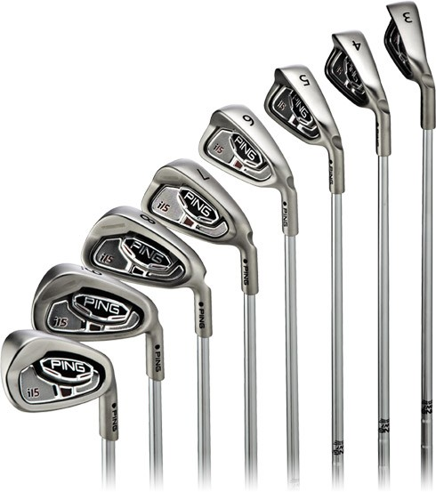
By golfsmith.com
Figure 3: An iron set with steel shafts. [III]
Graphite was first used in aerospace after World War II. Its physical properties were noted, and it was soon used in many other applications. In 1970s, graphite shafts made their debut in the world of golf. Even though graphite shafts were much lighter, they were inconsistent and soon disappeared from the market. Engineers continued to work on the manufacturing and composition of graphite shafts. In mid 1980s, graphite shafts made their come back to the market. They quickly gained popularity due to their light weight, improved consistency, and flexibility. Graphite shafts’ light weight allowed a faster club-head speed and therefore farther ball distance. Stiffness of the shafts could be adjusted to increase distance.
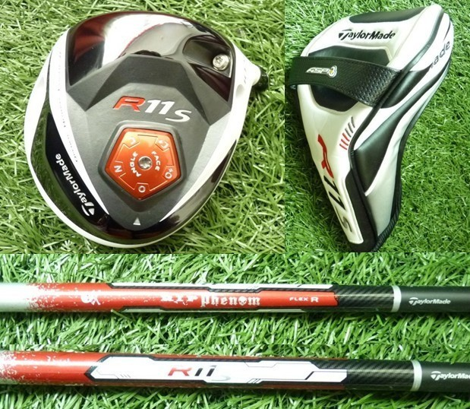
By bestpricegolfshop.com
Figure 4: A Taylormade driver with a graphite shaft of regular flex. [IV]

Now most professional golfers have custom-fitted graphite shafts for their drivers and fairway woods. Players use the same controlled body swing with a graphite shaft as they do with a steel shaft. Since the innovation of graphite shafts, the driving distance in professional golf has increased drastically, making modern golf an even more exciting game.
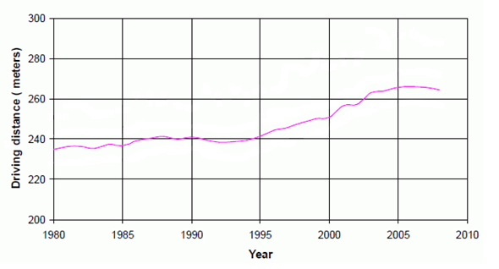By Tutelman
Figure 5: The average driving distance has been constantly increasing since the innovation of graphite shafts. [V]

Properties of a Graphite Golf Club Shaft and the Physics of Golf
One obvious advantage of graphite shafts is their light weight comparing to steel shafts, but why do we want light shafts? The club-ball collision time happens in a split second. During this really short collision time, the momentum from the golf club is transferred to the golf ball. Bigger mass and bigger velocity will result in bigger momentum. Momentum is expressed mathematically expressed as:
P=m*v, [5]
where m is the mass of the object, v is the velocity of the object, and P is the momentum. The bigger that velocity of the club head, the bigger the momentum, and the faster the ball will travel. Therefore, players want a heavy club but not too heavy for them to swing at a slower speed.
Greater mass can also lead to a larger momentum, but only the mass of the club head contributes to momentum. Therefore, a great majority of the shaft's mass is not involved in momentum transfer to the ball. This means that all of the work done by the golfer to increase the velocity of the shaft is wasted. Lighter shafts are created to a more efficient swing. [4] In Figure 6, experiments also demonstrated the effects of shaft weight on ball distance. Reducing the shaft mass from about 130 grams (steel shafts) to about 60 grams (graphite shafts) has resulted in an increased driving distance of about 10m.
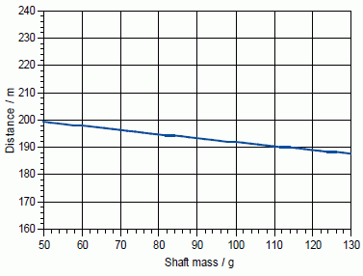
By Tutelman
Figure 6: Lower shaft mass will proportionally produce longer distance. [V]
Graphite shafts also have better flexibility than steel shafts. Many people think that a more flexible shaft is capable of “restoring energy,” and consequently generating higher club head speed. Contrary to popular belief, shaft flexibility has nothing to do with club head speed. In the study “The Role of the Shaft in the Golf Swing” by Ronald Milne and John Davis, evidence showed that the club head speed is virtually unchanged for different shaft flexibilities. However, different flexibilities will cause different amount of deflection of the shaft right before impact, resulting in different lofts, or launching angles, and ultimately different driving distance. [6]
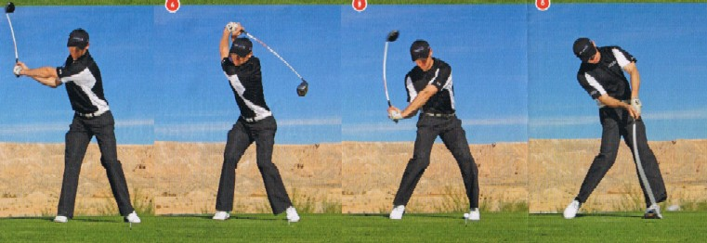
By goodergolf.com
Figure 7: In the golf pro’s swing, the shaft goes through a severe deflection toward the target right before impact. [VI]

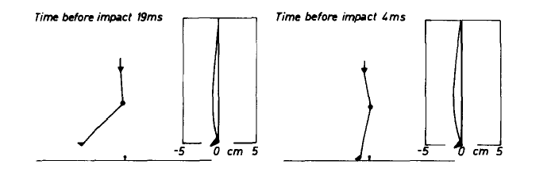
By Milne/Davis
Figure 8: The deflection of the shaft right before the impact moment, causing a launching angle. [VII]

Both Fig. 7 and Fig. 8 illustrate the launching angle at impact. Different shafts will result in different launching angles. A flexible shaft will enhance loft by as much as 5 degrees, while a stiff shaft only about 2 degrees. Golfers with a slow swing speed require drivers with a high loft (14-15 degrees say) to achieve the greatest distance, whereas golfers with a high swing speed achieve optimum distance with a lower loft (as low as 9 degrees). [4] If air resistance and ball spin effects are not taken into consideration, the golf ball will travel in a two-dimensional trajectory motion. The driving distance, or the range is mathematically expressed as:
$R$=$\frac{{v_{o}}^{2}sin⁡(2θ)}{g}$, [7]
Where v_{o} is the initial speed of the ball, Ɵ is the launching angle, g is the acceleration due to gravity, and R is the range or driving distance.
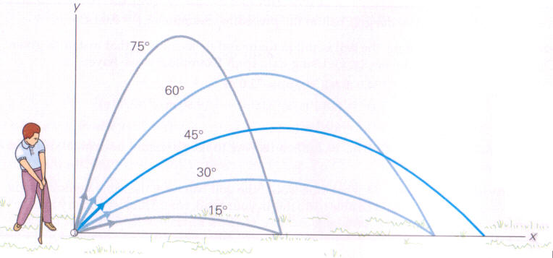
By highline.edu
Figure 9: Different driving distances with the same initial speed at different lofts. [VIII]

As shown in Fig. 8, with the same initial speed, different launching angles will lead to different ranges. Only one angle will lead to maximum distance. For different players, the club head speed varies, so they should choose different shaft flexibility to get the optimal launching angle for the longest distance. Professional golfers are able to swing at a higher club head speed, so they want stiff shafts to get lower lofts and longer distance. Players with slower swing speed will want a more flexible shaft to get higher lofts and longer distance.
The Future of Graphite Shafts
However, limitations also exist in the development of graphite shafts. Some golf strokes require not only distance but also accuracy. When the golf ball lies only eighty yards from the green, players need precisely eighty yards to get on the green, and a greater distance, a hundred yards, may not be a good thing.Graphite shafts can produce more distant strokes, but at the price of precision. This is why most golf professionals use graphite shafts on their woods to get long driving distance, but they keep steel shafts on irons to achieve maximum accuracy when hitting the ball closer to the green.
The technology of graphite shafts is still evolving. Manufacturers are working on making even lighter graphite shafts. They are also trying to come up with more flexibility choices to fit players at different skill levels. Graphite shafts are now widely adopted by both golf pros and amateurs, offering more efficient swings with a light weight and optimal lofts. The future of graphite material is a bright one. The success of graphite’s application in golf also inspired the use of graphite in other sports. A lot of sport equipment also desire light-weight yet strong material, such as hockey sticks, baseball bats, lacrosse sticks, and fishing rods. Graphite will bring a revolution to sport equipment and make sports more powerful and exciting than ever before!

Reference:

[1] | R. Brasch, How did sports begin? : A look at the the origins of man at play, McKay, 1970.
[2] | Golf Club Revue, "Golf Club History," [Online]. Available: www.golf-club-revue.com/golf-club-history.html. [Accessed 08 Oct 2012].
[3] | R. D. P. Arthur, "Shafts: The History of the Golf Shaft," The GolfWorks, [Online]. Available: www.golfworks.com/article.asp?ai=70. [Accessed 8 Oct 2012].
[4] | R. D. Milne and J. P. Davis, "The Role of the Shaft in the Golf Swing," Journal of Biomechanics, vol. 25, no. 9, pp. 975-983, 1992.
[5] | D. Tutelman, "Golf Swing Physics," [Online]. Available: www.tutelman.com/golf/swing/golfSwingPhysics4.php. [Accessed 8 Oct 2012].
[6] | H. D. Young, University Physics with Modern Physics, Pittsburg: Addison Wesley, 2008.
[7] | P. G. Hewitt, Conceptual Physics, Prentice Hall, 2004.
[I] | SuperSports, "Woods knocked for six," SuperSports.com, 18 June 2012. [Online]. Available: http://www.supersport.com/golf/us-open/news/120618/Woods_knocked_for_six. [Accessed 8 Oct 2012].
[II] | druidswood.co, "Hickory Fairway Woods," druidswood.co, [Online]. Available: http://www.druidswood.co.uk/hickory-firewood.htm. [Accessed 8 Oct 2012].
[III] | GolfSmith, "Ping Irons," GolfSmith, [Online]. Available: golfsmith.com. [Accessed 8 Oct 2012].
[IV] | "Taylormade Mens R11S driver," Best Price Golf Shop, [Online]. Available: http://www.bestpricegolfshop.com/taylormade-mens-r11s-driver-p-144.html. [Accessed 8 Oct 2012].
[V] | D. Tutelman, "Golf Swing Physics," [Online]. Available: www.tutelman.com/golf/swing/golfSwingPhysics4.php. [Accessed 8 Oct 2012].
[VI] | Goodergolf, "Shaft Bend," Gooder golf, [Online]. Available: http://www.goodergolf.com/Babble/Shaft_Bend.jpg. [Accessed 8 Oct 2012].
[VII] | R. D. Milne and J. Davis, "The role of the Shaft in the Golf Swing," Journal of Biomechanics, vol. 25, no. 9, pp. 975-983, 1992.
[VIII] | Highline, "Range vs. Angle," [Online]. Available: http://flightline.highline.edu/iglozman/classes/physnotes/media/rangevsangle.jpg. [Accessed 8 Oct 2012].

