Discovering the health issues surrounding load-carrying backpacks
USC Illumin Call For Papers
Nathan Perry

Abstract:
It is often the most mundane, “common” articles in our world that are the most novel. The humble backpack, for example, is one of the most ubiquitous objects in the modern world. This paper explores two aspects of backpacks: their modern design, as well as health issues related to their use. Discover how modern backpack design is mostly perfected, but ultimately limited by the physical constraints of the humans using them. Issues of lack of concern and study on the negative health implications of wearing a backpack are discussed, and the issue of how to use a backpack correctly is tackled.

Multimedia Suggestions:
The video (and article) on this site shows how packing a pack is important to avoiding health problems. http://www.rei.com/expertadvice/articles/loading+backpack.html
Otherwise, a flash or html5 video of a person's posture changing as more weight is added to the backpack would help accent the paper.

Bio: Nathan Perry is a Junior at the University of Southern California, majoring in Computer Engineering/Computer Science. Outside of school, he enjoys his job at Southern California Edison, as well as long walks on the beach.

Contact: nathanpe@usc.edu
Keywords: backpack, internal frame, external frame, back health, stress

Discovering the health issues surrounding load-carrying backpacks

Nathan Perry
WRIT 340
November 2, 2011

It is often the most mundane, “common” articles in our world that are the most novel. Imagine if you didn't have a backpack. At first thought, it might not be an issue. You might tell yourself, “Thank goodness, now I don't need to strain my back by loading it down with tons of heavy books!” What would you use instead? Would you carry everything to class or work, or would another tool take the place of the humble backpack? Could wheelbarrows become the new load-carrying device? Not if there are stairs!
This thought experiment is mostly tongue-in-cheek, but it is meant to show two concepts: That functional and thoughtful design exists even in the most commonplace objects, and that backpacks are really cool. Their almost ubiquitous use covers up the fact that very little backpack oriented research exists. Few have studied the effects on the human body about how we hold objects, and whether we should hold objects with a backpack! The darn things are just so useful! While much of backpack design has been “perfected,” there are still health related problems because of improper use or over use of backpacks and their load-carrying abilities. The human component of backpack design, or having to design around the limits of the human body, is the wall that blocks new backpack design, and it is important to understand how these health issues can effect children and adults.
The noble backpack has changed over the centuries since its invention. Historically, the backpack has been used since large-scale farming became the staple of human civilization and in some cases, even farther back to hunter-gathering times as a way of transporting game. In fact, a very basic primitive external frame backpack was found “The Iceman” - a famous archeological find of a man frozen for over 5000 years - made of “two boards of larch and hazel rod… shaped like a U” [1]. Development of the backpack can be broken down into two types that exist even today: the external frame and the rucksack (now modernized as the internal frame). Backpacks like the one shown in Fig. 1 were used by farmers, peasants and serfs to carry heavy loads of crops and other materials, and creating an effective method to improve worker efficiency lead the external frame, which offered load-bearing capability far beyond using just hands. These basic external frame backpacks were simple, sometimes just a long wooden frame with a smaller “shelf” for setting objects on. Matched against the external frame was the more traditional rucksack, which was a simple canvas or animal skin bag in which objects (often animal parts) could be kept and transported. Such designs might seem simple, but practically are close to modern day designs. Modern backpack design has evolved in the areas of materials used for construction and comfort of user, but are functionally little different from backpacks used a thousand years ago.
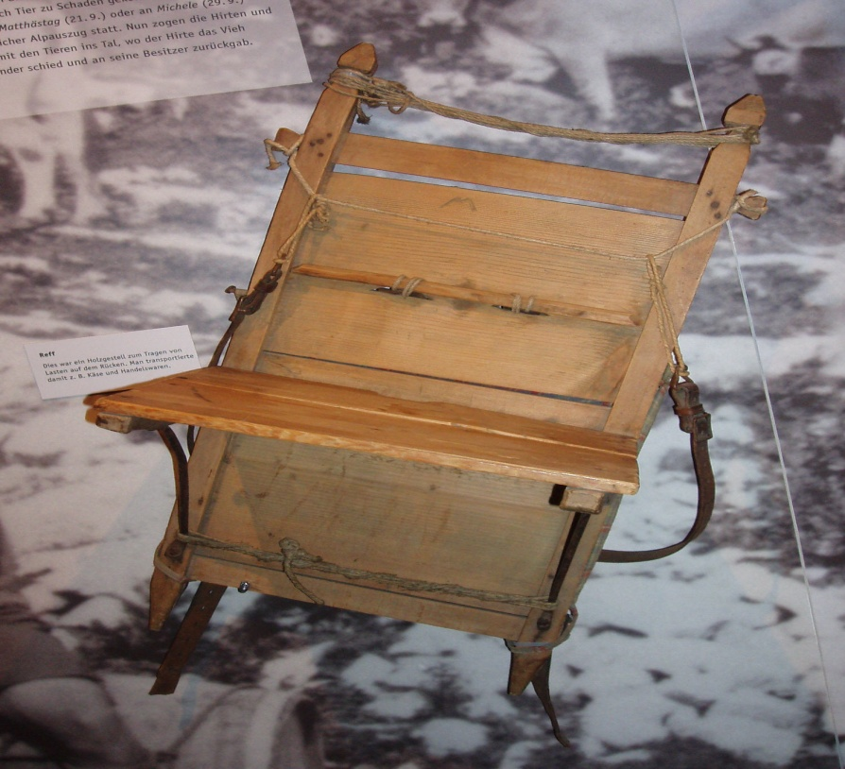
Figure 1: A peasant backpack used in ancient Eastern Europe
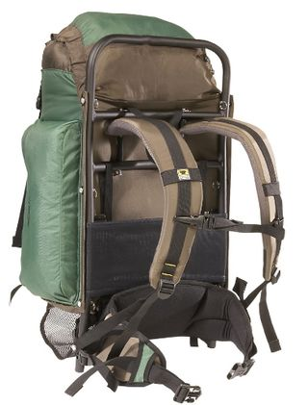
The figures below compare the most common modern designs of backpacks; the internal frame (Fig. 1) and the external frame (Fig. 2). The backpacks used by children and teens are technically considered “frameless”, however, for now they will be considered within the whole of internal frame backpacks, as they tend to match those more closely than external frames. While all backpacks offer the ability store and carry loads, how they do it and the physical impact on the wearer is important to understand. As Fig. 3 shows, the external frame has a metal outside, designed to ensure even distribution of weight and stop shifting from occurring. The internal frame (and the frameless, to some extent) acts more as the traditional rucksack, where the form is kept by stuffing the pack as full of objects as possible, so that nothing can shift because it is packed tightly together. It is important to note here that the external frame is considered to be the superior pack for maximizing load-carrying capacity (as objects can be simply lashed together), and has common use amongst the military [2], even more so than recreational backpacking. Internal frames (and frameless) are sleeker and tighter, but if packed incorrectly can lead to discomfort more easily then external frames as objects are placed within the sack, as opposed to either strapped or separated from head and back by the metal frame in the external packs. Also notice the abundance of straps on the internal frame. This is to allow adjustments of the size of the sack, to secure objects put within the pack.
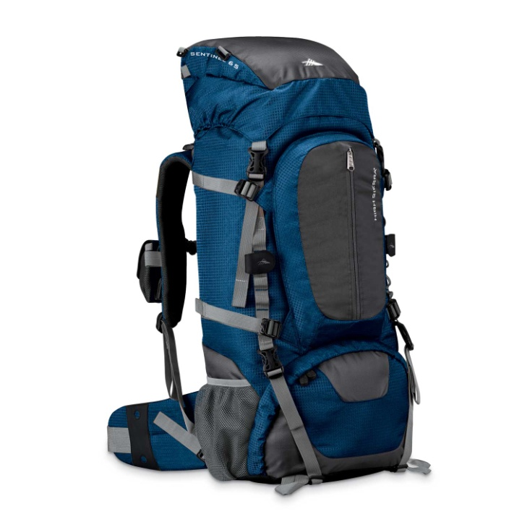
Figure 2: Internal Frame
Figure 3: External Frame
Despite the advances in backpack creation, plus the quality of backpack design, it is surprising to know that there are health related issues associated with backpack usage. Some (but most certainly not all) problems of backpack related injuries can be related to improper packing of the sack. Amongst the external and internal frame backpacks used by the military and backpacking hobbyists, improper packing can easily lead to discomfort and shifting weight while using the pack over long treks across the wilderness. However, with just a little forethought this whole issue can be avoided, simply by packing smarter. One popular backpack designer has instructional videos and how-to guides [3] on how to correctly pack a backpack, including key areas to hold heavy items and how to apply even weight distribution. Heavy items should located at the lowest point of the pack, and shifted more towards the outside if possible (to counterbalance the wearer more efficiently), while avoiding over packing as much as possible. While it might seem like common sense, it is often the extra little steps added that make the difference. However, soldiers and climbers are not the demographic most at risk. It is not uncommon to see teens and children using backpacks improperly, who “opt out of this by only using one backpack-strap, and some even leave the primary pocket open.” [4], despite the fact that studies show it is 4 times more likely to cause back and dorsal pain [5]. It would require some extra encouragement to educate and explain why proper usage of backpacks is needed to avoid health complications.
One might argue that with better construction, perhaps some of these health hazards could be avoided. Can’t we easily design straps, zippers and cloths that distribute weight more easily? The answer is that we have little left to improve in the way of material construction of backpacks, and is an area of design that could be considered to be completely “conquered”. Backpacks are greatly benefited by mass industrialization of fabrics, as common materials such as polyester, nylon and cloth canvas make up much of backpack construction [6], and as such the type of backpack you purchase is not limited by the materials available, but the style available as well as the amount money the consumer wishes to spend. Backpacking packs are often made of tougher nylon-polyester blended materials, as those packs are expected to go through harsher environments than a standard school bag. Of course, not everyone uses a simple backpack. Military issue packs incorporating ultra-high-molecular-weight polyethylene like Dyneema (advertised as the “World's Strongest Fiber” [7], and the fabric equivalent of diamonds) are common as well, as these strong fibers offer increased tensile strength that can be as resistant as Kevlar [7]. As these materials become cheaper, even commonplace backpacks will gain the benefit of these advanced fibers. While these improvements on fabric construction and tensile strength are well-received by backpack makers, there is another factor that keeps little Jimmy from carrying around a diamond tough backpack to keep his books secure. Just because he can stuff 30lbs. more books into his diamond backpack, that doesn’t mean his spine will be able to handle the additional weight. So material use ultimately does little to alleviate the issue that backpacks are over packed!
Looking up scientific studies on backpacks doesn’t yield much in the arena of load-carrying design or functionality; such concerns have long since been solved by modern fabrics and quality materials used for zippers and stitching. Groups of backpack scientists don’t meet yearly, comparing research papers on the newest theoretical backpack designs. The few studies that exist admit how little research there exists about the effect of heavy backpack loads on the spine, especially amongst children [8]. Instead, the greatest obstacle to backpack design is the human limitations on how much weight can be carried comfortably and safely. Even measuring and testing such amounts is dangerous, as the spine can be a delicate part of the body, especially for developing children. For example, one study limited the weight of its backpack testing to 10% of a participant’s body weight, to avoid even the possibility of injuring them [9], despite the fact that the average weight carried by school children and teens is equivalent to 15 – 25% of their total body weight [10]. However, some studies are required to see how much strain can be put on the body [8], giving loads up to 17% of the participants body weight. The participants were all adolescents, who are those most at risk for health complications from backpacks and load-carrying because of the high amount of backpack use, as well as a lack of correction from the adults who can analyze when there is improper use of a backpack going on with a child. School children are the largest group of backpack users, and their health concerns need to be targeted more carefully by scientific researchers.
But not all research in the health effects of backpacks is limited to school children. Militaries around the world are invested in maximizing the transportation of troops and materials, even hosted a NATO conference in June 2000 to discuss the area of soldier health and load-carrying. According to one military study conducted at the Borden Institute [2], the major health hazards from overloaded or incorrectly-packed packs are foot stress fractures and Rucksack Palsy. Rucksack Palsy, according to the study, involves spine and back problems that result in the physical symptoms of winged shoulder-blades and hunched posture. Not only does the heavy weight of backpacks laden with equipment exert downwards, but much of the design of these backpacks does not fit for the often day long use of a backpack. As military backpacks are often wrapped up tightly with the person wearing them, it is not farfetched to see why other military studies found that long-term use of heavy backpacks caused intense skin irritation where the straps were located [11]. It is important to note that these health issues are different from other areas of research, such as school children. The military testing participants are fully grown men and women, trained in carrying heavy packs over vast distances and in extreme conditions. They are at less risk for spine and posture issues, as they have a fully developed skeletal structure in adult hood, but are more prone to foot damage because of the rough terrain they have to deal with, and the constant walking.
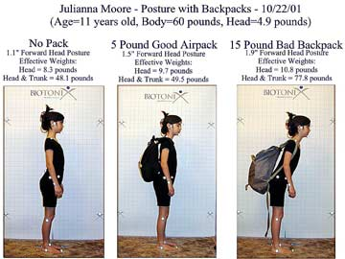
The below figure shows a young schoolgirl in three resting positions, both with and without a backpack. It is as part of a study on adolescent standing postural response, that set out to confirm or refute the belief that wearing a backpack high on the back is the best position to avoid back pain. In the 5 lb “Good Airpack” photo, we can see that the backpack is higher on the girls’ back, and her posture remains straight. However, in the 15 lb “Bad Backpack” (which should noted is 25% of the young girls’ weight), the backpack is moved lower. This makes sense, as a backpack is intended to adjust to create the best sense of balance for the body. Clearly, though, that heavy of a bag is resulting in an extreme re balancing of the body, and ultimately causing much more harm than the benefit of adding a few more books in her bag. Not surprisingly, the participant looks very uncomfortable and is most likely incurring negative effects from the heavy load.
Figure 4: Adolescent posture with backpack of varying weight
We’ve seen how there are some serious health problems surrounding backpacks, but most people do not suffer these severe of issues. So, if backpack design seems to be “solved” for the most part, why bother discussing it at all? Backpacking nowadays is as much a personal choice as it is the actual design and price. However, the key component of modern backpack design failure is not in the physical design, but in the instruction in proper backpack use. Yes, even the use of the most mundane objects needs to be thoughtfully planned and explained as to avoid improper and detrimental use. If improper use of backpacks can cause increased risks in spinal damage [10], it is clear that we need some new solutions to preventing mistreatment of the physical self. While backpacks remain a useful and ubiquitous tool in today’s load-carrying world, it is important to remember that proper care and moderate use of backpacks is what results in long term health and enjoyment.

Bibliography
[1] G. Casanovas. (2001, October 16). The Iceman. [Online] Available: http://www1.american.edu/ted/iceman.htm

[2] J. Knapik and K. Reynolds, "Load Carriage in Military Operation," Monograph, Washington D.C. : Borden Institute.

[3] T. Skallerud. (2010, April). How to Load a Backpack [Online]. Available: http://www.rei.com/expertadvice/articles/loading+backpack.html

[4] J. Hall (1997, April 7). The Backpack: Most Humane Luggage. [Online]. Available: http://www.links.net/vita/swat/course/every/backpack/.

[5] P. Korovessis MD et al. “ Backpacks, Back Pain, Sagittal Spinal Curves and Trunk Alignment in Adolescents,” Spine, vol. 30, no. 2, pp. 247 – 255, 2005

[6] Z. Seeker. Backpack Fabrics and Construction [Online]. Available: http://zenbackpacking.net/BackpackFabrics.htm.

[7] Dyneema® high-strength, high-modulus polyethylene fiber, Dyneema Fact Sheet[Online]; January 1, 2008, http://www.dyneema.com/en_US/public/dyneema/downloads/Comprehensive_factsheet_UHMWPE.pdf (accessed October 17, 2011).

[8] D. Pascoe. “Influence of carrying book bags on gait cycle and posture of youths,” Ergonomics, vol. 40, no. 6, pp. 631 – 641, 1997

[9] SK. Grimmer et al. “Adolescent standing postural response to backpack loads: a randomised controlled experimental study,” BMC Musculoskelet Discord, vol. 3, 2002.

[10] S. Negrini, MD; and R. Carabalona. “Backpacks on! Schoolchildren’s Perceptions of Load, Associations With Back Pain and Factors Determining the Load,” Spine, vol. 27, no. 2, pp. 187 – 195, 2002

[11] M. Walker; and T. Meeuwsen. “Physiological Strain During Load Carrying: Effects of Mass and Type of Backpack.” presented at the RTO Human Factors and Medicine Panel, Kingston, Canada, 2000. [Online]. Available: http://www.dtic.mil/dtic/tr/fulltext/u2/p010987.pdf

Table of Figures

Figure 1: A peasant backpack used in ancient Eastern Europe,
http://upload.wikimedia.org/wikipedia/commons/c/c5/Reffunbeladen.jpg

Figure.2 Internal Frame Backpack, http://www.backpackstash.com/files/2019938/uploaded/59401_422_Internal_Frame_Backpack_Pacific_Blue.jpg

Figure. 3 External Frame Backpack,
http://outside-blog.away.com/.a/6a00d83453140969e20133f42c8e13970b-320wi

Figure. 4 Adolescent posture with backpack of varying weight,
http://www.cascadewellnessclinic.com/GRAPHICS/4SPORTGX/BPCollage.jpg

