Andrew Ronald
aronald@usc.edu

A History of America’s Oldest Sport: The Evolution of the Lacrosse Stick

Abstract: Native Americans created the sport of lacrosse long before European explorers discovered the Americas. Traditional wooden sticks similar to those used by the early Native Americans dominated the sport until 1970. This paper discusses the evolution of the modern lacrosse stick. It covers the development of the first plastic symmetrical lacrosse head that revolutionized future stick development as the lacrosse stick was now split into two separate pieces for the first time in its history. The modern lacrosse stick consisting of a plastic head mounted on a carbon fiber composite shaft represents significant advances in engineering and material science. The continued growth of the sport promises to bring further innovation of the lacrosse stick.

About the Author: Andrew Ronald is a junior at USC studying Biomedical Engineering. He is a member of USC’s Men’s Lacrosse Team and Beta Theta Pi fraternity.

Intro:
Lacrosse is a game with a rich history rooted in Native American tradition. With the influence of modern engineering and technology the game of lacrosse has slowly evolved into the modern game that it is today as America’s fastest growing sport. Advances in material science and understanding of sports kinematics have greatly changed the face of the game; nowhere is this change more evident than in the evolution of the lacrosse stick.

History of the game:
The earliest accounts of the game of lacrosse come from European settlers upon their first contact with Native American tribes in what is the present day New England. The Europeans thought the sticks being used by the players resembled a bishop's crosier, and thus they began calling the game “La crosse” [1]. The sticks the European settlers observed varied considerably from tribe to tribe. The modern day lacrosse stick evolved from an Iroquois model in which one long piece of wood, usually hickory, was steam bent on one end to form the crook of the “head” portion of the stick, while the bottom straight portion of the stick constituted the handle, or “shaft”, with which the player gripped the stick [2]. The bent crook of the stick created an unsymmetrical open loop with one wall at one end of the stick. Leather ties were used to create a second wall that completed the loop; these ties were also used to string netting across the two side walls of the loop in which the lacrosse ball could be carried [3] (Fig. 1).
The basic structure of the lacrosse stick remained mostly the same until 1970 when the plastic lacrosse head was developed [3]. Lacrosse sticks were no longer one long piece of wood but now consisted of a separate headpiece that was mounted onto the shaft. Additionally, the lacrosse head was now symmetrical and allowed both right and left-handed players to use any given stick. As the lacrosse stick split in two, so too did its evolution; the lacrosse shaft and head have since evolved in distinct ways as a result of modern advances in engineering and understanding of
sports kinematics.
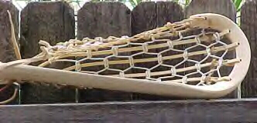
Figure 1. An old-fashioned Iroquois model lacrosse stick.

Evolution of the lacrosse shaft:
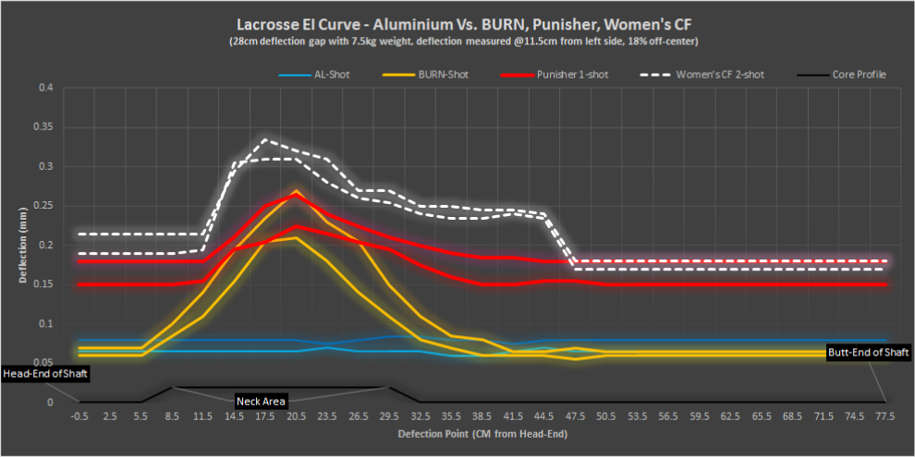
After the introduction of the separate lacrosse head in 1970 the lacrosse shaft continued to evolve. These evolutions have been constituted by changes in the material making up the shaft. The early 1980’s brought the aluminum shaft to the game of lacrosse [3]. Hollow aluminum shafts were significantly lighter than their wood predecessors and allowed for players to swing their sticks through the air at a much higher velocity. Faster stick speed meant faster shots and passes. The introduction of the aluminum shaft to lacrosse resulted from innovations to hockey stick design, and the shaft gained popularity in both sports throughout the remainder of the decade. However, lacrosse posed issues to the aluminum material that hockey did not. Unlike in hockey, lacrosse sticks are used to swing at and hit other players and their sticks; this resulted in aluminum lacrosse shafts easily becoming dented, bent and even broken in half. This issue was solved in 1992 when Warrior Lacrosse manufactured the first lacrosse shaft made of titanium. Titanium has a relatively low atomic weight and density, meaning that compared to many other metals its molecules both weigh less and are packed together less tightly; this combination yields an extremely light metallic substance. In addition to its lightweight, titanium also has a remarkably strong crystal structure in which the molecules arrange themselves into a strong and rigid orientation in the solid form of the metal. This combination of strength and low weight makes titanium an ideal material out of which to make lacrosse shafts [4]. Through the end of the century titanium dominated the lacrosse shaft market. However, due to high cost and the advancement of composite materials, titanium shafts have fallen in popularity in recent years.
Figure 2. A graph showing the deflection profile of 3 composite lacrosse shafts compared to an alumnium shaft.
The decline of titanium shafts has been met by the rise of composite shafts, which hold many advantages over their predecessors. These composite shafts are made my layering carbon fibers together to obtain the desired form of the shaft. This process results in an extremely lightweight and durable shaft. In addition to its
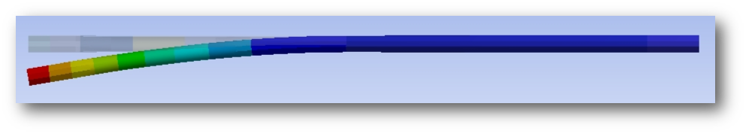
lightweight and strength, the carbon fiber also allows for greater flexibility of the shaft under conditions of high force which is advantageous to lacrosse motions such as shooting. Figure 2 illustrates the amount of deflection during a shot along a series of composite shafts made by manufacturer Joule Lacrosse compared with a typical metal (aluminum) shaft [5]. This deflection, or flex, is a measure of how flexible the shaft is along its length. The composite shafts all show significant deflection while the aluminum shaft does not. This flex allows the maximum force of the shot to be rapidly delivered during the optimum time as the ball is being released from the stick, whereas an aluminum shaft with less flex delivers this force less efficiently throughout the range of the shooting motion. As a player begins their shooting motion, the upper portion of the shaft begins to flex backwards as shown in Figure 3 [5]. When a shaft flexes away from its natural position it has a propensity to want to return to this position; this tendency is stored as the potential energy of the shaft, as the shaft now has the “potential” to snap back into its original position. When a player shoots with a composite shaft, just before the ball is released from their stick, the shaft snaps back into its original position and releases its stored potential energy adding additional force the shot; this additional force does not happen when using a metal shaft as it cannot flex like a composite shaft.
Figure 3. The way a composite lacrosse shaft flexes backwards while shooting. The left or flexed end represents the end that is attached to the head of the stick.
The method of layering the carbon fibers together also allows manufacturers to build composite shafts that are non-homogeneous in shape. By controlling the density and shape of the composite shaft in different areas, manufactures can customize the deflection profile, or how the shaft flexes, creating shafts that are even further optimized for efficient energy transfer during a players shooting motion [5]. Composite shafts, as a result, yield an excellent combination of low weight, strength, and design customization.

Evolution of the lacrosse head:
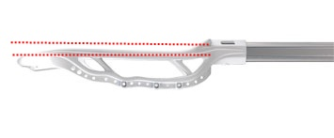
The evolution of the modern lacrosse head is less extensive compared to that of the shaft. As the field of material science has continued to advance, the plastic material of lacrosse heads has been optimized to the strong, lightweight material it is today. However, the major evolution of the lacrosse head has not been in its material but rather in its shape. The shape of lacrosse heads has for the most part maintained the triangular shape first introduced with the plastic symmetrical head in 1970. The revolution to lacrosse head design came in the mid 90s with the development of the offset head. The offset head lowered the face of the lacrosse head slightly below the plane of the base of the head and the shaft [6] (Fig. 4.) The resulting effect of setting the plane of the head below the shaft was a lowering of the center of gravity of the stick. The center of gravity can be thought of as the average position of the entire stick’s weight [7]. By lowering the center of gravity away from the plane of the shaft, players could now have a better sense of feeling in their hands for where their stick was and what direction it was facing [8].
Figure 4. An offset lacrosse head. The two dotted red lines show how the plane of the head sits slighly below, or offset from, the shaft of the stick.
In addition to the enhanced tactile feel for the ball, the lowered plane of an offset head results in the ball leaving the stick while the shaft has already passed through the typical release point of a non offset head. During the shooting motion, the offset causes the head of the stick to trail behind the shaft, thus by the time the ball releases from the stick the shaft is farther along in the shooting motion compared to where it be if the head was non offset. Lacrosse players know this offset release as “whip”. Whip allows for quicker passing and shooting. As evidenced by the study conducted by Crisco, Rainbow, and Wang, a shot in which the ball leaves the stick later in the shooting motion rather than earlier results in a faster shot [8]. Thus the innovation of the offset head to lacrosse brought both increased player ball handling ability and also increased shot and pass speeds. Although the lacrosse head has remained largely unchanged since 1970, the slight offset of the head below the plane of the shaft has revolutionized the playing of the game.

Future Lacrosse Stick Evolution:
New equipment companies continue to spring up at ever increasing rates in an effort to keep up with lacrosse, America’s fastest growing sport. With the influx of these new companies comes an increase in new research and development. The continued growth of the sport will bring in more revenue to these companies and in turn will lead to new technological advances in the equipment these companies produce. Ironically enough, the future of the lacrosse stick may be returning to its origins. Many one-piece composite lacrosse stick models have begun to be released for the women’s game. The development of similar models for the contact heavy men’s game has been slowed due to issues with the durability of a potential composite lacrosse head. Despite these issues, continued research could in fact lead to modern day lacrosse sticks that eerily resemble those that were used by Native American tribes centuries ago.

Conclusion:
The lacrosse stick has evolved significantly from its original one-piece wooden model. The first step in the evolution was marked by the development of the plastic head that for the first time split the stick into two separate pieces. Advances in material science have significantly changed the material that lacrosse shafts are made out. Modern lacrosse shafts are made from carbon fiber composites that yield lightweight, durable, and flexible shafts. The biggest innovation to the lacrosse head in the last 40 years was the development of the offset head. These modern evolutions of the lacrosse stick have resulted in a faster and more competitive game. As the sport of lacrosse continues to grow, the lacrosse stick will continue to evolve.

References:
[1] T. Vennum. The History of Lacorsse.. [Online]. Available:
http://www.uslacrosse.org/about-the-sport/history.aspx
[2] The Trade of the Tools. [Online]. Available: http://www.e-
lacrosse.com/na/ven.htm
[3] C. Ely. An Adventure in Lacrosse Product History. [Online]. Available:
http://www.e-lacrosse.com/2003/ely/5.html
[4] Highest Specific Strength of Existing Metallic Materials. [Online]. Available:
http://www.e-lacrosse.com/na/ven.htm
[5] Joule Lacrosse: The Technology. [Online]. Available:
http://www.joulelacrosse.com/#!optimal-flex/c19mr
[6] Offset Lacrosse Head. [Online]. Available:
http://www.lacrossegearreview.com/offset-lacrosse-head
[7] H. D. Young and R. A. Freedman, “Equilibrium and Elasticity,” in University
Physics, 12th ed. San Francisco, CA: Pear. Ed. Inc, 2008, ch. 11. Pp. 357.
[8] IL's Biggest 15: Off-Set Technology, the Brine Edge. [Online].
Avalible: http://www.insidelacrosse.com/news/2012/12/12/ils-biggest-15-set-technology-brine-edge

