Holly Li
Dr. Ramsey
WRIT 340
Illumin
April 28, 2014

BIOGRAPHY:
Holly Li is a junior studying Accounting and Real Estate Finance at University of Southern California. She wrote an article on Bitcoin to explore the economic implications and security issues of this “perfect” digital currency.

ABSTRACT:
This article examines how bitcoin transactions occur. Bitcoin was first introduced in 2009 by developer under the pseudonym Satoshi Nakamoto. Bitcoin is a new network of payment system that is bringing wallets more mobile. Bitcoin transactions involve three parties: the buyer, seller, and the network. So there is no central bank or government involved. This network eliminates the middlemen in any given transaction thus keeping transaction costs low. Bitcoin is the perfect currency by design because circulation of Bitcoin has been set to never exceed 21 million units, thus preventing the currency from inflation. Digital currency transactions revolve around a process called mining. Mining is the process of making the computer hardware perform mathematical calculations for the Bitcoin network to confirm transactions and to increase security. Some benefits of the currency include making international business transactions easier, attracts new customers, and the currency has a built in security. However, since this currency is so attractive by design, many hackers have been successful in hacking these Bitcoin wallets. Moreover, Bitcoin’s anonymity feature makes it an attractive tool for illegal transaction because it is untraceable.
Keywords: bitcoin, cryptocurrency, cybersecurity, mining

MULTIMEDIA SUGGESTIONS:
I suggest making a video that demonstrates the Bitcoin transactions. The animation with illustrate the three parties involved in the transaction. Then the audience can see how the calculations are performed for the mining process. In the corner of the video, there would be a graph of the Market Price of Bitcoin. The graph will be interactive and show the fluctuation of Bitcoin value.
The video would end with an interactive portion. In which it will give the viewer a chance to mimic a Bitcoin transaction. It would ask the participant to select another party. Then it would be given a mathematical calculation to perform. Upon successful completion of the calculation, the participant will have successfully mined Bitcoins and be able to complete the sales transaction.
BITCOIN: THE PATH TO VIRTUAL WALLETS

Introduction
In 2013, the average adult in the United States spent more than five hours a day on their digital devices, which include computers, mobile and other tablet devices [1]. Consumers are spending more time on the web using their computers and Smartphones. Hence the trend for money or wallets to go mobile as well, which would eliminate the need to carry a physical wallet. Instead, all payments could be stored on individuals’ Smartphones. The road to digital wallets has been paved by various new innovations that seek to ease sales transactions. One such innovation is Bitcoin. Bitcoin is a new payment network and a new form of currency. This new digital currency also introduces a lot of business opportunities and cybersecurity risks for individuals, developers, and investors. Despite Bitcoin’s earlier success in the market, this new currency received a lot of bad press recently due to criminal activities and its risks for potential investors. Regardless of Bitcoin’s drawbacks: security issues, illegal activities, and fluctuation of its value, this exciting new technology is utilized worldwide and is appreciating in value.

Background
In 2009, someone under the pseudonym Satoshi Nakamoto introduced Bitcoin [2], a network that enables people to make payments in a new way. Bitcoin is a decentralized currency that is sent through the web. In other words, it is new form of the peer to peer (P2P) payment network that only involves the parties in the transaction and no middlemen such as a bank [3]. Bitcoin is not issued by any central bank or government. Bitcoin is also seen as a triple entry bookkeeping system which refers to the three parties involved in any given transaction: the buyer, seller, and the network. The network or technology is known as crypto currency, a new form of money that uses cryptography to maintain transactions rather than having a middleman [3]. The circulation limit has been programmed to never exceed 21 million units [4]. This scarcity prevents the currency from inflation. Thus by design it is the perfect currency.

Bitcoin Wallet
To begin mining Bitcoins, new users would have to install the Bitcoin wallet on their computer or mobile phone, which would create a new Bitcoin address for each transaction that they participate in. Bitcoin mining is going through the process of making the computer hardware perform mathematical calculations for the network to confirm transactions and to increase security [8]. Bitcoin miners are then rewarded a transaction fee based on how much calculation was done and number of new Bitcoins that are created. Block chain is a network of public ledgers, which shares public ledger records of every transaction process in the order of the user’s program to verify the validity of each transaction. Only the confirmed transactions are included in the block chain [5]. Moreover, the reliability and the sequential order of the block chain are enforced with cryptography [6], which refers to using mathematical proofs that provide high levels of security. In addition to the block chain, there is a digital signature that protects the authenticity of the transactions. Then, the transaction is broadcasted between users and confirmed by the network within ten minutes through the process of mining [7]. Mining also prevents the block chains from being altered.

Implications for Individuals
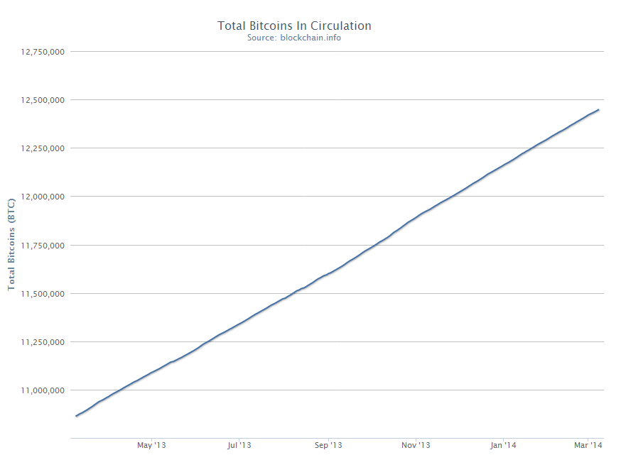
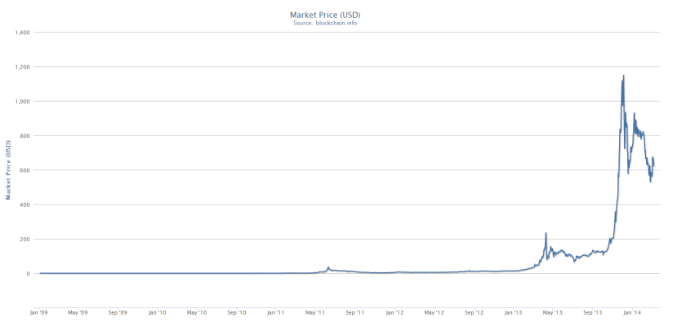
The Bitcoin network is not owned by anyone; instead, it is controlled by its worldwide users. For individuals, Bitcoin is not much different from an app or computer program that provides users with a personal digital currency wallet. This virtual wallet makes it easy to send and receive Bitcoin payments through these programs. Since the introduction of Bitcoins, there are now currency exchanges for people to trade Bitcoins for soft currencies such as dollars, Euros and other currencies. As seen in Figure 1 [9], currently there are over 12.4 million Bitcoins in circulation at a market price of about $623 USD. Over the last few years, the value of Bitcoin has grown rapidly. Figure 2 illustrates the exchange rate of Bitcoin to U.S. Dollars since its inception in 2009. Its value almost reached $1,200 last December. However, due to recent news reports of security issues, its value has been declining.
Figure 1: Total number of Bitcoins in circulation.
Source: blockchain.info/charts
Figure 2: Market price (USD) of Bitcoins since its inception in 2009.
Source: blockchain.info/charts

Benefits
Benefits of Bitcoin include built in security features, garners new customers, and good currency for international business transactions. One of the most important advantages of Bitcoin is that it helps business cut costs by eliminating Payment Card Industry (PCI) compliance and offer the lowest fees in the market since the transaction fees of Bitcoin is minimal. It is costly for businesses that accept online payments to conduct security checks. Bitcoin has a built in security thus businesses will not have to comply with PCI standards [10]. Moreover, the raising PCI compliance costs will not be of concern [10]. One of Bitcoin’s built in security features is signatures. Bitcoin wallets maintain a private key that is used to sign transactions. Another built in security feature is multi-signatures. A transaction will be authorized only when all required signatures have been collected. Signatures limit how coins can be spent and prevents any transactions from being altered once it has been issued [11].
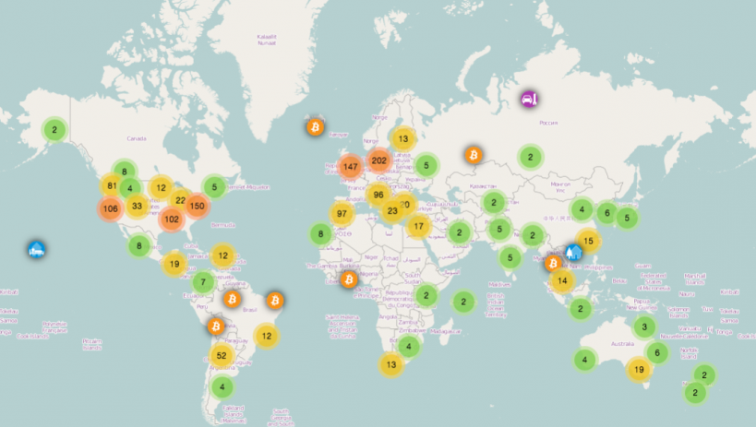
Moreover, Bitcoin could help businesses get new customers as businesses expand their web presence. Additionally, there is potential for Bitcoin to revolutionize international business since Bitcoin can transfer payments within 10 minutes, eliminating the need to wait for banks to process international payments. Figure 3 maps the stores around the world that is currently accepting Bitcoin payments. This new payment is already accepted in every continent so there are a lot of opportunities for individuals to get into Bitcoin. Nonetheless, with the great opportunities that Bitcoin introduced, the risks are not to be dismissed.
Figure 3: Map tracking number of stores around the world that accepts Bitcoin payments.
Source: www.businessinsider.com/bitcoin-store-map-2013-12

Challenges to Overcome
Security is crucial problem for Bitcoin’s greater expansion. Bitcoin is vulnerable to theft. Bitcoin wallets are unencrypted, thus making them attractive targets for hackers since it is. Unlike losing a credit card in which case the account can be suspended or close; however, there no such mechanism to help recover stolen Bitcoins. The most recent case of stolen digital currencies occurred last month. A virus, “Pony” infected computers of Bitcoin wallet holders and got their account information. 85 virtual wallets with $220,000 were stolen making it the largest attack on digital currency to date [12].
Bitcoin is also an ideal currency for illegal transactions because it is untraceable, without physical existence, and anonymous. Users could purchase illegal substance, partake in money laundering, or perform other illegal activities anonymously online without government interference. Virtual currency is privately owned online payment systems that enable international payments without transmittal services of the traditional financial institutions [13].
Consequently, it is difficult to detect the illegal transactions. However, there was a case last year in which FBI arrested Ross William Ulbrichi, the administrator of Silk Road, an online black market for drug trading. The FBI shut down Silk Road and discovered from investigations that the Silk Road had total illegal sales of over 9.5 million Bitcoins and collected revenue over 600,000 digital coins [14].
Another concern of Bitcoin is the fluctuation of its value. Since its inception Bitcoin market price reached as high as $1,151 in last December. But now the price has fallen to $621 per unit. Since Bitcoin is traded in the free market, the risk of price fluctuation is unavoidable. Moreover, as countries start creating policies to regulate Bitcoin as a real currency will also affect its value. The early adopters, like Cameron and Tyler Winklevoss made great returns on their investment [15], but going forward it may be more difficult for the new investors to gain as much return as the Winklevoss brothers.
Future Opportunities
Despite some of the challenges, Bitcoin creates opportunities for engineers specifically developers to continually improve this software. Developers within businesses can use Bitcoin system to build and further improve the payment system for companies. In this age of globalization, businesses are expanding and growing. Consumers are spending more time on the web. Thus the trend is for money to go mobile. Gartner, a research firm, estimated that mobile payments could be as high as $720 billion a year by 2017 [16]. Just last year, there was $15 trillion worth of retail transactions made in the world [16]. These statistics illustrate that there are new prospects in the field of new digital currency.
Corporate America: Apple, Amazon, Google, and Visa and MasterCard have already begun to develop their mobile digital wallet. Developers should also seek ways to further improve the relatively new Bitcoin system which would pave the path to virtual wallets. Further making progress on the Bitcoin network will pave the path for more startups such as BitWall and further influence how business is done in the future. Bitcoin could give online content creators an alternative to relying on advertisements for revenue. Bitcoin’s micropayments could change that because the fees are lower [17]. Lastly, correcting Bitcoin’s security flaws and helping the technology mature will enable the government to recognize it as an official currency.

Works Cited

[1] Kleinman, Alexis. "Americans Will Spend More Time On Digital Devices Than Watching TV This Year: Research." The Huffington Post. TheHuffingtonPost.com, 01 Aug. 2013. Web. 3 Mar. 2014.
[2] Lyford, Joshua. "Digital Currency Gaining Acceptance." Telegram & GazetteFeb 16 2014. ProQuest. Web. 1 Mar. 2014.
[3] Bitcoin.org. N.p.Web. 5 Mar 2014.
[4] "Bitcoin Money Supply and Money Creation." DGC. N.p., n.d. Web. 4 Mar. 2014.
[5] "How Does Bitcoin Work?" Bitcoin.org. N.p., n.d. Web. 2 Mar. 2014.
[6] "Some Bitcoin Words You Might Hear." Vocabulary. N.p., n.d. Web. 2 Mar. 2014. <https://bitcoin.org/en/vocabulary>
[7] "How Does Bitcoin Work?" Bitcoin.org. N.p., n.d. Web. 2 Mar. 2014.
[8] Light, Joe. "For Virtual Prospectors, Life in the Bitcoin Mines Gets Real." The Wall Street Journal. N.p., 19 Sept. 2013. Web. 2 Mar. 2014.
[9] "Home Welcome to Blockchain More..." Bitcoin Block Explorer. N.p., n.d. Web. 6 Mar. 2014.
[10] Bjorhusb, Jennifer, and Jim Spencer. "Financial, Retail Industries Keep Cybersecurity Mistakes and Punishments Secret." StarTribune. N.p., 23 Feb. 2014. Web. 26 Feb. 2014.
[11] "How Does Bitcoin Work?" Bitcoin.org. N.p., n.d. Web. 2 Mar. 2014.
[12] Miners, Zach. "Bitcoins, Other Digital Currencies Stolen in Massive 'Pony' Botnet Attack."CIO. N.p., 24 Feb. 2014. Web. 26 Feb. 2014.
[13] Money Laundering in Digital Currencies. Johnstown, PA: U.S. Dept. of Justice, National Drug Intelligence Center, 2008. Print.
[14] Hill, Kashmir. "The FBI's Plan For The Millions Worth Of Bitcoins Seized From Silk Road." Forbes. N.p., 4 Oct. 2013. Web. 3 Mar. 2014.
[15] Sablik, Tim. "DIGITAL CURRENCY." Econ Focus 17.3 (2013): 18,20,27. ProQuest. Web. 1 Mar. 2014.
[16] Bertoni, Steven. "Can PayPal Beat Apple, Google, Amazon And Icahn In The Wallet Wars?"Forbes. Forbes Magazine, 12 Feb. 2014. Web. 26 Feb. 2014.
[17] Ha, Anthony. "BitWall Allows Publishers To Make Money Through Bitcoin Micropayments." TechCrunch RSS. N.p., 21 Sept. 2013. Web. 1 Mar. 2014.

